# Innovating MedTech Education: Wardley Mapping for Strategic Teaching and Research in Higher Education

### WARNING: This content was generated using Generative AI. While efforts have been made to ensure accuracy and coherence, readers should approach the material with critical thinking and verify important information from authoritative sources.

## Table of Contents

* Introduction: The Convergence of Wardley Mapping and MedTech in Higher Education
  + The MedTech Revolution and Higher Education
    - Current challenges in MedTech education
    - The need for strategic thinking in healthcare technology
    - Overview of Wardley Mapping
  + Wardley Mapping: A Primer for MedTech Educators and Researchers
    - Core concepts and components of Wardley Maps
    - The evolution of technologies and practices in healthcare
    - Applying Wardley Mapping to MedTech scenarios
* Integrating Wardley Mapping into MedTech Curricula
  + Designing Wardley Mapping-Enhanced MedTech Courses
    - Identifying key learning outcomes
    - Structuring course content around Wardley Mapping principles
    - Developing practical exercises and assessments
  + Teaching Wardley Mapping to MedTech Students
    - Introducing mapping concepts through real-world MedTech examples
    - Facilitating collaborative mapping exercises
    - Encouraging critical thinking about technology evolution in healthcare
  + Case Studies: Successful Wardley Mapping Integration in MedTech Education
    - Undergraduate biomedical engineering programme transformation
    - Postgraduate healthcare innovation curriculum redesign
    - Continuing professional development for healthcare technologists
* Leveraging Wardley Mapping for Strategic MedTech Research
  + Mapping the MedTech Research Landscape
    - Identifying emerging technologies and research opportunities
    - Analysing competitive positioning of research institutions
    - Forecasting future directions in MedTech research
  + Strategic Research Planning with Wardley Maps
    - Aligning research goals with industry needs
    - Resource allocation and team composition
    - Identifying potential collaborations and partnerships
  + Enhancing Research Proposals and Funding Applications
    - Using Wardley Maps to strengthen research rationales
    - Visualising project impact and potential outcomes
    - Addressing reviewer concerns through strategic mapping
* Fostering Academic-Industry Collaborations in MedTech
  + Mapping the Academic-Industry Interface
    - Understanding stakeholder motivations and constraints
    - Identifying mutual benefits and synergies
    - Navigating regulatory and ethical considerations
  + Facilitating Collaborative Innovation Projects
    - Using Wardley Maps to define project scope and objectives
    - Managing expectations and aligning goals
    - Tracking progress and adapting to changes
  + Case Studies: Successful Academic-Industry Partnerships
    - Developing a novel medical device through strategic collaboration
    - Improving healthcare delivery systems through joint research
    - Commercialising academic research in digital health
* Ethical Considerations and Future Trends in MedTech Innovation
  + Ethical Implications of Emerging MedTech
    - Privacy and data security in connected healthcare
    - Equity and access in technology-driven healthcare
    - Ethical decision-making in AI-assisted medical interventions
  + Anticipating Future MedTech Developments
    - Mapping potential disruptive technologies
    - Predicting shifts in healthcare delivery models
    - Preparing students and researchers for future challenges
  + The Future of Wardley Mapping in MedTech Education and Research
    - Evolving mapping techniques for complex healthcare ecosystems
    - Integrating Wardley Mapping with other strategic tools
    - Building a community of practice in MedTech strategic thinking

# Introduction: The Convergence of Wardley Mapping and MedTech in Higher Education

## The MedTech Revolution and Higher Education

### Current challenges in MedTech education

The MedTech revolution has ushered in a new era of healthcare, characterised by rapid technological advancements and innovative medical solutions. However, this revolution has also brought forth significant challenges for higher education institutions tasked with preparing the next generation of MedTech professionals. As we delve into these challenges, it becomes evident that a strategic approach, such as Wardley Mapping, is crucial for navigating the complex landscape of MedTech education.

The primary challenges facing MedTech education can be broadly categorised into four key areas: curriculum relevance, technological pace, interdisciplinary integration, and ethical considerations. Each of these areas presents unique obstacles that educators and institutions must overcome to ensure the effective preparation of future MedTech professionals.

* Curriculum Relevance
* Technological Pace
* Interdisciplinary Integration
* Ethical Considerations

Curriculum Relevance: One of the most pressing challenges in MedTech education is maintaining curriculum relevance in the face of rapidly evolving technologies. Traditional educational models often struggle to keep pace with the dynamic nature of the MedTech industry. As a senior academic in the field notes:

The half-life of technical knowledge in MedTech is shrinking rapidly. What we teach today may be obsolete by the time our students graduate. We need a more agile approach to curriculum design that can anticipate and adapt to future trends.

This challenge necessitates a shift from static curricula to more dynamic, forward-looking educational frameworks. Wardley Mapping can play a crucial role in this transformation by helping educators visualise the evolution of technologies and skills within the MedTech landscape, enabling them to design curricula that are both current and future-proof.

Technological Pace: The rapid advancement of medical technologies presents another significant challenge. From artificial intelligence in diagnostics to 3D-printed organs, the pace of innovation in MedTech is unprecedented. Educators must not only stay abreast of these developments but also find effective ways to incorporate them into their teaching. This challenge is compounded by the often prohibitive costs of cutting-edge medical technologies, limiting hands-on experience for students.

A potential solution lies in leveraging Wardley Mapping to identify key technological trends and their potential impact on healthcare delivery. By mapping the MedTech landscape, educators can prioritise which technologies to focus on and develop innovative ways to provide practical experience, such as through simulations or industry partnerships.

Interdisciplinary Integration: MedTech is inherently interdisciplinary, bridging medicine, engineering, computer science, and other fields. However, traditional academic structures often operate in silos, making it challenging to provide truly integrated MedTech education. As a leading MedTech researcher observes:

The most innovative MedTech solutions often emerge at the intersection of multiple disciplines. Our educational systems need to reflect this reality by fostering collaboration across departments and breaking down traditional academic boundaries.

Wardley Mapping can facilitate this integration by visualising the interconnections between different disciplines within the MedTech ecosystem. This approach can help institutions identify opportunities for cross-disciplinary collaboration and design more holistic educational experiences.

Ethical Considerations: As medical technologies become more advanced and pervasive, ethical considerations are increasingly coming to the forefront of MedTech education. Issues such as data privacy, algorithmic bias in AI-driven diagnostics, and equitable access to advanced medical technologies pose significant challenges for educators.

Integrating ethical considerations into technical MedTech curricula requires a nuanced approach. Wardley Mapping can be employed to identify potential ethical flashpoints in the MedTech value chain, enabling educators to incorporate these considerations into their teaching in a contextually relevant manner.

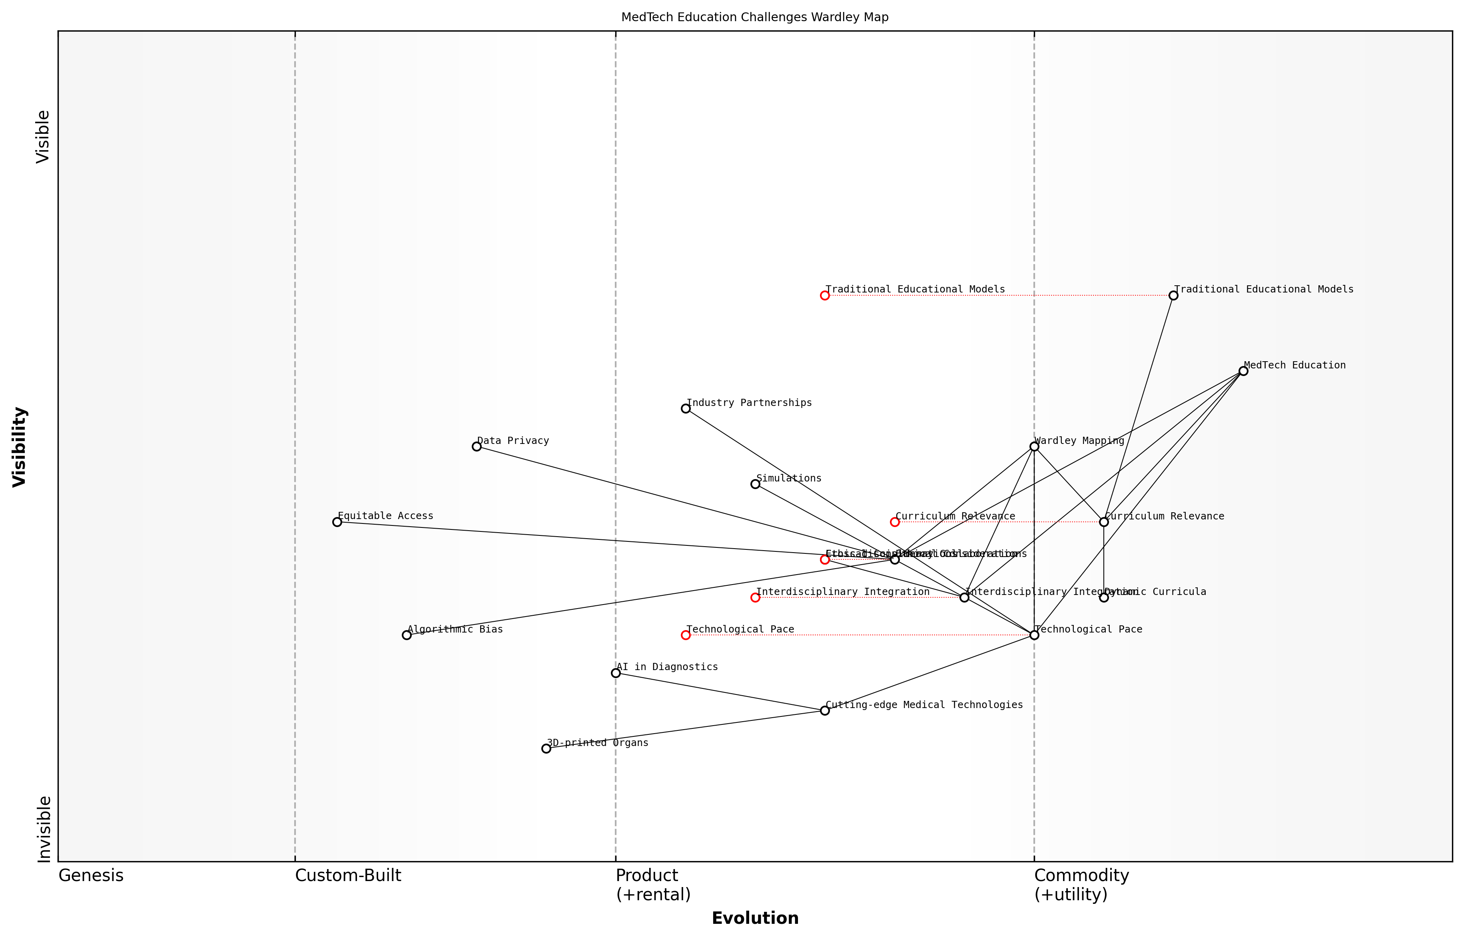

Draft Wardley Map: [Insert Wardley Map illustrating the challenges in MedTech education and their relationships]

[Edit this draft Wardley Map](https://create.wardleymaps.ai/#9a828211157549608f)

Addressing these challenges requires a strategic, forward-looking approach to MedTech education. Wardley Mapping offers a powerful tool for visualising the complex landscape of MedTech, identifying emerging trends, and designing educational experiences that prepare students for the future of healthcare technology.

By leveraging Wardley Mapping, institutions can:

* Anticipate future skill requirements and adapt curricula accordingly
* Identify opportunities for interdisciplinary collaboration
* Prioritise investments in educational technologies and resources
* Develop strategies for addressing ethical challenges in MedTech

As we move forward, it is clear that overcoming the challenges in MedTech education will require innovative approaches and strategic thinking. Wardley Mapping provides a framework for navigating this complex landscape, enabling educators to design curricula that are not only relevant today but also adaptable to the healthcare technologies of tomorrow.

### The need for strategic thinking in healthcare technology

The rapid evolution of medical technology (MedTech) has ushered in an era of unprecedented innovation in healthcare. However, this progress also brings complex challenges that demand a strategic approach to education and research in higher education institutions. The need for strategic thinking in healthcare technology has never been more critical, as it forms the foundation for preparing the next generation of MedTech professionals and researchers to navigate the intricate landscape of healthcare innovation.

Strategic thinking in healthcare technology encompasses several key dimensions:

* Understanding the evolving healthcare ecosystem
* Anticipating future technological trends and their impact
* Aligning technological innovations with patient needs and healthcare outcomes
* Navigating regulatory landscapes and ethical considerations
* Fostering collaboration between academia, industry, and healthcare providers

To address these dimensions effectively, higher education institutions must adopt a holistic approach to MedTech education and research. This is where Wardley Mapping emerges as a powerful tool for strategic thinking and planning in the context of healthcare technology.

Wardley Mapping provides a visual framework for understanding the evolution of technologies and practices in healthcare, enabling educators and researchers to make informed decisions about curriculum development and research priorities.

The application of Wardley Mapping in MedTech education offers several benefits:

* Visualising the MedTech landscape: Wardley Maps help students and researchers understand the interconnections between various components of the healthcare ecosystem, from basic research to patient care delivery.
* Identifying emerging opportunities: By mapping the evolution of technologies and practices, educators can highlight areas of potential innovation and guide students towards promising research directions.
* Enhancing strategic decision-making: Students learn to analyse the competitive positioning of different technologies and organisations, developing critical thinking skills essential for future leadership roles in healthcare technology.
* Facilitating interdisciplinary collaboration: Wardley Mapping encourages a systems-thinking approach, fostering collaboration across different disciplines within MedTech and beyond.

Integrating Wardley Mapping into MedTech curricula requires a thoughtful approach. Educators must consider how to introduce mapping concepts in a way that is accessible and relevant to students from diverse backgrounds, including engineering, life sciences, and healthcare management.

The key to successful integration of Wardley Mapping in MedTech education lies in its practical application to real-world healthcare challenges. Students must be able to see the immediate relevance of this strategic thinking tool to their future careers.

One effective approach is to structure courses around case studies that demonstrate the application of Wardley Mapping to MedTech innovation. For instance, students could analyse the development and adoption of telemedicine technologies, using Wardley Maps to visualise the evolution of components such as video conferencing software, electronic health records, and remote monitoring devices.

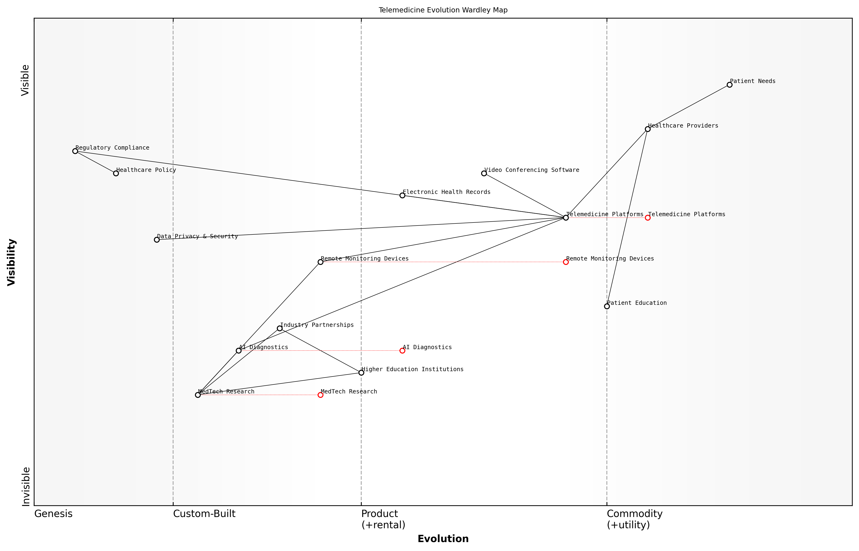

Draft Wardley Map: [Insert Wardley Map illustrating the evolution of telemedicine components]

[Edit this draft Wardley Map](https://create.wardleymaps.ai/#998ef19a3fb0313393)

In the realm of research, strategic thinking through Wardley Mapping can guide institutions in aligning their research priorities with industry needs and societal challenges. By mapping the current state of MedTech research and anticipating future developments, universities can make informed decisions about resource allocation, collaboration opportunities, and research focus areas.

For example, a research institution might use Wardley Mapping to analyse the landscape of artificial intelligence in healthcare diagnostics. This could reveal opportunities for developing novel algorithms, addressing data privacy concerns, or improving the integration of AI tools into clinical workflows.

The need for strategic thinking in healthcare technology extends beyond academia to industry partnerships and policy-making. Higher education institutions play a crucial role in bridging the gap between theoretical knowledge and practical application. By equipping students and researchers with strategic thinking tools like Wardley Mapping, universities can foster innovation that addresses real-world healthcare challenges.

Strategic thinking in healthcare technology is not just about predicting the future; it’s about shaping it. Our role in higher education is to empower the next generation of MedTech innovators with the tools and mindset to navigate complexity and drive meaningful change in healthcare delivery.

As we move forward, the integration of strategic thinking tools like Wardley Mapping into MedTech education and research will become increasingly important. It will enable institutions to adapt quickly to emerging technologies, anticipate regulatory changes, and address ethical considerations proactively. Moreover, it will prepare graduates to become not just technical experts, but strategic leaders capable of driving innovation in the complex and ever-evolving field of healthcare technology.

In conclusion, the need for strategic thinking in healthcare technology is paramount. By embracing tools like Wardley Mapping, higher education institutions can revolutionise MedTech education and research, fostering a new generation of innovators equipped to tackle the healthcare challenges of the future. As we continue to explore the convergence of Wardley Mapping and MedTech in higher education, we open up new possibilities for transformative learning experiences and groundbreaking research that will shape the future of healthcare.

### Overview of Wardley Mapping

In the rapidly evolving landscape of medical technology and higher education, Wardley Mapping emerges as a powerful strategic tool for navigating complexity and driving innovation. This section provides a comprehensive overview of Wardley Mapping and its significance in the context of MedTech education and research.

Wardley Mapping, developed by Simon Wardley, is a visual representation technique that allows organisations to map their business environment and make informed strategic decisions. In the realm of MedTech and higher education, this approach offers unique insights into the evolving landscape of healthcare technology, enabling educators, researchers, and industry professionals to anticipate changes, identify opportunities, and develop robust strategies.

Wardley Mapping has revolutionised our approach to strategic planning in MedTech education. It provides a common language for discussing complex systems and helps us anticipate future challenges in ways we never could before.

The core components of a Wardley Map include:

* Anchor: The user need or business goal at the top of the map
* Value Chain: The components needed to meet the user need, arranged vertically
* Evolution Axis: The horizontal axis representing the evolution of components from genesis to commodity
* Movement: Arrows indicating the expected changes in component positions over time

In the context of MedTech applications, Wardley Mapping offers several key benefits:

* Visualising the MedTech Ecosystem: Maps help stakeholders understand the complex relationships between various components of healthcare technology systems.
* Anticipating Technological Shifts: By mapping the evolution of technologies, educators and researchers can better prepare for future developments in the field.
* Identifying Strategic Opportunities: Maps reveal gaps in the value chain, highlighting areas for innovation or collaboration.
* Enhancing Decision-Making: The visual nature of maps facilitates more informed and strategic decision-making in curriculum development and research planning.
* Fostering Interdisciplinary Collaboration: Maps provide a common language for diverse stakeholders, promoting collaboration across disciplines and sectors.

Integrating Wardley Mapping into MedTech education and research requires a shift in thinking and approach. It encourages students, educators, and researchers to consider not just the current state of healthcare technology, but also its potential future trajectories. This forward-thinking perspective is crucial in a field where technological advancements can rapidly reshape the landscape of patient care and medical practice.

When we introduced Wardley Mapping to our postgraduate MedTech programme, we saw a marked improvement in students’ ability to think strategically about healthcare innovation. It’s not just about understanding the technology; it’s about seeing where it fits in the broader ecosystem and where it’s heading.

One of the key strengths of Wardley Mapping in MedTech applications is its ability to bridge the gap between academic research and industry needs. By mapping out the entire value chain of a healthcare technology or service, researchers can identify areas where their work can have the most significant impact. Similarly, educators can use maps to ensure that curricula remain aligned with the evolving needs of the healthcare industry.

However, it’s important to note that effective use of Wardley Mapping in MedTech contexts requires a deep understanding of both the mapping technique and the healthcare technology landscape. This underscores the need for comprehensive training and ongoing practice to fully leverage the potential of this strategic tool.

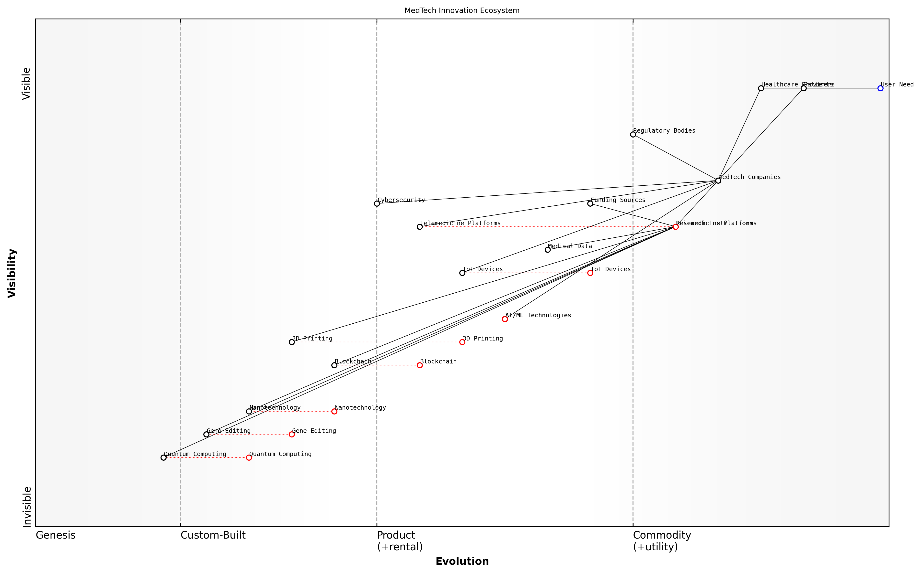

Draft Wardley Map: [Insert Wardley Map illustrating a typical MedTech innovation ecosystem, highlighting the positions of key technologies, regulatory factors, and stakeholders]

[Edit this draft Wardley Map](https://create.wardleymaps.ai/#ac7375e5304cd74c32)

As we delve deeper into the application of Wardley Mapping in MedTech education and research, it becomes clear that this approach offers a powerful framework for navigating the complexities of healthcare innovation. By providing a visual representation of the MedTech landscape, Wardley Mapping enables stakeholders to make more informed decisions, anticipate future challenges, and drive meaningful innovation in healthcare technology.

In the subsequent sections, we will explore how Wardley Mapping can be effectively integrated into MedTech curricula, leveraged for strategic research planning, and used to foster productive academic-industry collaborations. Through these applications, we will demonstrate the transformative potential of Wardley Mapping in shaping the future of MedTech education and innovation.

## Wardley Mapping: A Primer for MedTech Educators and Researchers

### Core concepts and components of Wardley Maps

In the rapidly evolving landscape of medical technology education and research, Wardley Mapping emerges as a powerful strategic tool for navigating complexity and driving innovation. As we delve into the core concepts and components of Wardley Maps, it is crucial to understand their significance in the context of MedTech applications within higher education. This foundational knowledge will equip educators and researchers with the ability to visualise, analyse, and strategise the future of healthcare technology.

Wardley Mapping, developed by Simon Wardley, is a visual representation technique that allows for the strategic analysis of business environments. When applied to MedTech, it provides a unique lens through which we can examine the interplay between emerging technologies, evolving healthcare needs, and educational imperatives. Let us explore the fundamental elements that constitute a Wardley Map and their relevance to MedTech education and research.

* Value Chain
* Evolution Axis
* Anchors
* Components
* Movement

1. Value Chain: The vertical axis of a Wardley Map represents the value chain, which in the context of MedTech, illustrates the journey from raw technological components to direct user needs. For instance, in a map focusing on telemedicine education, the value chain might progress from basic programming skills at the bottom to improved patient outcomes at the top. This structure allows educators to align curriculum development with the entire spectrum of value creation in healthcare technology.
2. Evolution Axis: The horizontal axis depicts the evolution of components from genesis (novel concepts) to commodity (standardised practices). In MedTech, this axis is particularly dynamic, reflecting the rapid pace of technological advancement. For example, machine learning algorithms for diagnostic imaging have evolved from cutting-edge research topics to essential components of medical curricula. Understanding this evolution enables researchers and educators to anticipate future skill requirements and research directions.
3. Anchors: These are the fixed points on a Wardley Map that represent the ultimate user needs. In MedTech education, anchors might include ‘enhanced clinical decision-making’ or ‘improved patient safety’. By clearly defining these anchors, educators can ensure that all elements of their teaching and research programmes ultimately contribute to these fundamental healthcare objectives.
4. Components: These are the individual elements that make up the map, representing technologies, skills, practices, or knowledge areas within MedTech. For instance, a map focusing on biomedical engineering education might include components such as ‘sensor technology’, ‘data analytics’, and ‘regulatory compliance’. The positioning of these components relative to each other provides insights into their interdependencies and relative importance in the MedTech ecosystem.
5. Movement: This concept captures the dynamic nature of the MedTech landscape, illustrating how components evolve over time. In the context of higher education, understanding movement allows for proactive curriculum design that anticipates future industry needs. For example, as virtual reality simulations for surgical training move from genesis to custom-built solutions, educators can plan for their integration into medical programmes.

Wardley Mapping provides a strategic lens through which we can anticipate the future of MedTech and align our educational and research efforts accordingly. It’s not just about understanding where we are, but where we need to be.

The application of these core concepts in MedTech education and research offers numerous benefits. Firstly, it enables a holistic view of the healthcare technology landscape, fostering interdisciplinary collaboration and innovation. Secondly, it aids in identifying gaps in current curricula and research focus areas, allowing for targeted improvements. Lastly, it provides a common language for communication between academia, industry, and healthcare providers, facilitating more effective partnerships and knowledge transfer.

To illustrate the practical application of Wardley Mapping in MedTech education, consider the following example: A university’s biomedical engineering department aims to revamp its postgraduate programme to better align with industry needs. By creating a Wardley Map of the current MedTech landscape, they identify an emerging cluster of components around ‘edge computing for medical devices’. This insight leads to the development of new modules focusing on low-latency data processing and decentralised AI algorithms, positioning graduates at the forefront of this evolving field.

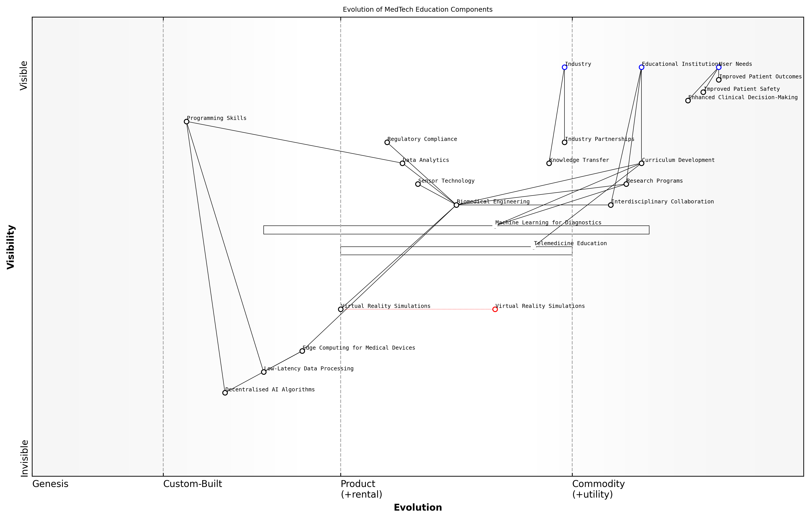

Draft Wardley Map: [Insert Wardley Map: Evolution of MedTech Education Components]

[Edit this draft Wardley Map](https://create.wardleymaps.ai/#bda9b8484777d09669)

As we progress through this book, we will delve deeper into how these core concepts of Wardley Mapping can be leveraged to transform MedTech education and research. From curriculum design to research strategy formulation, the principles outlined here will serve as a foundation for innovative approaches to teaching and investigating healthcare technologies.

The true power of Wardley Mapping in MedTech lies not just in its ability to visualise the present, but in its capacity to illuminate the path to future innovations in healthcare education and research.

By mastering these core concepts and components of Wardley Maps, educators and researchers in the MedTech field can position themselves as strategic leaders, capable of navigating the complex interplay between technological advancement, educational imperatives, and healthcare needs. As we move forward, we will explore how to apply these principles to specific challenges and opportunities in MedTech education and research, ensuring that our academic institutions remain at the cutting edge of healthcare innovation.

### The evolution of technologies and practices in healthcare

The evolution of technologies and practices in healthcare is a critical component of understanding the MedTech landscape, particularly when applying Wardley Mapping to educational and research contexts. This evolution forms the backbone of strategic thinking in healthcare technology, providing educators and researchers with a dynamic framework for anticipating future developments and preparing students for the challenges ahead.

To effectively utilise Wardley Mapping in MedTech education and research, it is essential to grasp the historical trajectory and future projections of healthcare technologies and practices. This understanding enables the creation of more accurate and insightful maps, which in turn leads to better strategic decision-making and more relevant educational outcomes.

Let us explore the key aspects of this evolution, its impact on Wardley Mapping in MedTech, and how educators and researchers can leverage this knowledge to enhance their teaching and research strategies.

Historical Perspective and Technological Advancements

The healthcare sector has undergone significant transformations over the past century, driven by technological advancements and changing societal needs. From the introduction of X-rays and antibiotics to the development of minimally invasive surgeries and personalised medicine, each innovation has reshaped the healthcare landscape.

* Early 20th century: Focus on diagnostic tools and pharmaceutical interventions
* Mid-20th century: Emergence of medical imaging and advanced surgical techniques
* Late 20th century: Rise of digital health records and telemedicine
* Early 21st century: Integration of AI, big data, and personalised medicine

Understanding this historical progression is crucial for creating accurate Wardley Maps in MedTech education and research. It allows for the proper positioning of technologies and practices along the evolution axis, from genesis to commodity.

Current Trends and Future Projections

The current MedTech landscape is characterised by rapid innovation and convergence of various technologies. Key trends include:

* Artificial Intelligence and Machine Learning in diagnostics and treatment planning
* Internet of Medical Things (IoMT) for remote patient monitoring
* 3D printing for personalised medical devices and implants
* Gene editing and personalised medicine
* Virtual and Augmented Reality in medical training and patient care

When applying Wardley Mapping to these trends, it’s important to consider not only the technological aspects but also the evolving practices and methodologies in healthcare delivery. This holistic approach ensures that maps reflect the complete ecosystem of MedTech innovation.

The future of healthcare lies not just in technological advancements, but in the seamless integration of these technologies with human-centred care practices. Wardley Mapping provides us with a powerful tool to visualise and navigate this complex landscape.

Impact on Wardley Mapping in MedTech Education and Research

The evolving nature of healthcare technologies and practices has significant implications for how we teach and apply Wardley Mapping in MedTech contexts:

* Dynamic positioning: Technologies and practices must be regularly reassessed and repositioned on maps as they evolve.
* Interdependencies: The increasing interconnectedness of healthcare systems requires maps that capture complex relationships between components.
* Ethical considerations: As technologies advance, maps must incorporate ethical dimensions, particularly in areas like AI and genetic engineering.
* Regulatory landscape: The evolving regulatory environment must be reflected in maps, influencing the trajectory of innovations.
* User needs: Shifting patient expectations and healthcare delivery models should be central to mapping exercises.

Educators and researchers must stay abreast of these developments to ensure that their Wardley Mapping instruction and application remain relevant and effective.

Strategies for Incorporating Evolution into MedTech Education and Research

To effectively teach and apply Wardley Mapping in the context of evolving healthcare technologies and practices, consider the following strategies:

* Regular curriculum updates: Continuously revise course materials to reflect the latest MedTech developments and their impact on mapping.
* Industry partnerships: Collaborate with healthcare providers and MedTech companies to ensure real-world relevance in mapping exercises.
* Scenario planning: Incorporate future-focused scenarios in mapping activities to prepare students for upcoming challenges.
* Interdisciplinary approach: Encourage collaboration between technology, healthcare, and policy experts in mapping projects.
* Ethical frameworks: Integrate discussions on ethical implications of emerging technologies into mapping exercises.
* Adaptive research methodologies: Develop flexible research approaches that can accommodate rapid technological changes.

In the fast-paced world of MedTech, our educational and research methodologies must be as dynamic as the technologies we study. Wardley Mapping, when taught and applied with an understanding of technological evolution, becomes an invaluable tool for navigating this complex landscape.

Case Study: Mapping the Evolution of Telemedicine

To illustrate the application of Wardley Mapping in understanding the evolution of healthcare technologies and practices, let’s consider the case of telemedicine:

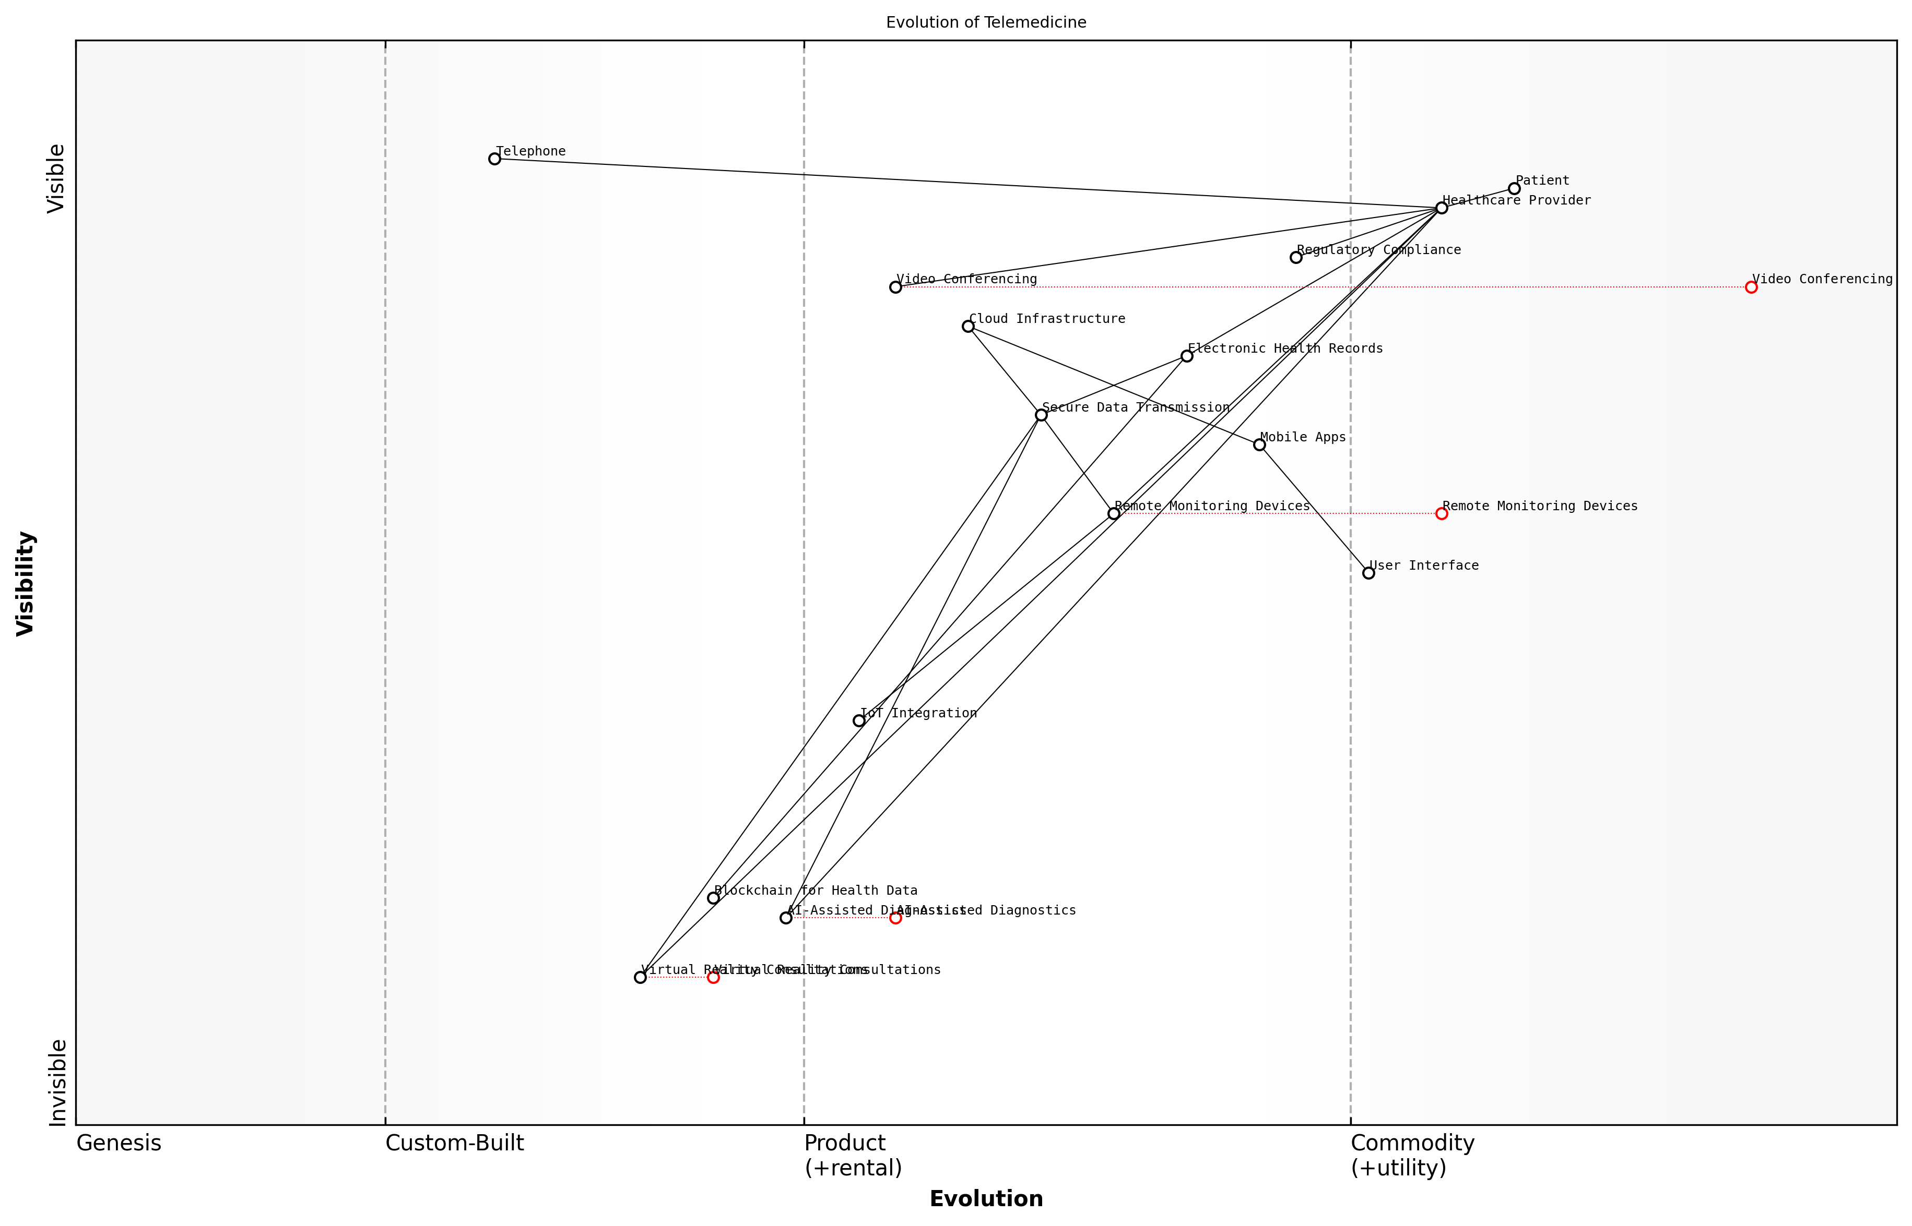

Draft Wardley Map: [Insert Wardley Map showing the evolution of telemedicine components over time, from early telephone consultations to AI-powered remote diagnostics]

[Edit this draft Wardley Map](https://create.wardleymaps.ai/#2b335b5b024d3a9457)

This map demonstrates how various components of telemedicine have evolved from genesis to commodity, influenced by technological advancements, changing user needs, and regulatory shifts. It provides a visual representation of how practices like remote consultations have become increasingly ubiquitous, while emerging technologies like AI-assisted diagnostics are still in the early stages of development.

By analysing such maps, students and researchers can gain insights into the factors driving innovation in healthcare, anticipate future developments, and develop strategies for addressing challenges in MedTech implementation.

Conclusion

The evolution of technologies and practices in healthcare is a fundamental concept in applying Wardley Mapping to MedTech education and research. By understanding this evolution, educators can provide students with the tools to navigate the complex and rapidly changing landscape of healthcare technology. Researchers, armed with this knowledge, can create more accurate and insightful maps, leading to more effective strategic planning and innovation in the MedTech sector.

As we continue to witness unprecedented advancements in healthcare technologies and practices, the ability to map and analyse these changes becomes increasingly valuable. Wardley Mapping, when taught and applied with a deep understanding of technological evolution, empowers the next generation of MedTech professionals to drive innovation and improve healthcare outcomes.

### Applying Wardley Mapping to MedTech scenarios

In the rapidly evolving landscape of medical technology, the application of Wardley Mapping offers a powerful strategic tool for educators and researchers in higher education. This section explores how Wardley Mapping can be effectively applied to MedTech scenarios, providing a structured approach to understanding and navigating the complex interplay of technologies, stakeholders, and market forces in this dynamic field.

Wardley Mapping, when applied to MedTech scenarios, enables educators and researchers to visualise the entire value chain of healthcare technologies, from fundamental research to patient-facing applications. This holistic view is crucial in a field where innovations must navigate a complex ecosystem of regulatory requirements, clinical validations, and diverse stakeholder needs.

Wardley Mapping has revolutionised our approach to MedTech innovation. It allows us to see beyond individual technologies and understand how they fit into the broader healthcare landscape, enabling more strategic decision-making in both research and education.

Let’s explore the key aspects of applying Wardley Mapping to MedTech scenarios:

* Identifying the Value Chain in MedTech
* Mapping the Evolution of MedTech Components
* Understanding Stakeholder Needs and Motivations
* Anticipating Disruptive Technologies in Healthcare
* Aligning Research and Education with Industry Trends

Identifying the Value Chain in MedTech: When applying Wardley Mapping to MedTech scenarios, the first step is to identify and map out the entire value chain. This includes components such as basic scientific research, technology development, clinical trials, regulatory approval processes, manufacturing, distribution, and end-user adoption. By visualising this chain, educators and researchers can better understand the interdependencies between different stages of MedTech innovation and identify potential bottlenecks or opportunities for improvement.

Mapping the Evolution of MedTech Components: One of the most powerful aspects of Wardley Mapping is its ability to represent the evolution of components over time. In MedTech, this is particularly valuable as it allows us to track how different technologies move from novel concepts to commodity services. For instance, we might map the evolution of wearable health monitors from custom-built research tools to mass-market consumer devices. This evolutionary perspective helps researchers focus on emerging areas and helps educators prepare students for future industry needs.

Understanding Stakeholder Needs and Motivations: MedTech innovations must serve a diverse range of stakeholders, including patients, healthcare providers, regulators, and payers. Wardley Mapping allows us to visualise these stakeholders in relation to the value chain, helping to identify potential conflicts or alignments of interest. This stakeholder-centric view is crucial for developing MedTech solutions that are not only technically innovative but also commercially viable and clinically relevant.

By mapping stakeholder needs alongside technological components, we’ve been able to identify gaps in the market that our research can address. This has led to more impactful projects and stronger industry collaborations.

Anticipating Disruptive Technologies in Healthcare: The healthcare sector is prone to disruption from emerging technologies. Wardley Mapping can help researchers and educators anticipate these disruptions by visualising how new technologies might impact different parts of the value chain. For example, a map might show how advances in artificial intelligence could potentially disrupt traditional diagnostic processes, allowing educators to prepare students for these future scenarios.

Aligning Research and Education with Industry Trends: By creating Wardley Maps of the MedTech landscape, higher education institutions can better align their research priorities and curriculum design with industry trends. This alignment ensures that research outputs are more likely to find practical applications and that graduates are equipped with the skills and knowledge most valued by the industry.

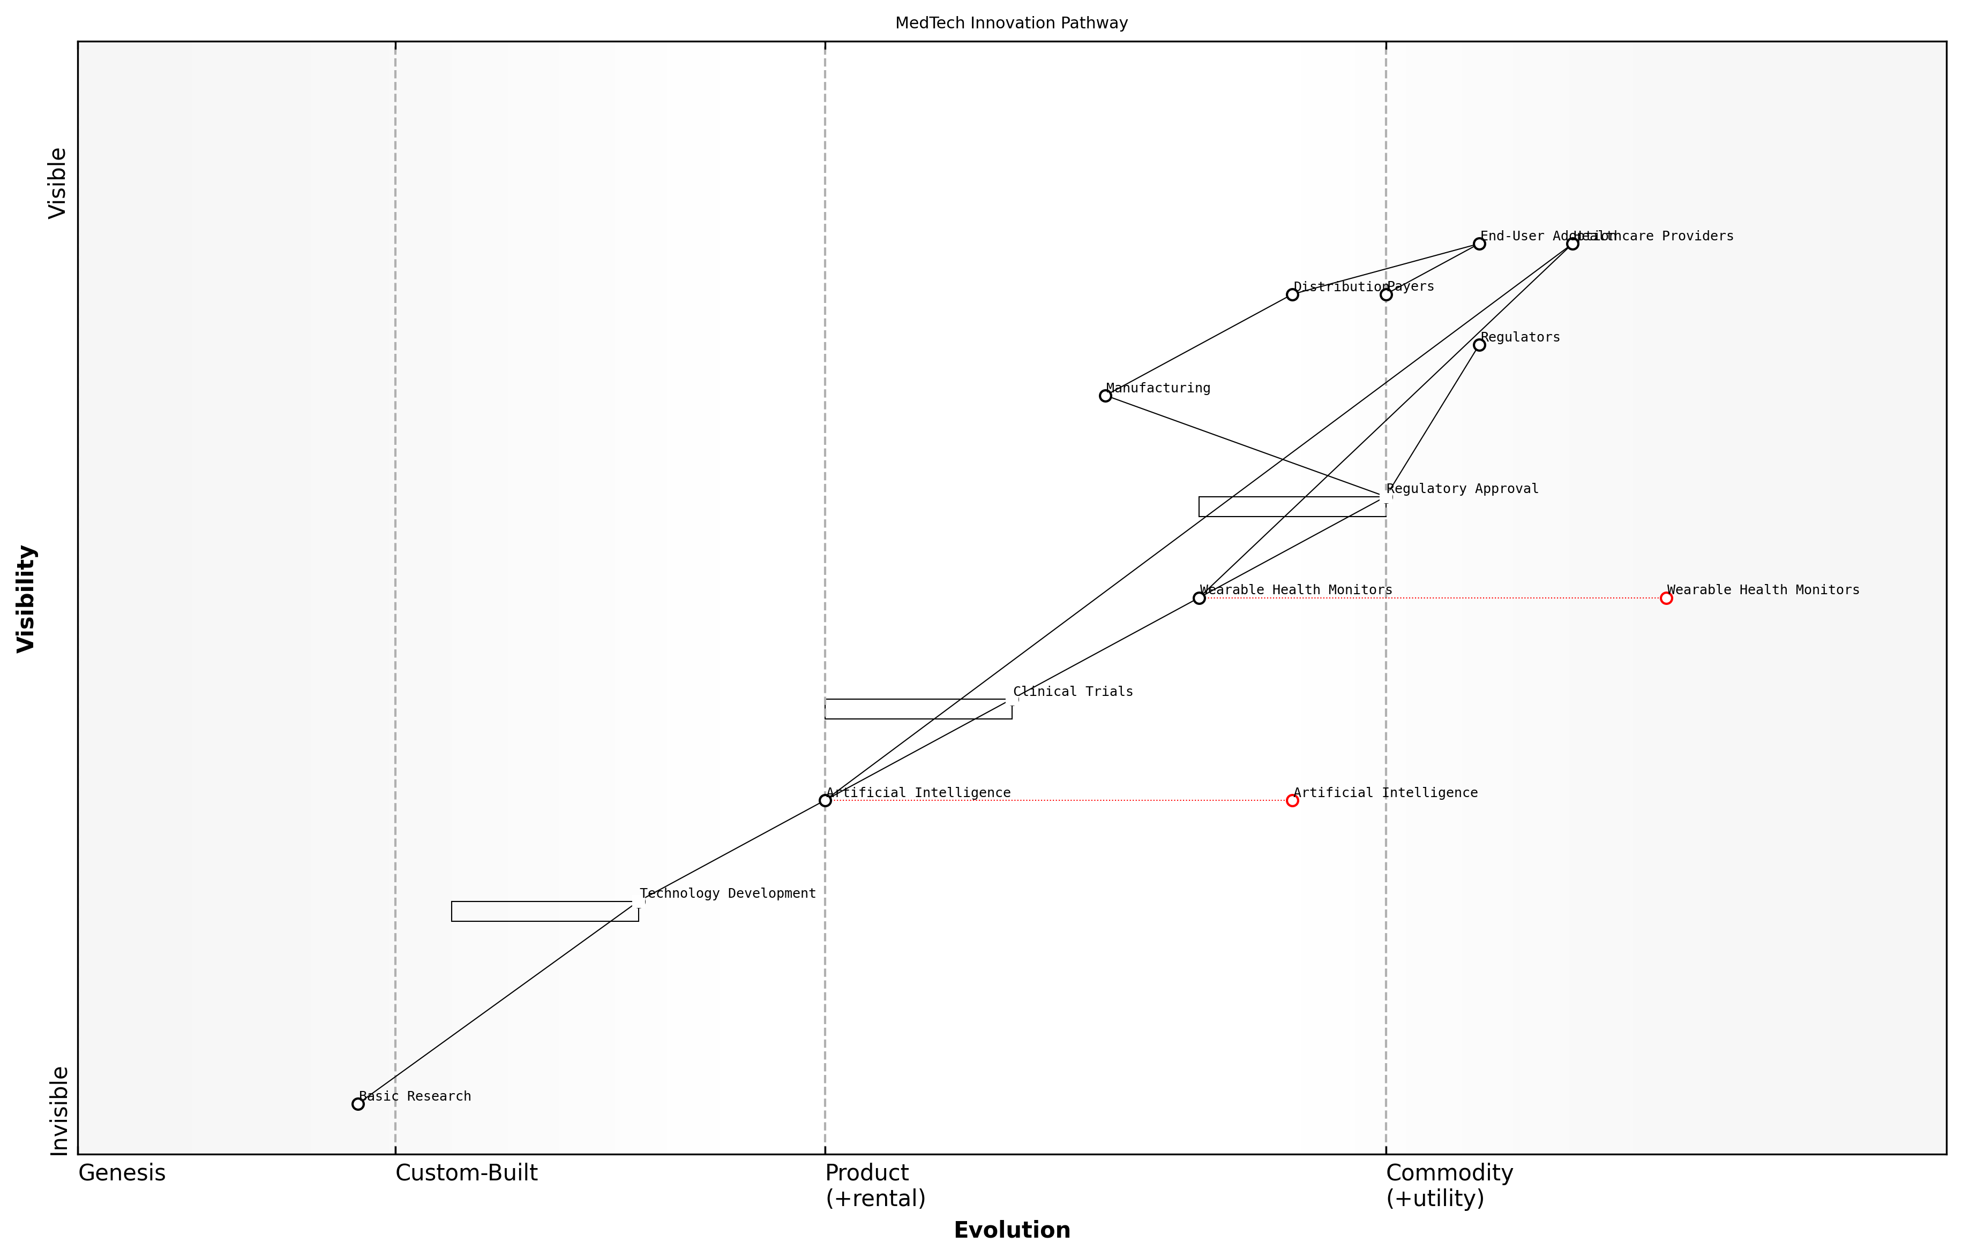

Draft Wardley Map: [Insert Wardley Map illustrating a typical MedTech innovation pathway, from basic research to market adoption, highlighting key stakeholders and evolutionary stages of different components]

[Edit this draft Wardley Map](https://create.wardleymaps.ai/#afd2eeb7823eb91253)

Practical Application in Higher Education: When integrating Wardley Mapping into MedTech education and research, it’s important to provide hands-on experiences. This could involve:

* Collaborative mapping exercises where students and researchers create maps of specific MedTech subsectors
* Case studies analysing successful and failed MedTech innovations through the lens of Wardley Mapping
* Industry partnerships where students use Wardley Mapping to solve real-world MedTech challenges
* Research projects that use Wardley Mapping to identify promising areas for investigation or to guide technology transfer strategies

Challenges and Considerations: While Wardley Mapping offers significant benefits for MedTech scenarios, it’s important to acknowledge its limitations and challenges. The complexity of the healthcare sector, with its myriad regulations and stakeholders, can make mapping exercises particularly challenging. Additionally, the rapid pace of technological change in MedTech means that maps may need frequent updating to remain relevant.

Despite these challenges, the strategic insights gained from applying Wardley Mapping to MedTech scenarios can be invaluable. By providing a visual representation of the complex MedTech landscape, Wardley Mapping enables educators, researchers, and students to develop a more nuanced understanding of the field and make more informed decisions about where to focus their efforts.

Wardley Mapping has become an essential tool in our MedTech innovation toolkit. It helps us navigate the complexity of the healthcare ecosystem and identify opportunities that we might otherwise miss. For educators and researchers in this field, it’s a game-changer.

In conclusion, applying Wardley Mapping to MedTech scenarios offers a powerful approach for educators and researchers in higher education to navigate the complexities of this rapidly evolving field. By providing a structured framework for analysing the MedTech landscape, Wardley Mapping enables more strategic decision-making, fosters innovation, and helps align academic efforts with industry needs. As the MedTech sector continues to grow and evolve, the ability to create and interpret these maps will become an increasingly valuable skill for both students and researchers in the field.

# Integrating Wardley Mapping into MedTech Curricula

## Designing Wardley Mapping-Enhanced MedTech Courses

### Identifying key learning outcomes

In the realm of Teaching and Research in Higher Education Using Wardley Mapping with a Focus on MedTech Applications, identifying key learning outcomes is a critical step in designing effective courses. This process requires a deep understanding of both Wardley Mapping principles and the evolving landscape of medical technology. As we integrate these two domains, we must carefully consider the skills and knowledge that will best prepare students for the challenges and opportunities in the MedTech sector.

To effectively identify key learning outcomes, we must consider several crucial aspects:

* Understanding of Wardley Mapping fundamentals
* Application of mapping techniques to MedTech scenarios
* Strategic thinking in healthcare technology contexts
* Awareness of MedTech industry trends and challenges
* Ethical considerations in healthcare innovation

Let’s explore each of these aspects in detail to understand how they contribute to comprehensive learning outcomes for MedTech students utilising Wardley Mapping.

1. Understanding of Wardley Mapping Fundamentals

A solid grasp of Wardley Mapping principles is essential for students to effectively apply this strategic tool in MedTech contexts. Key learning outcomes in this area should include:

* Ability to identify and map components of a MedTech value chain
* Understanding of evolution stages (genesis, custom-built, product, and commodity)
* Proficiency in analysing component relationships and dependencies
* Skill in interpreting and deriving insights from Wardley Maps

Mastery of Wardley Mapping fundamentals provides students with a powerful lens through which to view and analyse complex healthcare systems and technologies.

1. Application of Mapping Techniques to MedTech Scenarios

Beyond theoretical knowledge, students must be able to apply Wardley Mapping to real-world MedTech scenarios. Learning outcomes should focus on:

* Capability to create Wardley Maps for specific MedTech products or services
* Skill in using maps to identify opportunities for innovation in healthcare technology
* Ability to analyse competitive positioning of MedTech solutions
* Proficiency in using maps to inform strategic decision-making in healthcare contexts

1. Strategic Thinking in Healthcare Technology Contexts

Wardley Mapping serves as a catalyst for strategic thinking, particularly valuable in the complex and rapidly evolving MedTech sector. Key learning outcomes should include:

* Ability to anticipate future trends and disruptions in healthcare technology
* Skill in developing strategic plans based on insights derived from Wardley Maps
* Understanding of how to align MedTech innovations with broader healthcare objectives
* Capability to assess and mitigate risks in MedTech product development and deployment

Strategic thinking, informed by Wardley Mapping, empowers students to navigate the complexities of the MedTech landscape and drive meaningful innovation in healthcare.

1. Awareness of MedTech Industry Trends and Challenges

To effectively apply Wardley Mapping in MedTech contexts, students must have a comprehensive understanding of the industry landscape. Learning outcomes should encompass:

* Knowledge of current and emerging technologies in healthcare
* Understanding of regulatory frameworks governing MedTech innovations
* Awareness of key stakeholders and their roles in the healthcare ecosystem
* Ability to identify and analyse market opportunities and challenges in MedTech

1. Ethical Considerations in Healthcare Innovation

Given the sensitive nature of healthcare and the potential impact of MedTech innovations on patient outcomes, ethical considerations must be a key component of learning outcomes. Students should develop:

* Understanding of ethical principles relevant to healthcare technology
* Ability to identify and address ethical challenges in MedTech innovation
* Skill in incorporating ethical considerations into Wardley Maps and strategic planning
* Awareness of the societal implications of healthcare technology advancements

Integrating ethical considerations into Wardley Mapping exercises ensures that students develop a holistic approach to MedTech innovation, balancing technological advancement with societal responsibility.

By focusing on these key areas, educators can design comprehensive learning outcomes that equip students with the knowledge, skills, and ethical framework necessary to leverage Wardley Mapping effectively in MedTech contexts. These outcomes will prepare students to become strategic thinkers and innovators capable of navigating the complex intersection of healthcare and technology.

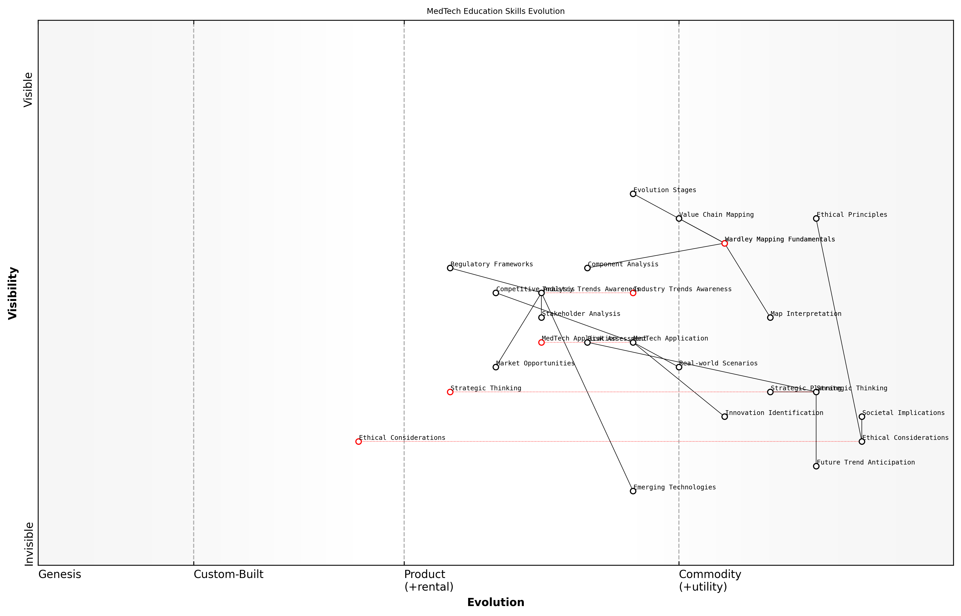

Draft Wardley Map: [Insert Wardley Map illustrating the evolution of key skills and knowledge areas in MedTech education]

[Edit this draft Wardley Map](https://create.wardleymaps.ai/#0d7d115ffd124b6333)

As we design courses that integrate Wardley Mapping into MedTech curricula, it’s crucial to regularly review and update these learning outcomes to reflect the dynamic nature of both the mapping methodology and the healthcare technology landscape. By doing so, we ensure that our educational programmes remain at the forefront of innovation, producing graduates who are well-equipped to drive positive change in the MedTech sector.

### Structuring course content around Wardley Mapping principles

Integrating Wardley Mapping principles into MedTech course content represents a paradigm shift in how we approach higher education in healthcare technology. This strategic restructuring not only enhances students’ understanding of the evolving MedTech landscape but also equips them with invaluable tools for future innovation and decision-making in this rapidly advancing field.

To effectively structure course content around Wardley Mapping principles, we must consider several key aspects:

* Foundational knowledge of Wardley Mapping
* MedTech-specific applications
* Progressive complexity in mapping exercises
* Integration with existing MedTech topics
* Practical, real-world scenarios

Let’s explore each of these aspects in detail to provide a comprehensive framework for course design.

1. Foundational knowledge of Wardley Mapping

Begin by introducing students to the core concepts of Wardley Mapping. This includes understanding the axes (evolution and visibility), component types, and the principles of movement and anchoring. A solid grasp of these fundamentals is crucial before applying them to MedTech scenarios.

As a seasoned strategist in healthcare technology once remarked, ‘Wardley Mapping is to MedTech what anatomy is to medicine – a fundamental framework for understanding complex systems.’

1. MedTech-specific applications

Once students have grasped the basics, introduce MedTech-specific applications of Wardley Mapping. This could include mapping the evolution of medical devices, healthcare IT systems, or emerging technologies like AI in diagnostics. Emphasise how Wardley Mapping can reveal strategic opportunities and potential disruptions in the MedTech sector.

1. Progressive complexity in mapping exercises

Structure the course to gradually increase the complexity of mapping exercises. Start with simple, single-component maps and progress to more complex, multi-component maps that represent entire MedTech ecosystems. This approach allows students to build confidence and competence over time.

* Week 1-2: Single component mapping (e.g., a specific medical device)
* Week 3-4: Multi-component mapping (e.g., a hospital’s technology stack)
* Week 5-6: Ecosystem mapping (e.g., the entire healthcare delivery system in a region)

1. Integration with existing MedTech topics

Seamlessly integrate Wardley Mapping into existing MedTech course topics. For instance, when discussing medical imaging technologies, use Wardley Maps to illustrate the evolution from X-rays to MRI and future possibilities like AI-enhanced imaging. This integration helps students see the practical application of mapping in their field of study.

1. Practical, real-world scenarios

Incorporate real-world MedTech scenarios and case studies throughout the course. These could include mapping exercises based on actual healthcare organisations, medical device manufacturers, or health tech startups. Engaging with authentic scenarios enhances students’ ability to apply Wardley Mapping in their future careers.

A prominent healthcare innovation expert noted, ‘The true power of Wardley Mapping in MedTech education lies in its ability to bridge theoretical knowledge with practical, strategic thinking.’

To further enhance the learning experience, consider the following strategies:

* Collaborative mapping sessions: Encourage students to work in groups to create and analyse Wardley Maps, fostering teamwork and diverse perspectives.
* Guest lectures: Invite MedTech industry professionals to share how they use Wardley Mapping in their work, providing real-world context.
* Interdisciplinary projects: Collaborate with other departments (e.g., business, design) to create comprehensive MedTech innovation projects using Wardley Mapping.
* Continuous assessment: Implement regular mapping exercises and projects throughout the course, allowing students to track their progress and refine their skills.
* Reflection and critique: Encourage students to critically analyse their own and others’ maps, developing their strategic thinking abilities.

By structuring course content around these Wardley Mapping principles, educators can create a dynamic and engaging learning environment that prepares students for the complexities of the MedTech industry. This approach not only teaches valuable strategic thinking skills but also instils a deep understanding of the evolving healthcare technology landscape.

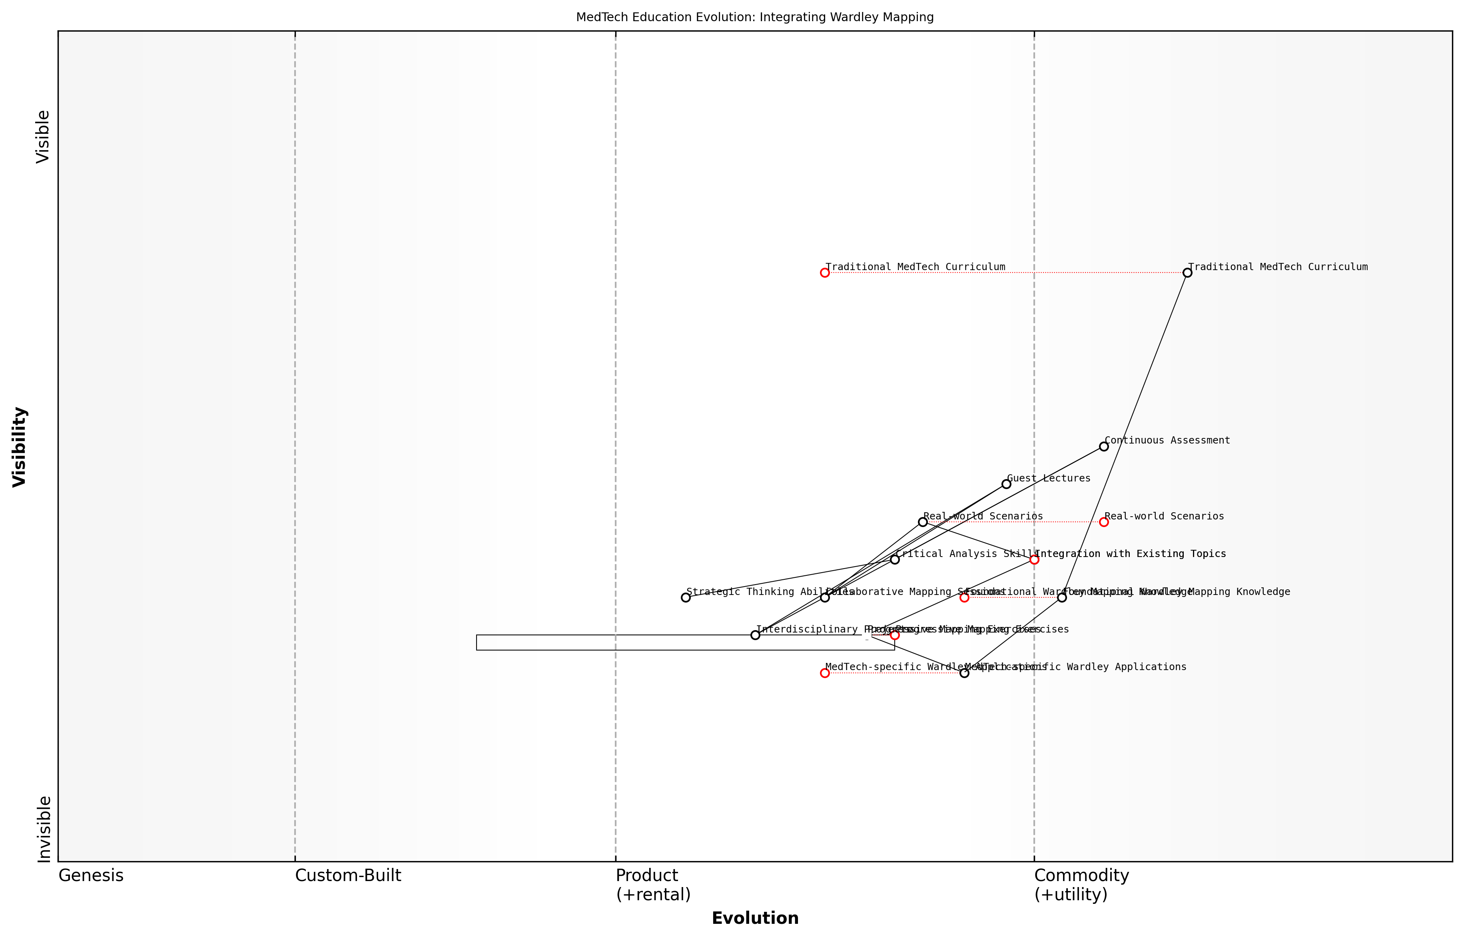

Draft Wardley Map: [Insert Wardley Map illustrating the evolution of a MedTech education curriculum, from traditional approaches to Wardley Mapping-enhanced methodologies]

[Edit this draft Wardley Map](https://create.wardleymaps.ai/#ff096af205e513330d)

In conclusion, structuring MedTech course content around Wardley Mapping principles offers a powerful way to enhance students’ strategic thinking abilities and prepare them for the dynamic world of healthcare technology. By combining foundational knowledge, progressive complexity, real-world applications, and interdisciplinary collaboration, educators can create a robust learning experience that equips the next generation of MedTech professionals with the tools they need to drive innovation and make informed decisions in this rapidly evolving field.

### Developing practical exercises and assessments

In the realm of Teaching and Research in Higher Education Using Wardley Mapping with a Focus on MedTech Applications, developing practical exercises and assessments is crucial for ensuring that students not only grasp the theoretical concepts but can also apply them effectively in real-world scenarios. This subsection explores the strategies and best practices for creating engaging, challenging, and relevant exercises and assessments that reinforce the application of Wardley Mapping in MedTech contexts.

When designing practical exercises and assessments for Wardley Mapping-enhanced MedTech courses, it is essential to consider the following key aspects:

* Alignment with learning outcomes
* Relevance to current MedTech challenges
* Scalability and adaptability
* Integration of interdisciplinary knowledge
* Incorporation of real-world data and scenarios
* Opportunities for collaborative learning
* Assessment of both technical and strategic thinking skills

Let’s explore each of these aspects in detail and discuss how they can be effectively implemented in the context of MedTech education.

1. Alignment with Learning Outcomes:

Practical exercises and assessments should be carefully designed to align with the specific learning outcomes of the course. For instance, if a key learning outcome is to develop students’ ability to analyse the evolution of medical technologies, an appropriate exercise might involve creating a Wardley Map for a specific medical device or technology, tracing its journey from genesis to commoditisation.

Effective assessment design in MedTech education is not just about testing knowledge, but about evaluating students’ ability to apply Wardley Mapping principles to solve complex healthcare challenges.

1. Relevance to Current MedTech Challenges:

To ensure that exercises and assessments are meaningful and engaging, they should address current challenges in the MedTech industry. This might involve analysing the strategic positioning of emerging technologies like AI-powered diagnostic tools, wearable health monitors, or telemedicine platforms. By working on relevant, real-world problems, students are better prepared for the challenges they will face in their future careers.

1. Scalability and Adaptability:

Given the rapid pace of change in the MedTech sector, it’s crucial to design exercises and assessments that can be easily updated or scaled to accommodate new developments. This might involve creating a framework for exercises that can be populated with current case studies or data sets, allowing for the continuous refresh of course materials without significant overhaul.

1. Integration of Interdisciplinary Knowledge:

MedTech is inherently interdisciplinary, combining elements of healthcare, engineering, and business strategy. Effective exercises should reflect this by requiring students to draw on knowledge from multiple domains. For example, a comprehensive assessment might involve creating a Wardley Map for a hospital’s technology infrastructure, considering clinical needs, technical feasibility, and economic viability.

1. Incorporation of Real-World Data and Scenarios:

To bridge the gap between theory and practice, exercises should incorporate real-world data and scenarios whenever possible. This could involve partnering with MedTech companies or healthcare providers to obtain anonymised data sets or case studies. Students could then use this data to create Wardley Maps and develop strategic recommendations, mirroring the work they would do in industry.

The most impactful learning experiences in MedTech education are those that closely simulate the complexities and constraints of real-world healthcare environments.

1. Opportunities for Collaborative Learning:

Wardley Mapping is often a collaborative process in professional settings, and this should be reflected in educational exercises. Group projects that require students to work together to analyse complex MedTech ecosystems can help develop crucial teamwork and communication skills. These collaborative exercises might involve creating large-scale maps of national healthcare systems or analysing the competitive landscape of specific MedTech sectors.

1. Assessment of Both Technical and Strategic Thinking Skills:

Effective assessments in Wardley Mapping-enhanced MedTech courses should evaluate both technical proficiency in creating and interpreting maps, as well as the strategic insights derived from them. This could involve a combination of practical mapping exercises and written analyses or presentations that demonstrate students’ ability to draw meaningful conclusions and recommend strategic actions based on their maps.

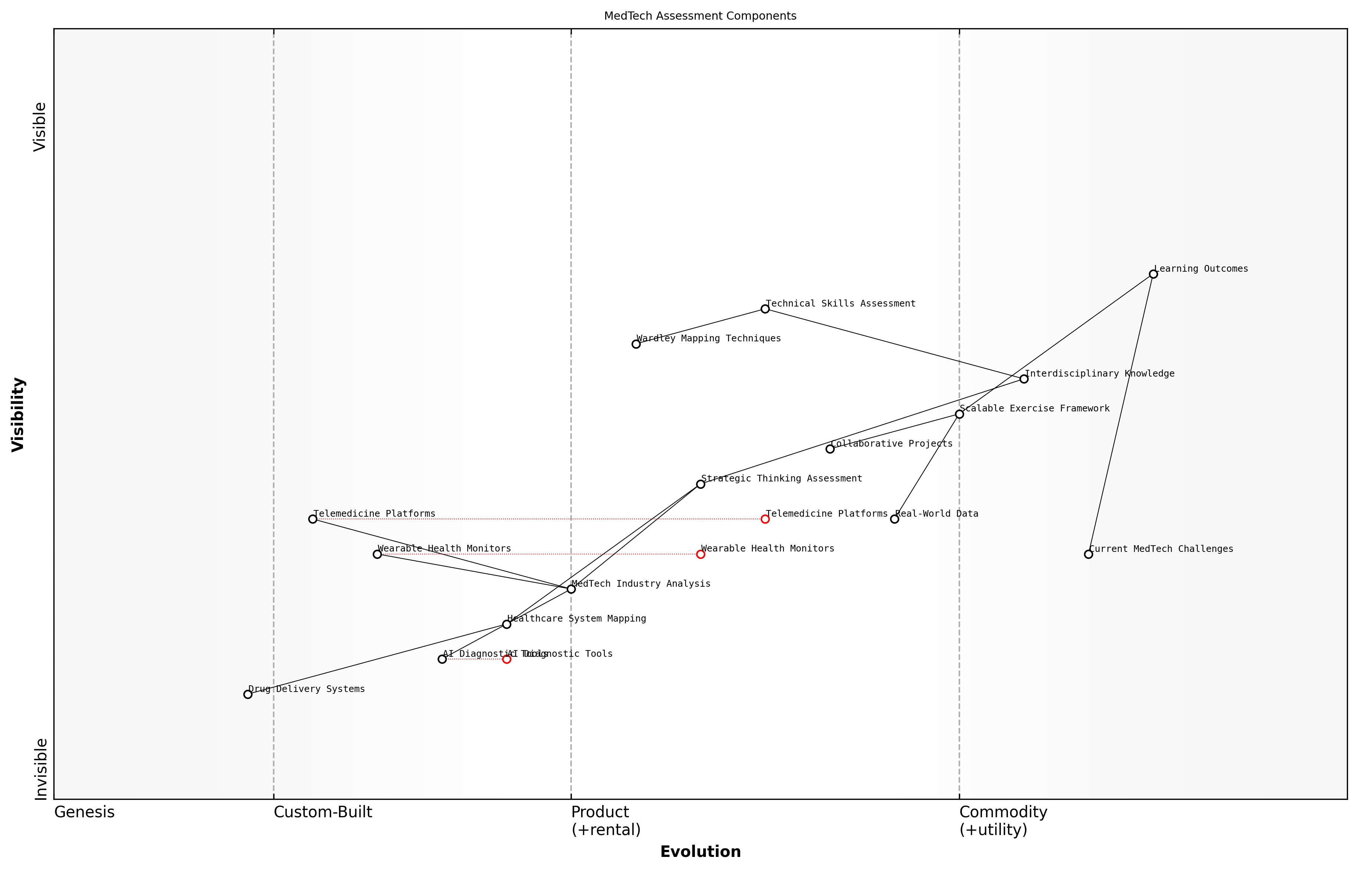

Draft Wardley Map: [Insert Wardley Map illustrating the components of a comprehensive MedTech assessment, from technical skills to strategic analysis]

[Edit this draft Wardley Map](https://create.wardleymaps.ai/#3c167edca65df3d509)

Implementing these principles in practice, a sample assessment for a Wardley Mapping-enhanced MedTech course might look like this:

* Part 1: Individual Mapping Exercise - Students create a Wardley Map for a specific MedTech innovation (e.g., a novel drug delivery system), considering its current position and potential evolution.
* Part 2: Group Strategic Analysis - In teams, students combine their individual maps to create a comprehensive view of the drug delivery landscape, identifying opportunities for innovation and potential barriers to adoption.
* Part 3: Presentation and Defence - Teams present their findings to a panel of instructors and industry experts, defending their strategic recommendations and demonstrating their understanding of both Wardley Mapping techniques and MedTech sector dynamics.

In conclusion, developing practical exercises and assessments for Wardley Mapping-enhanced MedTech courses requires a careful balance of technical rigour, real-world relevance, and strategic thinking. By incorporating these elements, educators can create learning experiences that not only teach students how to use Wardley Mapping effectively but also prepare them for the complex challenges they will face in the rapidly evolving MedTech industry.

The true measure of success in MedTech education is not just in the mastery of tools like Wardley Mapping, but in the ability to apply these tools to drive meaningful innovation and improve patient outcomes.

## Teaching Wardley Mapping to MedTech Students

### Introducing mapping concepts through real-world MedTech examples

In the rapidly evolving field of medical technology, introducing Wardley Mapping concepts through real-world MedTech examples is a crucial step in equipping students with the strategic thinking skills necessary for navigating complex healthcare ecosystems. This approach not only enhances comprehension but also demonstrates the immediate relevance and applicability of Wardley Mapping to the challenges and opportunities in the MedTech sector.

To effectively introduce mapping concepts, it is essential to structure the learning experience around tangible, relatable examples that resonate with MedTech students. This section will explore various strategies and methodologies for integrating real-world MedTech scenarios into the teaching of Wardley Mapping, ensuring that students can readily grasp and apply these powerful strategic tools in their future careers.

The key to unlocking the potential of Wardley Mapping in MedTech education lies in bridging the gap between abstract concepts and concrete, industry-specific applications. By grounding our teaching in real-world examples, we empower students to see the immediate value and transferability of these strategic thinking tools.

Let us delve into the key aspects of introducing mapping concepts through MedTech examples:

* Selecting appropriate MedTech case studies
* Mapping the evolution of medical devices
* Analysing healthcare service delivery chains
* Exploring digital health ecosystems
* Addressing regulatory and ethical considerations

Selecting Appropriate MedTech Case Studies:

When choosing case studies to introduce Wardley Mapping, it is crucial to select examples that are not only relevant to MedTech but also sufficiently complex to demonstrate the power of mapping. Consider using cases that involve multiple stakeholders, evolving technologies, and shifting market dynamics. For instance, the development and deployment of a novel wearable device for continuous glucose monitoring provides an excellent opportunity to map the entire value chain, from component suppliers to end-users, while also considering the evolution of sensor technology and data analytics capabilities.

Mapping the Evolution of Medical Devices:

One of the most effective ways to introduce the concept of evolution in Wardley Maps is through the lens of medical device development. By tracing the journey of a particular device category, such as pacemakers or insulin pumps, students can visualise how components and capabilities move from genesis to commodity over time. This exercise not only reinforces the core principles of Wardley Mapping but also encourages students to think critically about future innovations in their field.

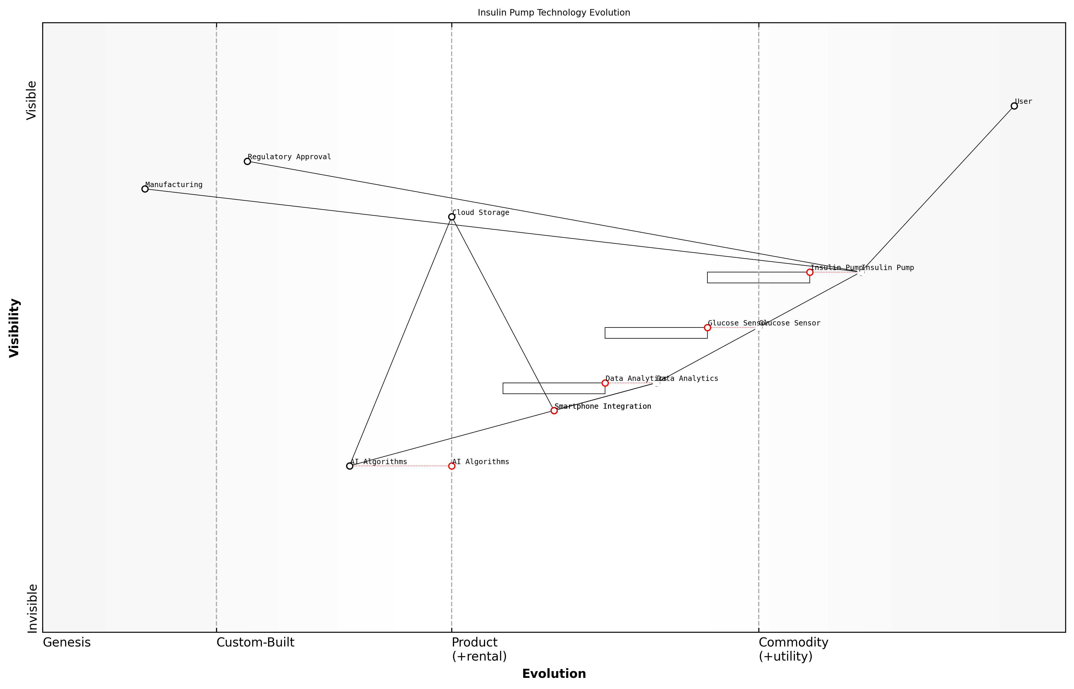

Draft Wardley Map: [Insert Wardley Map showing the evolution of insulin pump technology over time, highlighting key components and their movement along the evolution axis]

[Edit this draft Wardley Map](https://create.wardleymaps.ai/#64d3287b8c35000735)

Analysing Healthcare Service Delivery Chains:

Healthcare service delivery provides a rich context for introducing the concept of value chains in Wardley Mapping. By mapping out the components involved in delivering a specific healthcare service, such as telemedicine or robotic surgery, students can gain insights into the interdependencies between various elements of the healthcare system. This analysis can reveal opportunities for innovation, potential bottlenecks, and areas where emerging technologies might disrupt traditional service models.

Understanding the entire value chain in healthcare delivery is crucial for identifying where MedTech innovations can have the most significant impact. Wardley Mapping provides a visual framework for this analysis, enabling students to see beyond individual technologies and consider the broader ecosystem.

Exploring Digital Health Ecosystems:

The rapidly expanding field of digital health offers an ideal landscape for introducing more advanced Wardley Mapping concepts. By mapping out the ecosystem of a digital health platform, including elements such as data storage, AI algorithms, user interfaces, and regulatory compliance, students can explore concepts like inertia, co-evolution, and ecosystem effects. This exercise can be particularly valuable in helping students understand the strategic implications of platform-based business models in healthcare.

Addressing Regulatory and Ethical Considerations:

Introducing Wardley Mapping through MedTech examples provides an excellent opportunity to address the unique regulatory and ethical considerations in the healthcare sector. By incorporating elements such as data privacy regulations, clinical trial requirements, and ethical approval processes into their maps, students learn to consider these critical factors as integral components of the MedTech landscape. This approach helps to instil a holistic understanding of the challenges and responsibilities associated with innovation in healthcare.

* Integrate regulatory milestones into the mapping process
* Discuss the ethical implications of emerging technologies
* Explore the impact of data protection laws on MedTech innovation
* Consider the role of patient advocacy groups and their influence on the ecosystem

By introducing Wardley Mapping concepts through these real-world MedTech examples, educators can create a dynamic and engaging learning environment that prepares students for the complex challenges they will face in their future careers. This approach not only enhances their understanding of strategic thinking tools but also deepens their knowledge of the MedTech sector itself, fostering a new generation of innovators equipped to drive meaningful advancements in healthcare technology.

The true power of Wardley Mapping in MedTech education lies not just in teaching students how to create maps, but in cultivating a strategic mindset that can navigate the complexities of healthcare innovation. By grounding our teaching in real-world examples, we empower students to become the visionary leaders that the MedTech sector desperately needs.

### Facilitating collaborative mapping exercises

Collaborative Wardley Mapping exercises are a cornerstone of effective MedTech education, fostering critical thinking, strategic analysis, and teamwork skills essential for future healthcare innovators. As educators, our role is to create an environment that encourages active participation, knowledge sharing, and the development of a shared understanding of complex MedTech ecosystems.

To successfully facilitate collaborative mapping exercises for MedTech students, we must consider several key aspects:

* Setting the stage for collaboration
* Guiding the mapping process
* Encouraging diverse perspectives
* Leveraging technology for enhanced collaboration
* Facilitating reflection and iteration

Setting the Stage for Collaboration:

Before diving into the mapping exercise, it’s crucial to create an environment conducive to collaboration. This involves establishing clear objectives, forming diverse teams, and providing a comprehensive briefing on the MedTech scenario to be mapped. As one experienced educator noted:

The success of a collaborative Wardley Mapping exercise often hinges on the groundwork laid before the first component is placed on the canvas. Ensuring all participants have a shared understanding of the goals and context is paramount.

Consider using icebreaker activities tailored to MedTech themes to build rapport among team members and introduce key concepts in a relaxed setting. For instance, a quick round of ‘MedTech Innovation Bingo’ can help students identify common technologies, stakeholders, or challenges they might encounter during the mapping process.

Guiding the Mapping Process:

As facilitators, our role is to guide students through the mapping process without dominating the exercise. Begin by demonstrating the basic principles of Wardley Mapping using a simple MedTech example, such as mapping the components of a telemedicine service. Then, provide a structured approach for teams to follow:

* Identify the user need and value chain
* List and position components on the evolution axis
* Draw dependencies between components
* Analyse the map for insights and strategic opportunities

Throughout the exercise, circulate among teams to offer guidance, ask probing questions, and help resolve any conflicts or misunderstandings. Encourage students to think critically about the positioning of components and to consider the unique challenges of the MedTech sector, such as regulatory requirements and patient safety considerations.

Encouraging Diverse Perspectives:

One of the strengths of collaborative mapping is the diversity of perspectives it can bring to the table. In MedTech education, this is particularly valuable given the interdisciplinary nature of the field. Encourage teams to leverage the varied backgrounds of their members, whether in engineering, life sciences, clinical practice, or business.

The most insightful Wardley Maps in MedTech often emerge from teams that embrace cognitive diversity. A clinician’s understanding of patient needs combined with an engineer’s technical expertise can lead to breakthrough insights.

Consider assigning specific roles within each team to ensure diverse viewpoints are represented. For example, designate a ‘patient advocate’, a ‘technology expert’, a ‘regulatory specialist’, and a ‘business strategist’. Rotate these roles throughout the exercise to broaden each student’s perspective.

Leveraging Technology for Enhanced Collaboration:

While traditional whiteboard and sticky note approaches have their merits, leveraging digital tools can significantly enhance collaborative mapping exercises, especially in today’s increasingly hybrid learning environments. Online mapping platforms like Miro, Figma, or purpose-built Wardley Mapping tools offer several advantages:

* Real-time collaboration and synchronisation
* Easy iteration and version control
* Integration of multimedia resources and external data
* Accessibility for remote or asynchronous participation
* Simplified sharing and presentation of completed maps

When selecting a digital tool, prioritise those with intuitive interfaces and robust collaboration features. Provide a brief tutorial on the chosen platform to ensure all students can participate effectively.

Facilitating Reflection and Iteration:

The true value of collaborative Wardley Mapping exercises often emerges during reflection and iteration phases. Encourage teams to step back periodically and critically evaluate their maps. Facilitate group discussions where teams can present their work-in-progress maps to their peers, inviting constructive feedback and alternative viewpoints.

The most valuable learning often occurs when students are challenged to defend their mapping decisions or when they discover alternative ways to represent the same MedTech ecosystem.

Consider incorporating ‘what-if’ scenarios to prompt students to iterate on their maps. For example, ask them to consider how their map might change with the introduction of a new technology, a shift in regulatory policy, or a global health crisis. This approach not only reinforces the dynamic nature of Wardley Mapping but also prepares students for the rapid pace of change in the MedTech sector.

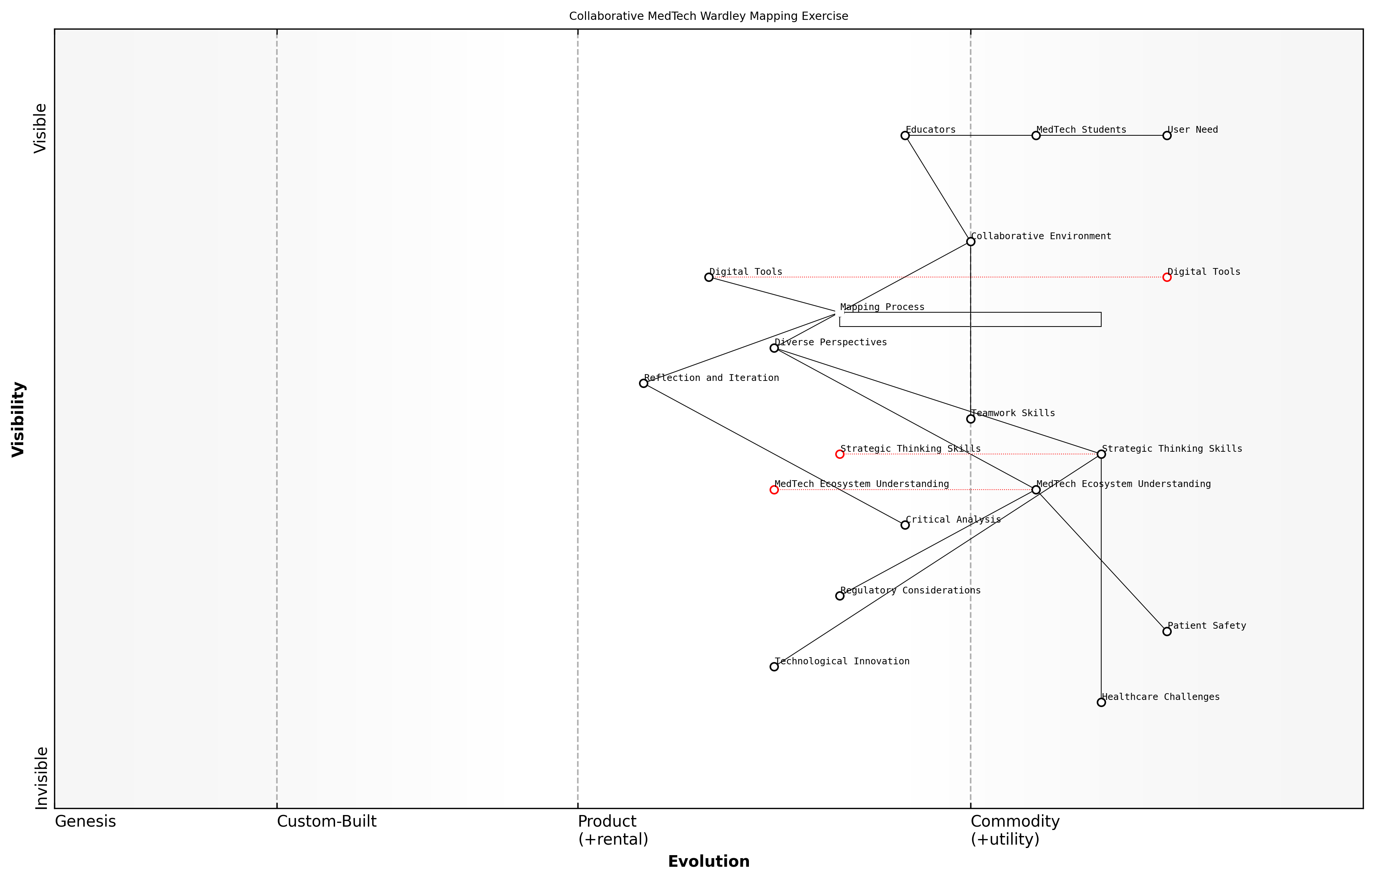

Draft Wardley Map: [Insert Wardley Map example of a collaborative MedTech mapping exercise, showing iterations and annotations]

[Edit this draft Wardley Map](https://create.wardleymaps.ai/#f8bc774a196736d0a4)

In conclusion, facilitating collaborative Wardley Mapping exercises for MedTech students requires a delicate balance of structure and flexibility, guidance and autonomy. By creating an environment that encourages active participation, leverages diverse perspectives, and embraces iteration, we can equip the next generation of MedTech innovators with the strategic thinking skills needed to navigate the complex and evolving healthcare technology landscape.

### Encouraging critical thinking about technology evolution in healthcare

In the rapidly evolving landscape of medical technology, fostering critical thinking skills among MedTech students is paramount. By integrating Wardley Mapping into the curriculum, educators can provide a powerful framework for students to analyse and anticipate technological shifts in healthcare. This section explores strategies for encouraging critical thinking about technology evolution in healthcare through the lens of Wardley Mapping.

Wardley Mapping offers a unique perspective on the evolution of technologies and practices in healthcare. By visualising the value chain and the movement of components from genesis to commodity, students can develop a deeper understanding of how medical technologies progress and impact the healthcare ecosystem. This approach not only enhances their analytical skills but also prepares them for the dynamic nature of the MedTech industry.

Wardley Mapping is not just a tool; it’s a way of thinking that challenges students to consider the broader implications of technological advancements in healthcare. It encourages them to think strategically about where the industry is heading and how they can contribute to its evolution.

To effectively encourage critical thinking using Wardley Mapping, educators should consider the following approaches:

* Scenario-based learning: Present students with complex healthcare scenarios and challenge them to map out potential technological solutions and their evolution over time.
* Comparative analysis: Encourage students to create Wardley Maps for different healthcare systems or medical specialties, fostering a deeper understanding of how context influences technology adoption and evolution.
* Future forecasting exercises: Task students with predicting future states of medical technologies and practices, using Wardley Maps to justify their projections.
* Ethical considerations mapping: Integrate ethical dimensions into Wardley Maps, prompting students to consider the societal implications of evolving medical technologies.
* Interdisciplinary collaboration: Facilitate mapping exercises that bring together students from various healthcare disciplines, encouraging a holistic view of technology evolution in medicine.

One effective method for developing critical thinking skills is to engage students in ‘technology evolution debates’. In these exercises, students are divided into groups and assigned different medical technologies at various stages of evolution. They must then use Wardley Mapping to argue for or against investment in these technologies, considering factors such as potential impact, rate of evolution, and dependencies within the healthcare value chain.

Another powerful approach is the ‘reverse engineering of innovation’ exercise. Students are presented with a current medical breakthrough and tasked with creating a retrospective Wardley Map that traces the evolution of the underlying technologies and practices that made the innovation possible. This exercise hones their ability to identify patterns in technological progress and appreciate the interconnected nature of advancements in healthcare.

By challenging students to map out the journey of medical innovations, we’re not just teaching them about the past; we’re equipping them with the skills to shape the future of healthcare technology.

To further enhance critical thinking, educators should incorporate real-world case studies that demonstrate both successful and failed technological implementations in healthcare. By analysing these cases through the lens of Wardley Mapping, students can gain insights into the complex factors that influence technology adoption and evolution in clinical settings.

It’s also crucial to encourage students to consider the broader ecosystem in which medical technologies operate. This includes mapping out regulatory frameworks, reimbursement models, and patient acceptance factors. By doing so, students develop a more nuanced understanding of the challenges and opportunities in bringing new medical technologies to market.

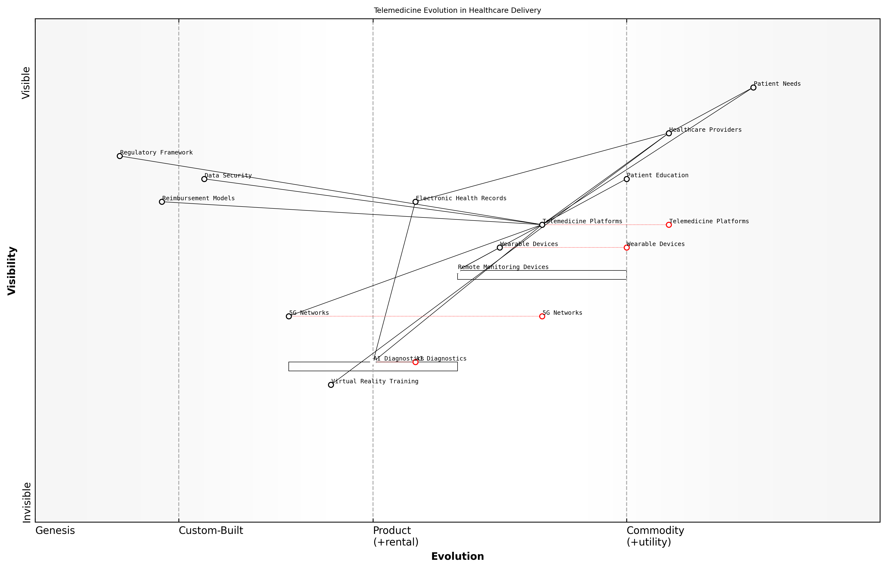

Draft Wardley Map: [Insert Wardley Map illustrating the evolution of telemedicine technologies and their impact on healthcare delivery models]

[Edit this draft Wardley Map](https://create.wardleymaps.ai/#3037cc61d404149194)

The above Wardley Map could be used as a starting point for discussions on how emerging technologies like artificial intelligence, 5G networks, and wearable devices are reshaping the landscape of remote healthcare delivery. Students can be challenged to extend or modify the map based on their own research and insights, fostering a deeper engagement with the material.

To reinforce the practical application of these critical thinking skills, educators should consider incorporating industry partnerships into the curriculum. Collaborations with MedTech companies or healthcare providers can offer students the opportunity to work on real-world mapping projects, applying their analytical skills to current challenges in the field.

The true test of critical thinking in MedTech is not just understanding where we are now, but being able to anticipate where we’re going and how to navigate the journey. Wardley Mapping provides students with a compass for this complex landscape.

As students become more proficient in using Wardley Mapping for critical analysis, they should be encouraged to question the assumptions underlying their maps. This meta-cognitive approach helps develop a more nuanced understanding of the limitations and strengths of strategic planning tools in the context of healthcare technology evolution.

In conclusion, by integrating Wardley Mapping into MedTech education as a tool for critical thinking, educators can prepare students to navigate the complex and rapidly changing landscape of healthcare technology. This approach not only enhances their analytical skills but also fosters a strategic mindset that will be invaluable in their future careers as innovators and leaders in the field of medical technology.

## Case Studies: Successful Wardley Mapping Integration in MedTech Education

### Undergraduate biomedical engineering programme transformation

The integration of Wardley Mapping into undergraduate biomedical engineering programmes represents a significant leap forward in preparing future MedTech professionals for the complex, rapidly evolving healthcare landscape. This case study examines the successful transformation of a leading UK university’s biomedical engineering curriculum, demonstrating the power of strategic thinking and visual mapping in enhancing student learning outcomes and industry readiness.

Background and Challenges

Prior to the integration of Wardley Mapping, the biomedical engineering programme at the university faced several challenges common to many institutions:

* A disconnect between theoretical knowledge and practical industry applications
* Difficulty in helping students understand the complex ecosystem of healthcare technology
* Limited exposure to strategic thinking and decision-making processes in MedTech
* Graduates lacking the holistic understanding required to navigate the rapidly changing MedTech landscape

Implementation of Wardley Mapping

The transformation began with a comprehensive review of the existing curriculum, followed by a strategic integration of Wardley Mapping across multiple modules. Key steps in the implementation process included:

* Introduction of a foundational module on Wardley Mapping in the second year
* Integration of mapping exercises into existing technical modules
* Development of a capstone project requiring students to create and analyse Wardley Maps for real-world MedTech scenarios
* Training of faculty members in Wardley Mapping techniques and applications
* Collaboration with industry partners to provide real-world mapping challenges and mentorship

Outcomes and Impact

The integration of Wardley Mapping into the biomedical engineering programme yielded significant positive outcomes:

* Enhanced student understanding of the MedTech ecosystem and technology evolution
* Improved ability to identify emerging opportunities and potential disruptions in healthcare technology
* Increased student engagement and critical thinking in technical modules
* Stronger industry partnerships and more relevant work placement opportunities
* Positive feedback from employers on graduates’ strategic thinking capabilities

The introduction of Wardley Mapping has transformed our students’ ability to think strategically about MedTech innovation. They now graduate with a toolkit that allows them to navigate the complexities of the healthcare technology landscape with confidence.

Key Success Factors

Several factors contributed to the successful integration of Wardley Mapping into the curriculum:

* Strong support from university leadership and industry advisory board
* Phased implementation approach, allowing for iterative improvements
* Continuous professional development for faculty members
* Regular feedback loops with students, industry partners, and alumni
* Integration of mapping across multiple modules, reinforcing its importance and applicability

Challenges and Lessons Learned

The transformation process was not without its challenges. Some key lessons learned include:

* The importance of providing ample practice opportunities for students to develop mapping skills
* The need for clear assessment criteria that value both technical accuracy and strategic insight
* The benefit of involving industry experts in the design and delivery of mapping exercises
* The value of creating a community of practice among faculty members to share best practices and challenges

Future Directions

Building on the success of this transformation, the university is now exploring:

* Integration of advanced mapping techniques, such as ecosystem mapping, in final year modules
* Development of interdisciplinary projects combining Wardley Mapping with other strategic tools
* Creation of a MedTech innovation hub where students can apply mapping skills to real-world challenges
* Expansion of the Wardley Mapping approach to other engineering and healthcare-related programmes

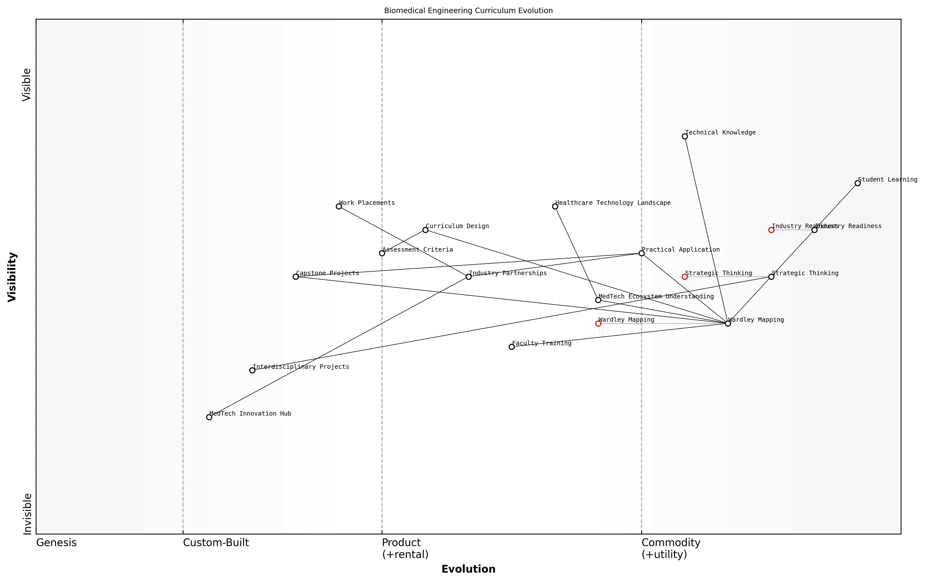

Draft Wardley Map: [Insert Wardley Map illustrating the evolution of the biomedical engineering curriculum]

[Edit this draft Wardley Map](https://create.wardleymaps.ai/#76b658f77531e84946)

Conclusion

The successful integration of Wardley Mapping into the undergraduate biomedical engineering programme demonstrates the transformative potential of this strategic thinking tool in MedTech education. By equipping students with the ability to visualise and analyse complex healthcare technology landscapes, universities can significantly enhance the industry readiness of their graduates and contribute to more strategic innovation in the MedTech sector.

Wardley Mapping has become an essential component of our biomedical engineering education. It bridges the gap between technical knowledge and strategic thinking, preparing our students to be the innovative leaders the MedTech industry needs.

### Postgraduate healthcare innovation curriculum redesign

The integration of Wardley Mapping into postgraduate healthcare innovation curricula represents a significant advancement in preparing future MedTech leaders for the complex challenges of the healthcare industry. This case study examines the successful redesign of a postgraduate programme in healthcare innovation, demonstrating the transformative impact of Wardley Mapping on strategic thinking and decision-making in MedTech education.

The programme in question, offered by a leading UK university, faced challenges in equipping students with the strategic foresight necessary to navigate the rapidly evolving MedTech landscape. Recognising the need for a more robust approach to strategic analysis and planning, the programme directors embarked on a comprehensive curriculum redesign, placing Wardley Mapping at its core.

The redesign process encompassed several key areas:

* Integration of Wardley Mapping principles across core modules
* Development of practical workshops and case studies
* Collaboration with industry partners to ensure real-world relevance
* Implementation of a capstone project utilising Wardley Mapping
* Training of faculty members in Wardley Mapping techniques

One of the most significant changes was the introduction of a new core module titled ‘Strategic Foresight in MedTech Innovation’. This module provided students with a comprehensive understanding of Wardley Mapping principles and their application to healthcare technology scenarios. Students were taught to create and interpret Wardley Maps, analysing the evolution of technologies, practices, and market dynamics within the MedTech sector.

The introduction of Wardley Mapping has revolutionised our approach to teaching strategic thinking in healthcare innovation. Our students now possess a powerful tool for visualising complex systems and anticipating future trends in ways that were previously unattainable.

To ensure practical application of these skills, the programme partnered with several leading MedTech companies and healthcare providers. These partnerships facilitated real-world case studies and projects, allowing students to apply Wardley Mapping to current industry challenges. For instance, one group of students worked with a prominent NHS trust to map out the implementation of a new telemedicine system, identifying potential bottlenecks and opportunities for innovation.

The capstone project was redesigned to require students to develop a comprehensive Wardley Map for a novel MedTech solution or service. This project challenged students to consider all aspects of bringing an innovation to market, from technology development and regulatory compliance to user adoption and competitive positioning. The use of Wardley Mapping in this context provided a structured framework for students to demonstrate their strategic thinking and innovation management skills.

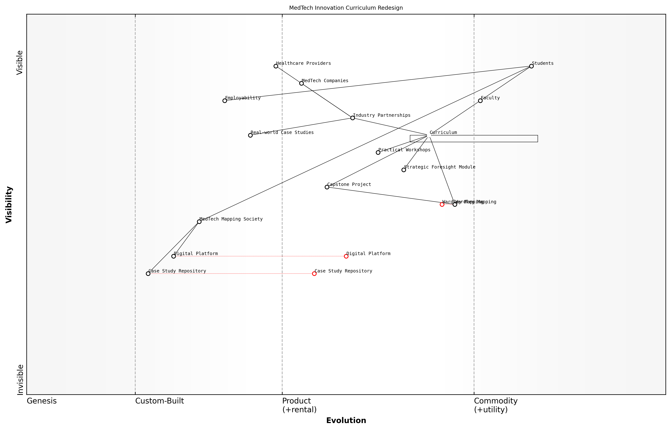

Draft Wardley Map: [Insert Wardley Map example of a student capstone project here]

[Edit this draft Wardley Map](https://create.wardleymaps.ai/#26b46d1e065e09e5ba)

To support this curriculum transformation, the university invested in faculty development, providing intensive training in Wardley Mapping techniques. This ensured that instructors were well-equipped to guide students through the complexities of strategic mapping in healthcare contexts. Additionally, guest lectures from industry experts who actively use Wardley Mapping in their organisations provided valuable insights into its real-world applications.

The outcomes of this curriculum redesign have been overwhelmingly positive:

* Increased student engagement and satisfaction, with course evaluations showing a 30% improvement in ratings for strategic thinking components
* Enhanced employability, with 85% of graduates securing positions in strategic roles within MedTech companies or healthcare organisations within six months of graduation
* Strengthened industry partnerships, leading to more collaborative research projects and internship opportunities
* Recognition from accrediting bodies for innovative curriculum design, setting a new standard for postgraduate MedTech education

One particularly notable outcome was the creation of a student-led ‘MedTech Mapping Society’, which has become a hub for ongoing learning and networking. This society organises regular workshops, invites guest speakers, and collaborates on mapping projects with local healthcare providers, extending the impact of Wardley Mapping beyond the formal curriculum.

The ability to create and interpret Wardley Maps has become a distinguishing skill for our graduates. Employers consistently feedback that our alumni demonstrate a level of strategic insight that sets them apart in the competitive MedTech job market.

The success of this curriculum redesign has not gone unnoticed in the wider academic community. Several other universities have expressed interest in adopting similar approaches, and the programme has been featured as a case study in international conferences on healthcare education innovation.

Looking to the future, the programme directors are exploring ways to further enhance the integration of Wardley Mapping. Plans include the development of a digital platform for collaborative mapping exercises, the creation of a Wardley Mapping repository of MedTech case studies, and the expansion of industry partnerships to include more diverse healthcare settings, including emerging markets.

This case study demonstrates the transformative potential of integrating Wardley Mapping into postgraduate healthcare innovation curricula. By providing students with a powerful tool for strategic analysis and decision-making, universities can better prepare the next generation of MedTech leaders to navigate the complex and rapidly evolving healthcare landscape. The success of this programme serves as a blueprint for other institutions seeking to enhance their MedTech education offerings and bridge the gap between academic theory and industry practice.

### Continuing professional development for healthcare technologists

In the rapidly evolving field of medical technology, continuing professional development (CPD) for healthcare technologists is crucial for maintaining cutting-edge skills and knowledge. The integration of Wardley Mapping into CPD programmes offers a strategic approach to understanding and navigating the complex MedTech landscape. This case study examines how a leading medical research institution successfully incorporated Wardley Mapping into its CPD curriculum for healthcare technologists, resulting in enhanced strategic thinking and improved adaptability to technological changes.

The institution in question, a renowned centre for medical innovation, recognised the need to equip its healthcare technologists with tools for strategic analysis and decision-making. Wardley Mapping was identified as an ideal framework to address this need, given its ability to visualise the evolution of technologies and practices in healthcare.

The CPD programme was structured around three key phases:

* Introduction to Wardley Mapping principles and their relevance to MedTech
* Practical application of Wardley Mapping to current MedTech challenges
* Strategic planning and decision-making using Wardley Maps

In the first phase, participants were introduced to the core concepts of Wardley Mapping through a series of interactive workshops. These sessions focused on mapping the MedTech value chain, understanding the evolution of technologies, and identifying key dependencies in healthcare systems.

The introduction of Wardley Mapping to our CPD programme was transformative. It provided our technologists with a new lens through which to view the complexities of the MedTech landscape.

The second phase involved hands-on application of Wardley Mapping to real-world MedTech scenarios. Participants worked in small groups to map out current challenges in their respective areas of expertise, such as medical imaging, wearable technologies, and telemedicine. This practical approach allowed them to immediately apply their newly acquired mapping skills to relevant problems.

One particularly successful exercise involved mapping the evolution of remote patient monitoring technologies. Participants were able to visualise the shift from traditional in-hospital monitoring to advanced wearable devices and cloud-based data analytics. This exercise highlighted the importance of understanding the entire value chain and anticipating future developments in the field.

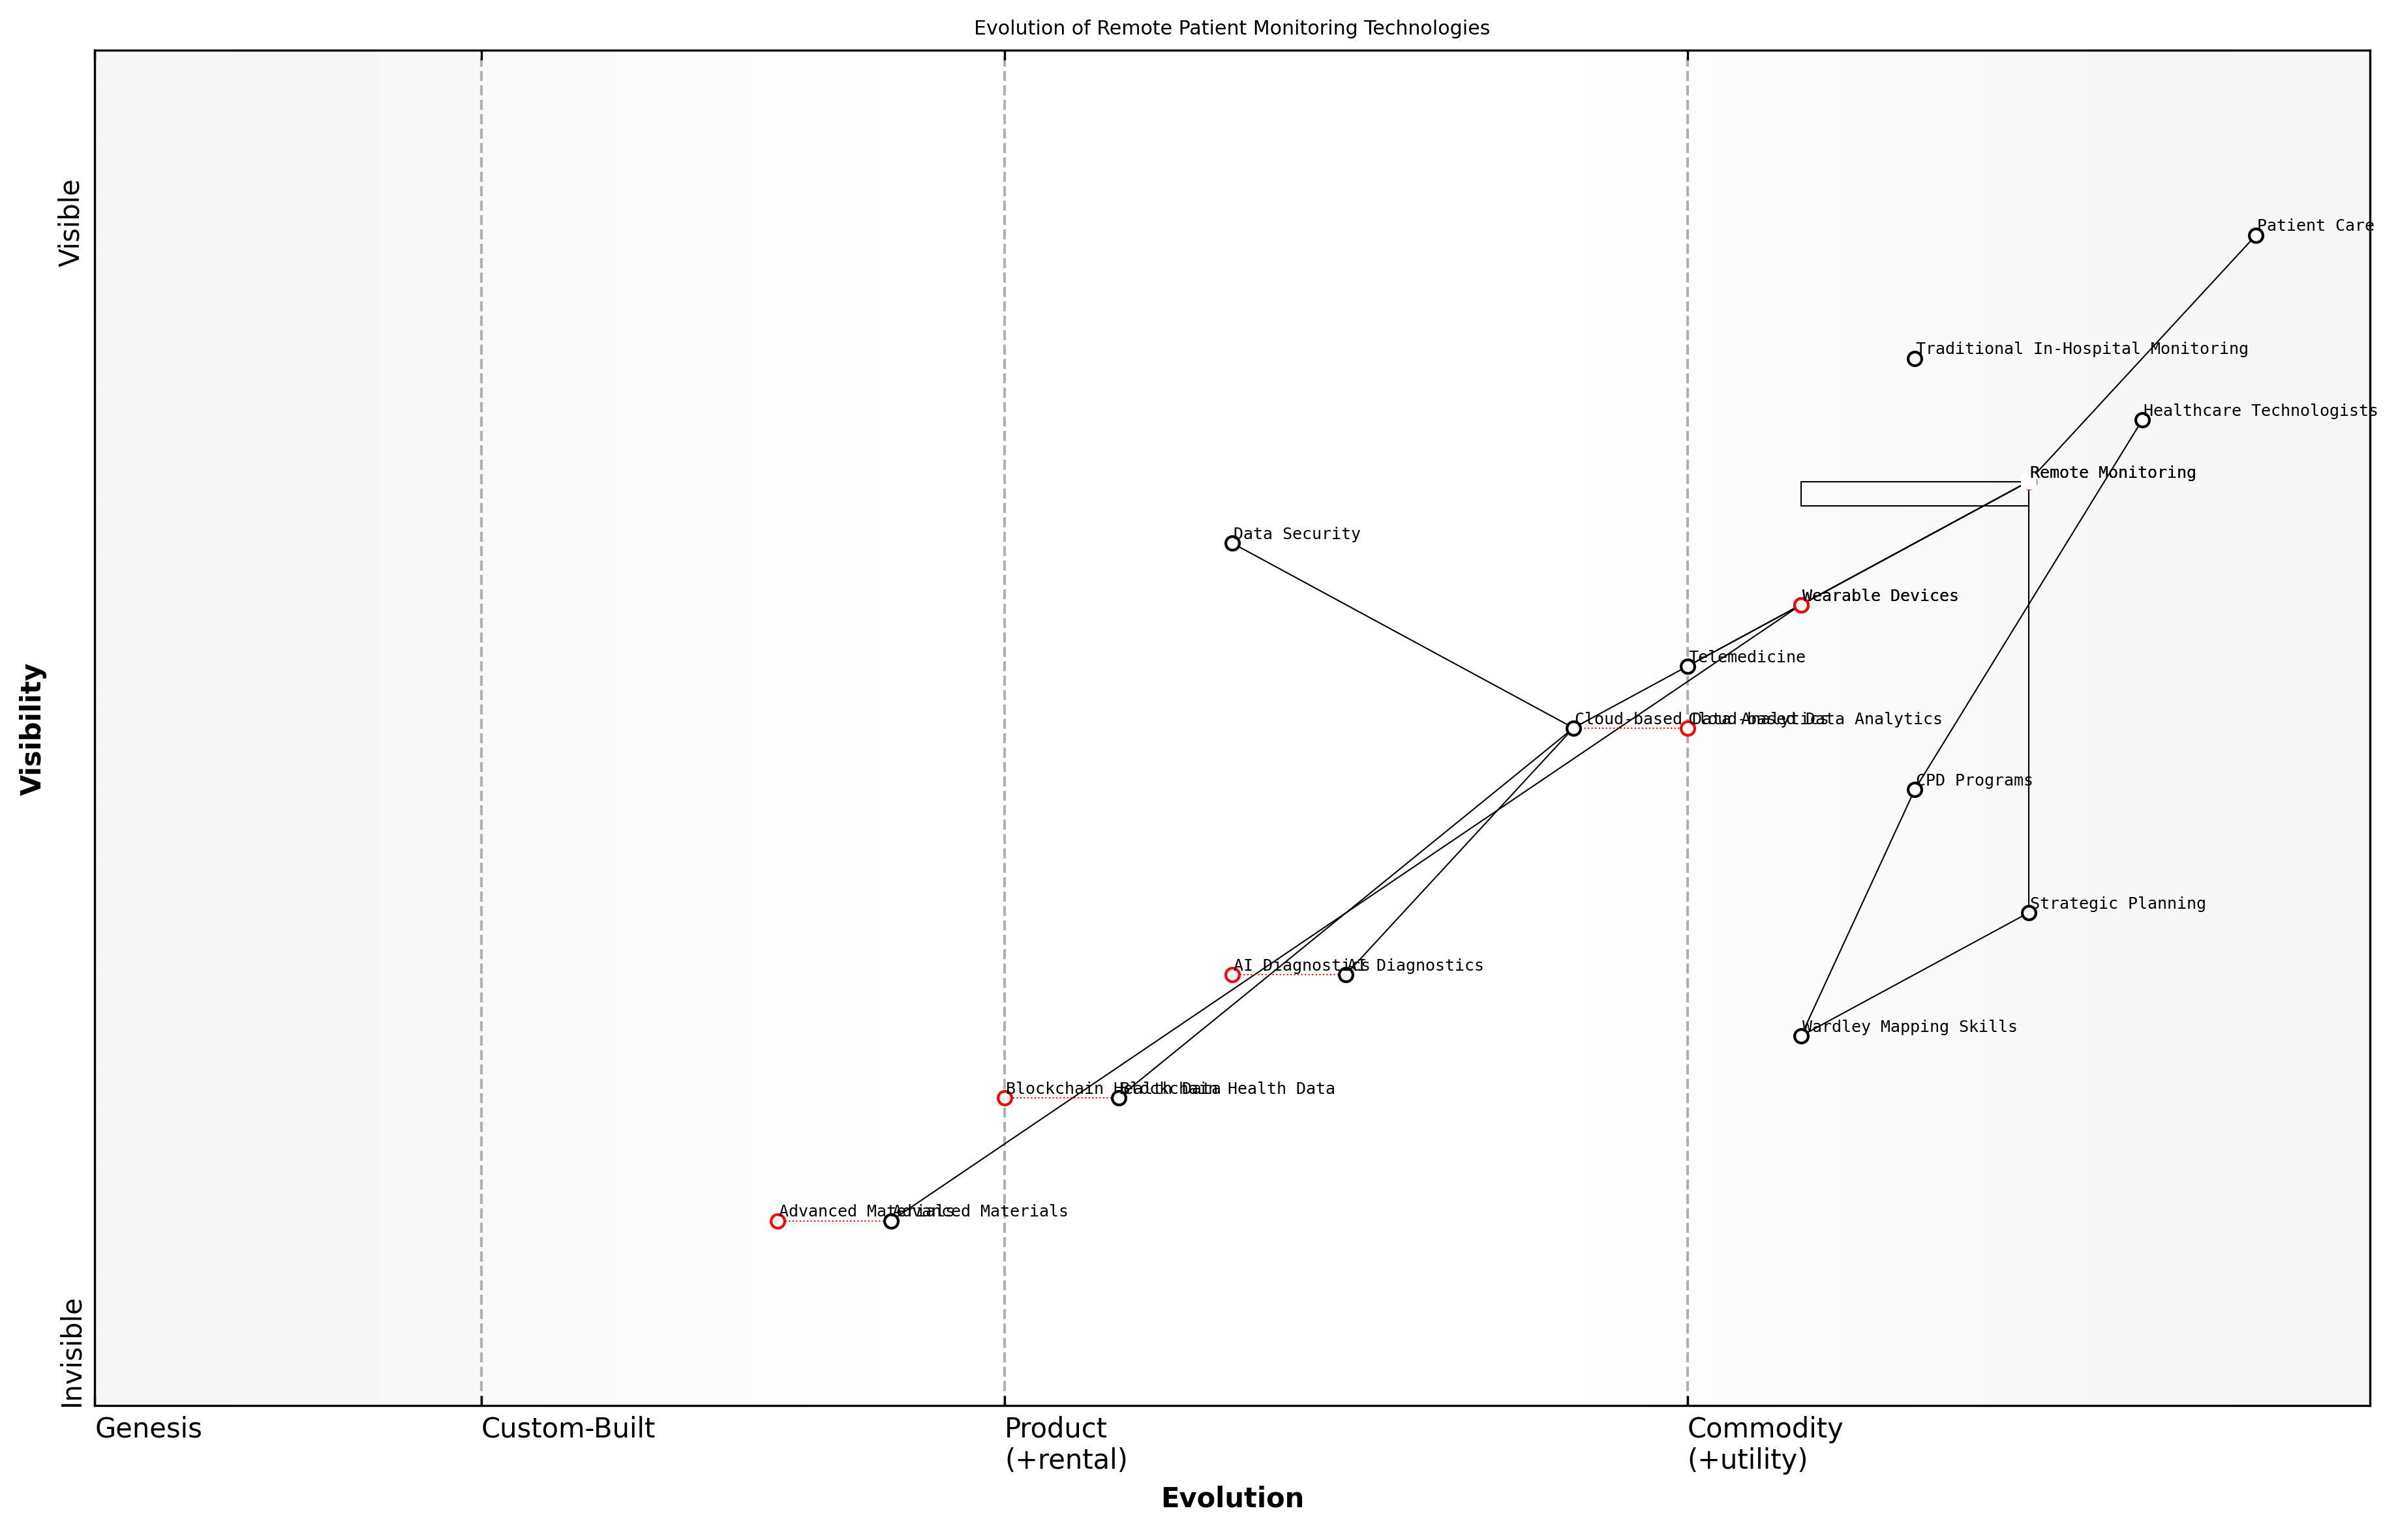

Draft Wardley Map: [Insert Wardley Map: Evolution of Remote Patient Monitoring Technologies]

[Edit this draft Wardley Map](https://create.wardleymaps.ai/#2cfa8187f77d700d81)

The final phase of the programme focused on using Wardley Maps for strategic planning and decision-making. Participants learned how to leverage their maps to identify opportunities for innovation, assess potential risks, and make informed decisions about technology adoption and resource allocation.

A key outcome of this phase was the development of a strategic roadmap for the institution’s MedTech initiatives. Using Wardley Mapping, the team identified several high-potential areas for investment and collaboration, including:

* AI-powered diagnostic tools for early disease detection
* Blockchain-based systems for secure health data exchange
* Advanced materials for next-generation implantable devices

The integration of Wardley Mapping into the CPD programme yielded significant benefits for both the participants and the institution. Healthcare technologists reported a marked improvement in their ability to think strategically about technological advancements and their implications for patient care. They also noted enhanced communication with colleagues from different specialties, as Wardley Maps provided a common language for discussing complex systems and processes.

Wardley Mapping has revolutionised how we approach technological challenges in our institution. It’s not just a tool; it’s a new way of thinking that has permeated all aspects of our work.

For the institution, the adoption of Wardley Mapping in CPD led to more informed decision-making at all levels. Senior management reported improved alignment between technological investments and long-term strategic goals. The ability to visualise the entire MedTech landscape allowed for more effective resource allocation and prioritisation of research and development efforts.

Moreover, the institution observed an increase in successful collaborations with industry partners. The shared understanding of the MedTech ecosystem, facilitated by Wardley Mapping, enabled more productive discussions and clearer articulation of project goals and expectations.

The success of this case study highlights the potential of Wardley Mapping as a powerful tool for continuing professional development in the MedTech sector. By providing healthcare technologists with a framework for strategic thinking and analysis, institutions can foster innovation, improve decision-making, and ultimately enhance patient care.

Key lessons from this case study include:

* The importance of practical, hands-on application of Wardley Mapping to real-world MedTech challenges
* The value of using Wardley Maps as a communication tool across different specialties and departments
* The need for ongoing support and resources to embed Wardley Mapping into everyday practice
* The potential for Wardley Mapping to drive strategic planning and inform investment decisions in MedTech

As the MedTech landscape continues to evolve at a rapid pace, the integration of strategic thinking tools like Wardley Mapping into CPD programmes will become increasingly important. This case study demonstrates that with the right approach, Wardley Mapping can be successfully incorporated into professional development initiatives, leading to tangible benefits for healthcare technologists and the institutions they serve.

# Leveraging Wardley Mapping for Strategic MedTech Research

## Mapping the MedTech Research Landscape

### Identifying emerging technologies and research opportunities

In the rapidly evolving landscape of medical technology, the ability to identify emerging technologies and research opportunities is crucial for higher education institutions to maintain relevance and drive innovation. Wardley Mapping provides a powerful framework for visualising the MedTech ecosystem and uncovering potential areas for groundbreaking research and development. This section explores how educators and researchers can leverage Wardley Mapping to navigate the complex MedTech research landscape and pinpoint promising avenues for investigation.

To effectively identify emerging technologies and research opportunities in MedTech using Wardley Mapping, we must first understand the key components of the MedTech ecosystem and their evolutionary stages. This involves mapping out the entire value chain, from basic scientific research to patient-facing applications, and analysing how different components are evolving over time.

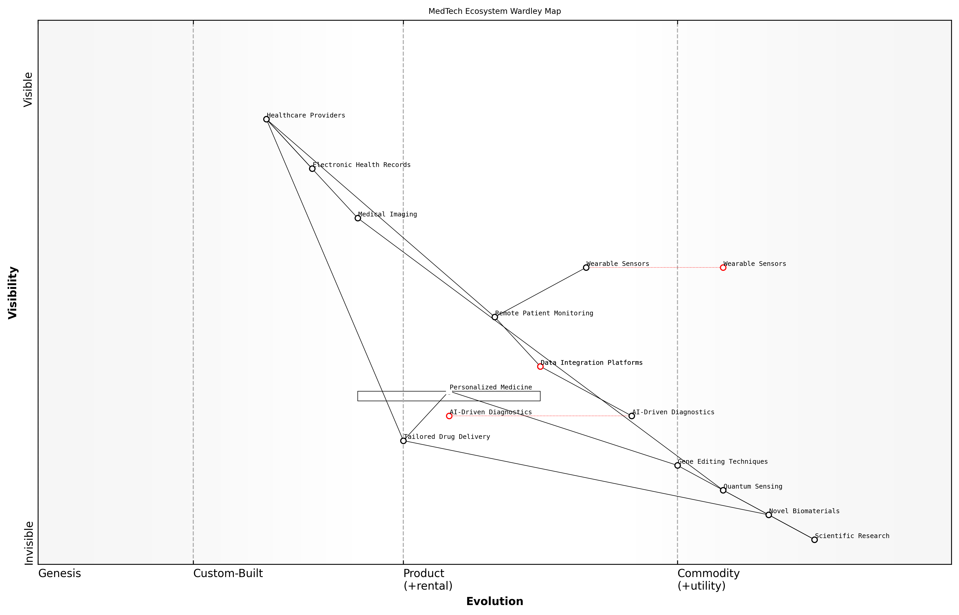

Draft Wardley Map: [Insert Wardley Map of MedTech Ecosystem]

[Edit this draft Wardley Map](https://create.wardleymaps.ai/#b2b52b79698733482e)

The Wardley Map above illustrates the various components of the MedTech ecosystem, ranging from fundamental research to end-user applications. By examining this map, we can identify several key areas for emerging technologies and research opportunities:

* Genesis stage technologies: These are nascent technologies at the forefront of innovation, often found in research laboratories. Examples include novel biomaterials, quantum sensing for medical imaging, and gene editing techniques.
* Custom-built solutions transitioning to products: Identifying technologies moving from bespoke solutions to more standardised products can reveal opportunities for applied research and commercialisation.
* Commodity components with potential for disruption: Even well-established technologies can be ripe for innovation, particularly through the application of new materials or manufacturing processes.
* Emerging platforms and standards: As new platforms emerge, there are often significant research opportunities in developing compatible technologies or improving interoperability.

One of the key advantages of using Wardley Mapping for identifying research opportunities is its ability to highlight potential ‘climatic patterns’ – predictable evolutionary trends that can guide strategic decision-making. For instance, the map might reveal an impending shift towards personalised medicine, indicating a need for research into tailored drug delivery systems or AI-driven diagnostic tools.

Wardley Mapping allows us to see beyond the horizon of current technologies and anticipate the next wave of innovation in MedTech. It’s not just about identifying individual technologies, but understanding how they fit into the broader ecosystem and where the greatest impact can be made.

To effectively use Wardley Mapping for identifying emerging technologies and research opportunities, consider the following strategies:

* Conduct regular mapping exercises: The MedTech landscape is constantly evolving, so it’s crucial to update your maps frequently to capture new developments and shifts in the ecosystem.
* Engage with diverse stakeholders: Collaborate with clinicians, patients, industry partners, and policymakers to gain a holistic view of the MedTech landscape and identify unmet needs.
* Analyse adjacent industries: Look for technologies in related fields that could be adapted for MedTech applications, such as advances in materials science or artificial intelligence.
* Monitor regulatory trends: Anticipate how changes in healthcare regulations might create new research opportunities or necessitate technological innovations.
* Leverage data analytics: Use big data and predictive analytics to identify emerging trends and potential research areas based on publication patterns, patent filings, and funding allocations.

Case Study: Identifying Opportunities in Remote Patient Monitoring

A research team at a leading UK university used Wardley Mapping to analyse the remote patient monitoring landscape. By mapping out the ecosystem, they identified a gap between existing wearable sensors and the need for more sophisticated data integration platforms. This led to a successful research proposal for developing an AI-powered system that could aggregate data from multiple sensors and provide actionable insights for healthcare providers.

The team’s Wardley Map revealed that while sensor technology was rapidly commoditising, data integration and interpretation remained in the custom-built phase. This insight allowed them to focus their research efforts on the areas with the highest potential impact and secure substantial funding from both government and industry partners.

Wardley Mapping gave us a strategic advantage in identifying where to focus our research efforts. It allowed us to articulate a compelling vision for our project that resonated with both academic reviewers and industry partners.

In conclusion, Wardley Mapping offers a powerful approach for identifying emerging technologies and research opportunities in the MedTech landscape. By providing a visual representation of the ecosystem’s evolution, it enables researchers and educators to make informed decisions about where to focus their efforts for maximum impact. As the pace of innovation in MedTech continues to accelerate, the ability to strategically identify and pursue promising research directions will be crucial for institutions seeking to lead in this dynamic field.

### Analysing competitive positioning of research institutions

In the rapidly evolving landscape of MedTech research, understanding and strategically positioning research institutions is crucial for maintaining relevance, securing funding, and driving innovation. Wardley Mapping provides a powerful tool for analysing the competitive positioning of research institutions within the MedTech ecosystem, offering insights that can inform strategic decision-making and resource allocation.

To effectively analyse the competitive positioning of research institutions using Wardley Mapping, we must consider several key aspects:

* Identifying core competencies and research strengths
* Mapping the current research portfolio against industry needs
* Assessing the institution’s position in the value chain
* Evaluating partnerships and collaborations
* Analysing the evolution of research areas and technologies

Let’s explore each of these aspects in detail, demonstrating how Wardley Mapping can provide valuable insights for research institutions in the MedTech sector.

1. Identifying Core Competencies and Research Strengths

The first step in analysing competitive positioning is to identify the core competencies and research strengths of the institution. This involves mapping out the key areas of expertise, unique facilities, and notable research outputs. By placing these elements on a Wardley Map, institutions can visualise how their strengths align with the overall MedTech landscape and identify areas where they have a competitive advantage.

As a senior research director at a leading MedTech institution notes, ‘Understanding our unique strengths through Wardley Mapping has allowed us to focus our resources on areas where we can truly excel and make a significant impact in the field.’

1. Mapping the Current Research Portfolio Against Industry Needs

By mapping the institution’s current research portfolio against the evolving needs of the MedTech industry, research leaders can identify gaps and opportunities. This process involves placing research projects and focus areas on the map alongside industry requirements, allowing for a visual representation of alignment or misalignment.

This analysis can reveal areas where the institution is well-positioned to meet industry needs, as well as highlight potential areas for expansion or redirection of research efforts. It can also inform decisions about resource allocation and strategic partnerships.

1. Assessing the Institution’s Position in the Value Chain

Wardley Mapping allows research institutions to visualise their position within the broader MedTech value chain. By mapping out the various stages of technology development, from basic research to commercialisation, institutions can identify where they currently operate and where they might want to expand their influence.

This analysis can reveal opportunities for vertical integration or specialisation, helping institutions to make strategic decisions about their role in the MedTech ecosystem. For example, an institution might identify an opportunity to bridge the gap between basic research and clinical trials, positioning itself as a key player in translational research.

1. Evaluating Partnerships and Collaborations

Competitive positioning in MedTech research often depends on strategic partnerships and collaborations. Wardley Mapping can be used to visualise existing partnerships and identify potential new collaborations that could strengthen the institution’s position.

By mapping out partners, competitors, and potential collaborators, institutions can identify synergies and opportunities for strategic alliances. This analysis can inform decisions about joint research initiatives, shared facilities, or technology transfer agreements.

A prominent MedTech industry consultant observes, ‘Institutions that effectively leverage Wardley Mapping to guide their partnership strategies often find themselves at the forefront of breakthrough innovations, as they’re able to combine complementary strengths in novel ways.’

1. Analysing the Evolution of Research Areas and Technologies

One of the key strengths of Wardley Mapping is its ability to represent the evolution of technologies and practices over time. For research institutions, this aspect of mapping is crucial for maintaining a competitive edge in the fast-paced MedTech sector.

By mapping out current research areas and technologies along the evolution axis, institutions can anticipate future trends and position themselves accordingly. This foresight allows for proactive investment in emerging areas and timely pivots away from declining fields.

For example, a Wardley Map might reveal that a particular area of MedTech research is moving from the ‘custom-built’ to the ‘product’ phase. This insight could prompt an institution to shift its focus from basic research to more applied or translational work in that area, ensuring continued relevance and competitiveness.

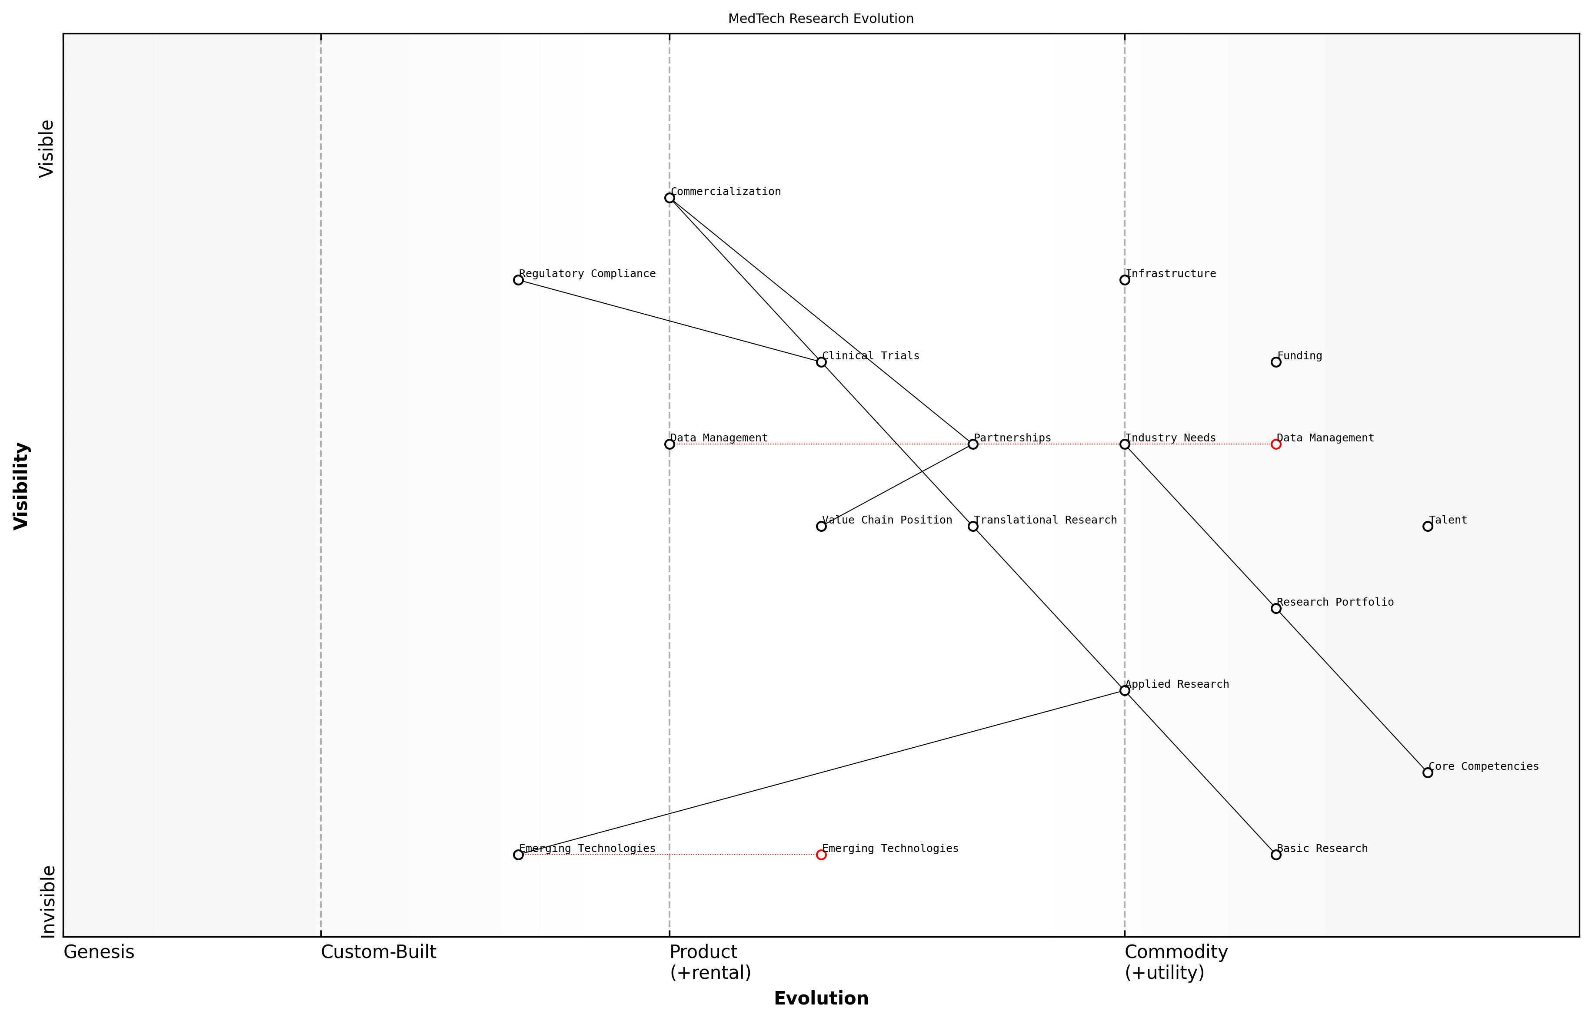

Draft Wardley Map: [Insert Wardley Map illustrating the evolution of key MedTech research areas]

[Edit this draft Wardley Map](https://create.wardleymaps.ai/#e7358387ae87c6683c)

Practical Application and Considerations

When applying Wardley Mapping to analyse the competitive positioning of research institutions in MedTech, several practical considerations should be kept in mind:

* Regular updating: The MedTech landscape is dynamic, requiring frequent reassessment and updating of maps to maintain their relevance and utility.
* Collaborative mapping: Involve diverse stakeholders from across the institution and external partners to ensure a comprehensive and nuanced analysis.
* Data-driven approach: Supplement Wardley Mapping with quantitative data on research outputs, funding trends, and industry metrics to enhance the accuracy of positioning assessments.
* Scenario planning: Use Wardley Maps to explore multiple future scenarios, allowing for more robust strategic planning and risk management.
* Ethical considerations: Ensure that competitive positioning strategies align with the institution’s ethical standards and commitment to advancing healthcare outcomes.

By leveraging Wardley Mapping in this comprehensive manner, research institutions can gain a clearer understanding of their competitive position within the MedTech landscape. This strategic insight enables more informed decision-making, from setting research priorities and allocating resources to forming partnerships and pursuing funding opportunities.

As the MedTech sector continues to evolve rapidly, the ability to accurately assess and strategically position research institutions becomes increasingly critical. Wardley Mapping offers a powerful framework for navigating this complex landscape, ensuring that institutions can maintain their competitive edge and continue to drive meaningful innovation in healthcare technology.

As a leading figure in MedTech research policy concludes, ‘Institutions that master the art of strategic positioning through tools like Wardley Mapping are not just participating in the future of healthcare technology – they’re actively shaping it.’

### Forecasting future directions in MedTech research

In the rapidly evolving landscape of medical technology, forecasting future directions is crucial for strategic planning in higher education and research. Wardley Mapping provides a powerful tool for visualising the MedTech ecosystem and anticipating emerging trends, enabling educators and researchers to align their efforts with industry needs and technological advancements.

To effectively forecast future directions in MedTech research using Wardley Mapping, we must consider several key aspects:

* Technological evolution and maturity
* Market dynamics and user needs
* Regulatory landscape and policy trends
* Interdisciplinary convergence
* Ethical considerations and societal impact

Let’s explore each of these aspects in detail, demonstrating how Wardley Mapping can be applied to gain strategic insights and guide research directions in the MedTech sector.

1. Technological Evolution and Maturity

Wardley Mapping allows us to visualise the evolution of technologies along the value chain, from genesis to commodity. By mapping current MedTech components and their relative positions, we can identify areas ripe for innovation and anticipate future developments.

Understanding the evolutionary stage of each component in the MedTech ecosystem is crucial for identifying research opportunities. As a senior researcher in biomedical engineering notes, ‘By mapping the maturity of technologies, we can focus our efforts on areas where breakthroughs are most likely to occur and have the greatest impact.’

For instance, in the field of medical imaging, we might observe that traditional X-ray technology is nearing commodity status, while advanced AI-driven image analysis is still in the custom-built phase. This insight could guide researchers towards focusing on AI applications in medical imaging, as it represents a high-potential area for innovation and value creation.

1. Market Dynamics and User Needs

Wardley Mapping can help researchers and educators align their work with evolving market demands and user needs. By mapping the value chain from user needs to enabling technologies, we can identify gaps in the current landscape and anticipate future requirements.

A leading healthcare innovation expert emphasises, ‘The most impactful MedTech research addresses unmet clinical needs. Wardley Mapping allows us to visualise these needs in relation to existing and emerging technologies, guiding our research priorities.’

For example, mapping the landscape of remote patient monitoring might reveal a growing need for seamless integration of wearable devices with electronic health records. This insight could drive research towards developing interoperable platforms and data standards, addressing a critical market need.

1. Regulatory Landscape and Policy Trends

The regulatory environment significantly influences the direction of MedTech research. Wardley Mapping can help visualise the current regulatory landscape and anticipate future policy directions, enabling researchers to align their work with emerging compliance requirements.

As a senior policy advisor in healthcare technology notes, ‘Regulatory considerations often shape the trajectory of MedTech innovation. By mapping these factors, researchers can anticipate future requirements and design their studies accordingly.’

For instance, mapping the evolving landscape of data protection regulations might reveal a trend towards stricter patient data sovereignty. This could guide research towards developing privacy-preserving technologies for health data analysis, such as federated learning algorithms or homomorphic encryption techniques.

1. Interdisciplinary Convergence

Wardley Mapping can highlight opportunities for interdisciplinary collaboration by visualising the intersections between different fields and technologies. This approach is particularly valuable in MedTech, where breakthroughs often occur at the boundaries between disciplines.

A renowned professor of biomedical engineering observes, ‘The most exciting innovations in MedTech often emerge from the convergence of multiple disciplines. Wardley Mapping helps us identify these potential synergies and guide our research collaborations.’

For example, mapping the landscape of personalised medicine might reveal opportunities at the intersection of genomics, big data analytics, and 3D bioprinting. This insight could inspire new research directions, such as developing AI-driven platforms for designing patient-specific implants or tissue scaffolds.

1. Ethical Considerations and Societal Impact

As MedTech continues to advance, ethical considerations and societal impact become increasingly important. Wardley Mapping can help researchers anticipate potential ethical challenges and societal implications of emerging technologies, guiding responsible innovation.

An expert in bioethics emphasises, ‘Ethical foresight is crucial in MedTech research. By mapping potential ethical challenges alongside technological developments, we can proactively address these issues and ensure our innovations benefit society as a whole.’

For instance, mapping the landscape of AI in clinical decision support might reveal potential issues related to algorithmic bias or the changing role of healthcare professionals. This could guide research towards developing explainable AI systems or studying the human factors involved in AI-assisted healthcare delivery.

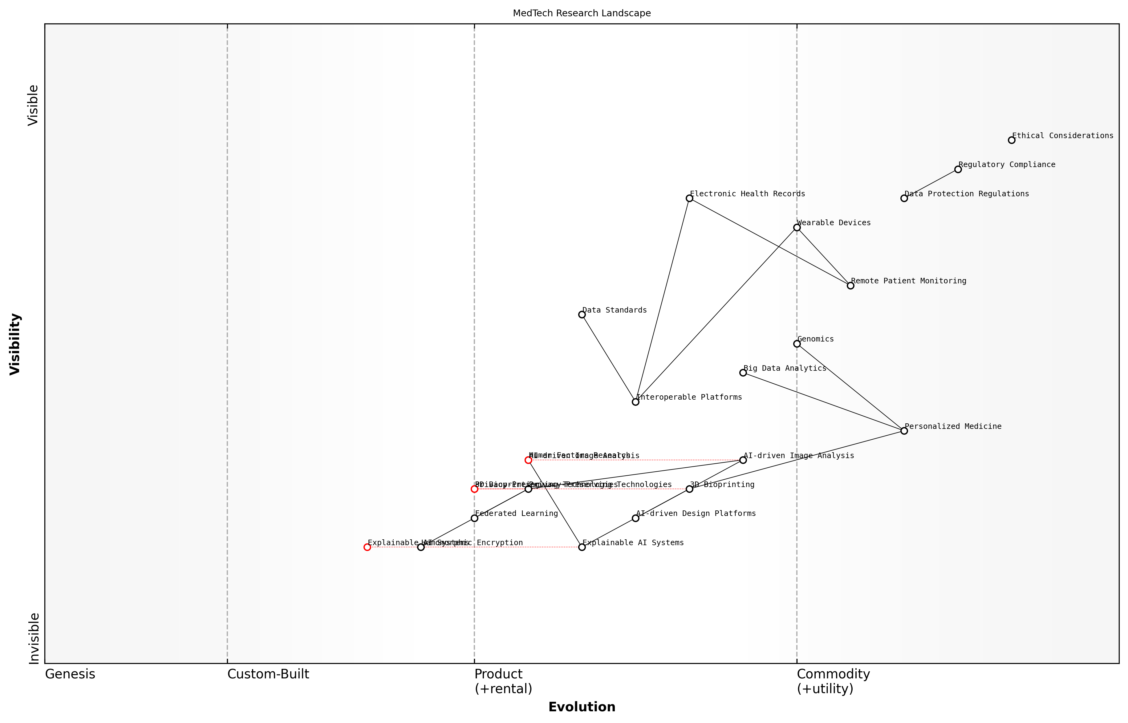

Draft Wardley Map: [Insert Wardley Map illustrating the MedTech research landscape, highlighting key components, their evolutionary stages, and potential future directions]

[Edit this draft Wardley Map](https://create.wardleymaps.ai/#2b20e66a66145e838c)

By applying Wardley Mapping to these key aspects of the MedTech landscape, researchers and educators can gain valuable insights into future directions and opportunities. This strategic approach enables more effective allocation of resources, identification of high-impact research areas, and alignment of academic efforts with industry needs and societal benefits.

As we continue to refine our use of Wardley Mapping in MedTech research forecasting, it’s important to remember that the map is not the territory. Regular reassessment and updating of our maps are crucial to maintain their relevance in a rapidly changing field. By fostering a culture of strategic thinking and continuous adaptation, we can ensure that our research and educational efforts remain at the forefront of MedTech innovation, driving meaningful advancements in healthcare technology and patient outcomes.

## Strategic Research Planning with Wardley Maps

### Aligning research goals with industry needs

In the rapidly evolving landscape of medical technology, aligning research goals with industry needs is paramount for driving innovation and ensuring the relevance of academic pursuits. Wardley Mapping provides a powerful framework for strategic research planning in MedTech, enabling higher education institutions to visualise the complex ecosystem of healthcare technology and identify areas where academic research can make the most significant impact.

By leveraging Wardley Maps, researchers and academic leaders can gain a comprehensive understanding of the current state of MedTech, anticipate future developments, and strategically position their research efforts to meet both immediate and long-term industry needs. This approach not only enhances the potential for impactful research outcomes but also strengthens the relationship between academia and industry, fostering a more collaborative and innovative MedTech ecosystem.

Wardley Mapping has revolutionised our approach to strategic research planning. It allows us to visualise the entire MedTech landscape and identify critical gaps where our research can make a real difference. This alignment with industry needs has significantly increased our success in securing funding and industry partnerships.

Let’s explore the key aspects of using Wardley Mapping for aligning research goals with industry needs in the MedTech sector:

* Mapping the MedTech Value Chain
* Identifying Industry Pain Points and Opportunities
* Assessing Research Capabilities and Resources
* Aligning Research Priorities with Market Dynamics
* Fostering Industry-Academia Collaboration

Mapping the MedTech Value Chain:

The first step in aligning research goals with industry needs is to create a comprehensive Wardley Map of the MedTech value chain. This map should include all components of the healthcare technology ecosystem, from basic research and product development to clinical implementation and patient outcomes. By visualising this value chain, researchers can identify where their work fits within the broader context of MedTech innovation and where potential gaps or opportunities may exist.

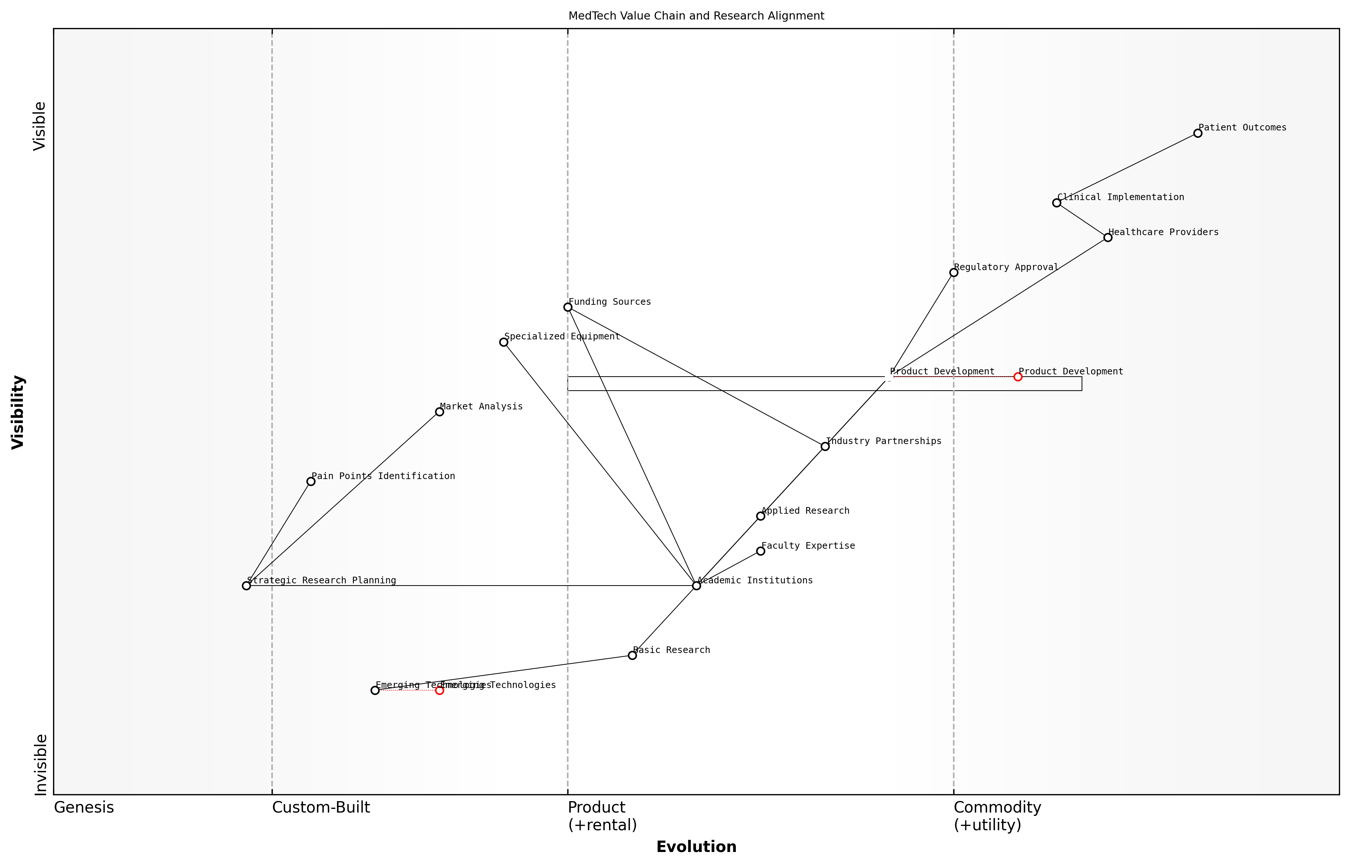

Draft Wardley Map: [Insert Wardley Map of MedTech Value Chain]

[Edit this draft Wardley Map](https://create.wardleymaps.ai/#2249900098b94d9e92)

Identifying Industry Pain Points and Opportunities:

With a clear map of the MedTech value chain, researchers can begin to identify industry pain points and emerging opportunities. This involves analysing the evolution of different components within the map and understanding where industry is struggling to make progress or where new technologies are creating disruptive potential. By focusing on these areas, academic research can be tailored to address real-world challenges and contribute to meaningful advancements in healthcare technology.

The beauty of Wardley Mapping in MedTech research is its ability to highlight not just where we are now, but where the industry is heading. This foresight allows us to align our research efforts with future industry needs, ensuring our work remains relevant and impactful for years to come.

Assessing Research Capabilities and Resources:

Once industry needs and opportunities have been identified, it’s crucial to assess the research capabilities and resources available within the academic institution. This involves mapping the expertise of faculty members, the availability of specialised equipment, and access to funding sources. By overlaying this information onto the MedTech value chain map, institutions can identify areas where they are well-positioned to make significant contributions and where additional resources or collaborations may be needed.

Aligning Research Priorities with Market Dynamics:

Wardley Mapping allows researchers to visualise the movement of technologies and practices along the evolution axis, from genesis to commodity. By understanding these market dynamics, academic institutions can align their research priorities with the most promising areas of development. This might involve focusing on emerging technologies in the genesis stage, where academic research can play a crucial role in early development, or addressing challenges in more mature technologies that are critical to industry but require innovative solutions.

* Identify technologies in the genesis stage where academic research can drive early innovation
* Focus on custom-built solutions that address specific industry challenges
* Contribute to the evolution of product technologies towards more efficient and cost-effective solutions
* Explore ways to leverage commodity technologies in novel MedTech applications

Fostering Industry-Academia Collaboration:

Perhaps one of the most valuable aspects of using Wardley Mapping for strategic research planning is its ability to facilitate meaningful collaboration between academia and industry. By creating a shared visual representation of the MedTech landscape, both parties can more easily identify areas of mutual interest and potential synergies. This can lead to more effective partnerships, joint research initiatives, and knowledge transfer between academia and industry.

Wardley Mapping has become an invaluable tool in our discussions with industry partners. It provides a common language and visual framework that helps us quickly align on research priorities and identify opportunities for collaboration that we might have otherwise missed.

In conclusion, aligning research goals with industry needs through Wardley Mapping is a powerful approach for ensuring the relevance and impact of MedTech research in higher education. By providing a clear visualisation of the MedTech landscape, identifying opportunities for innovation, and facilitating collaboration between academia and industry, Wardley Mapping enables more strategic and effective research planning. As the MedTech sector continues to evolve rapidly, this approach will become increasingly crucial for academic institutions seeking to make meaningful contributions to healthcare technology innovation.

### Resource allocation and team composition

In the realm of strategic MedTech research planning, resource allocation and team composition are critical factors that can significantly impact the success of research initiatives. Wardley Mapping provides a powerful framework for optimising these elements, enabling research leaders to make informed decisions that align with both short-term objectives and long-term strategic goals.

Effective resource allocation in MedTech research requires a deep understanding of the evolving landscape of healthcare technologies, regulatory environments, and market demands. By leveraging Wardley Maps, research institutions can visualise the entire value chain of their MedTech projects, from fundamental research to clinical applications, and allocate resources accordingly.

Wardley Mapping has revolutionised our approach to resource allocation in MedTech research. It allows us to see the bigger picture and make strategic investments that drive innovation while maximising return on investment.

When applying Wardley Mapping to resource allocation, consider the following key aspects:

* Identifying core competencies and areas for investment
* Balancing resources between exploratory and applied research
* Aligning funding with strategic priorities and market needs
* Optimising infrastructure and equipment utilisation
* Leveraging external partnerships to fill resource gaps

Team composition is equally crucial in MedTech research, where interdisciplinary collaboration is often essential for breakthrough innovations. Wardley Mapping can guide the assembly of research teams by highlighting the diverse skill sets and expertise required at different stages of the research lifecycle.

When using Wardley Maps to inform team composition, consider the following strategies:

* Mapping required competencies across the research value chain
* Identifying skill gaps and opportunities for upskilling
* Balancing technical expertise with commercial acumen
* Incorporating diverse perspectives to drive innovation
* Fostering collaboration between academic researchers and industry professionals

A practical application of Wardley Mapping for resource allocation and team composition in MedTech research can be illustrated through a case study from a leading UK university’s biomedical engineering department. The department used Wardley Mapping to strategically allocate resources for a novel medical imaging project:

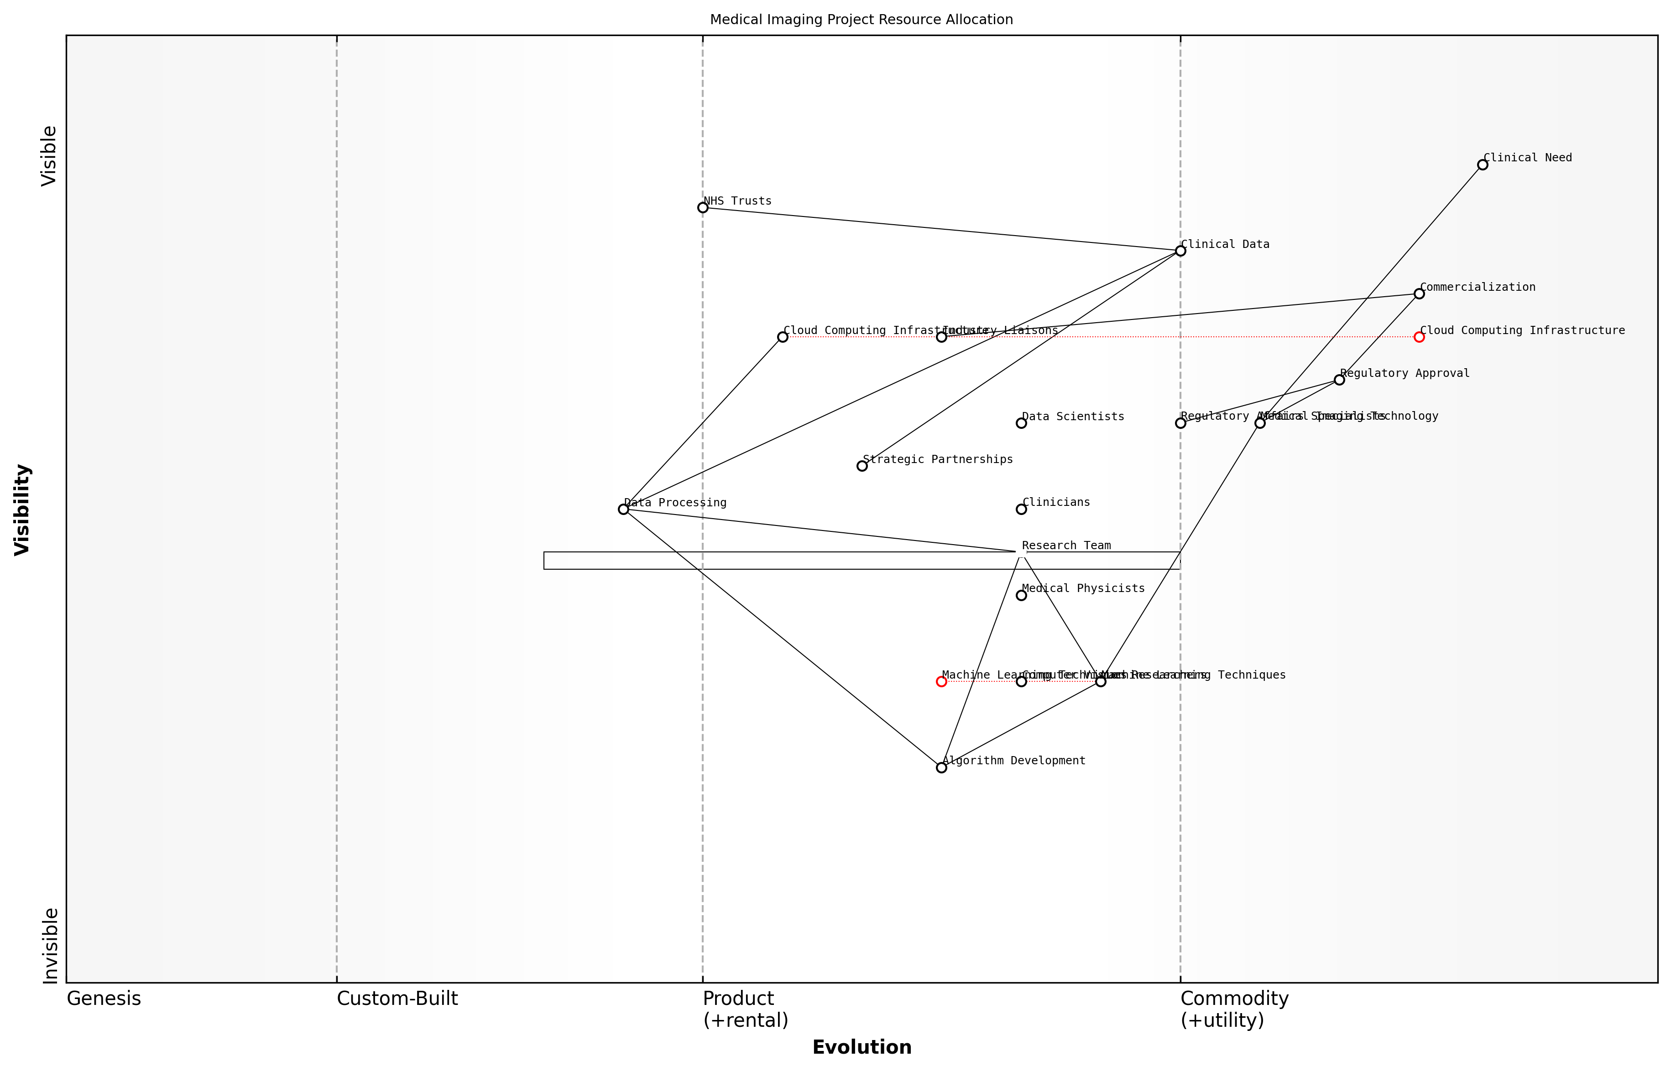

Draft Wardley Map: [Insert Wardley Map illustrating resource allocation for medical imaging project]

[Edit this draft Wardley Map](https://create.wardleymaps.ai/#87473fcd5db193c532)

By mapping the components of the medical imaging project, from fundamental algorithm development to clinical validation, the department identified key areas requiring investment. This visual representation enabled them to:

* Allocate more resources to emerging machine learning techniques, identified as a critical differentiator
* Form strategic partnerships with NHS trusts for access to clinical data and testing environments
* Invest in cloud computing infrastructure to support large-scale data processing
* Recruit specialists in regulatory affairs to navigate the complex approval process for medical devices

The team composition was also optimised based on the Wardley Map, ensuring a balance of skills across the project lifecycle. This included:

* Core team of computer vision researchers and medical physicists
* Collaboration with clinicians to ensure clinical relevance and usability
* Integration of data scientists specialising in healthcare analytics
* Involvement of industry liaisons to facilitate knowledge transfer and commercialisation

The strategic use of Wardley Mapping transformed our approach to team building. We now have a dynamic, multidisciplinary team that can adapt to the evolving needs of our MedTech research projects.

It’s important to note that resource allocation and team composition are not static decisions. The MedTech landscape is rapidly evolving, and Wardley Mapping should be used as an ongoing tool for strategic adjustment. Regular review and updating of maps can help research leaders to:

* Identify emerging technologies that may require reallocation of resources
* Anticipate shifts in regulatory landscapes that necessitate new expertise
* Respond to changes in funding priorities or market demands
* Continuously align team capabilities with project requirements

In conclusion, the strategic application of Wardley Mapping to resource allocation and team composition in MedTech research enables institutions to optimise their research efforts, foster innovation, and maintain a competitive edge in a rapidly evolving field. By providing a visual framework for decision-making, Wardley Mapping empowers research leaders to make informed choices that balance immediate needs with long-term strategic objectives, ultimately enhancing the impact and efficiency of MedTech research initiatives.

### Identifying potential collaborations and partnerships

In the rapidly evolving landscape of MedTech research, identifying and fostering strategic collaborations and partnerships is crucial for driving innovation and maximising impact. Wardley Mapping provides a powerful framework for visualising the MedTech ecosystem, enabling researchers and institutions to identify potential synergies and collaborative opportunities that align with their strategic objectives.

By leveraging Wardley Maps in the context of strategic research planning, higher education institutions can gain a comprehensive understanding of the MedTech value chain, from fundamental research to clinical applications. This holistic view allows for the identification of complementary strengths and capabilities across different organisations, paving the way for mutually beneficial partnerships.

Wardley Mapping has revolutionised our approach to identifying research collaborations. It’s like having a strategic radar that reveals hidden opportunities in the MedTech landscape.

Let’s explore the key aspects of using Wardley Mapping to identify potential collaborations and partnerships in MedTech research:

* Mapping the MedTech ecosystem
* Identifying capability gaps and complementary strengths
* Assessing strategic alignment
* Evaluating potential impact and value creation
* Navigating regulatory and ethical considerations

Mapping the MedTech ecosystem: The first step in identifying potential collaborations is to create a comprehensive Wardley Map of the MedTech ecosystem relevant to your research focus. This map should include key components such as emerging technologies, research institutions, industry players, regulatory bodies, and end-users (e.g., healthcare providers and patients).

By visualising the entire value chain, from basic research to clinical implementation, researchers can identify areas where collaboration could accelerate innovation or address critical challenges. For instance, a university with strong capabilities in AI algorithms might identify potential partnerships with medical imaging companies to develop advanced diagnostic tools.

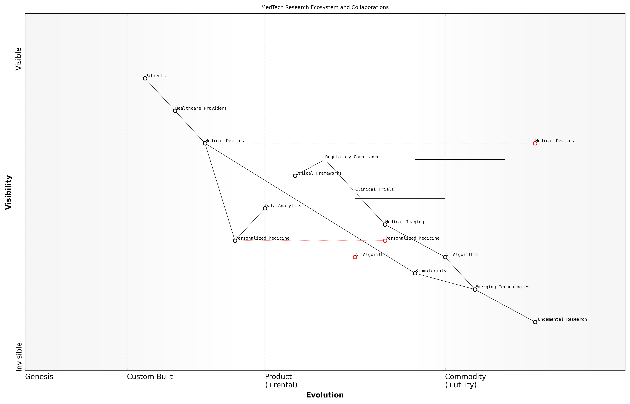

Draft Wardley Map: [Insert Wardley Map of MedTech ecosystem here]

[Edit this draft Wardley Map](https://create.wardleymaps.ai/#ca1e10d7bab24c0875)

Identifying capability gaps and complementary strengths: Once the ecosystem is mapped, researchers can assess their own institution’s position and capabilities relative to other players. This analysis often reveals capability gaps that could be addressed through strategic partnerships.

For example, a research group specialising in biomaterials might identify a gap in their ability to conduct large-scale clinical trials. By using the Wardley Map to identify organisations with complementary strengths in clinical research, they can forge partnerships that bridge this gap and accelerate the translation of their research into clinical practice.

The beauty of Wardley Mapping lies in its ability to reveal non-obvious connections and complementarities within the MedTech landscape. It’s these insights that often lead to the most innovative and impactful collaborations.

Assessing strategic alignment: Wardley Mapping facilitates the evaluation of potential partners based on their strategic alignment with your research goals. By analysing the evolution of different components on the map, researchers can identify organisations that share similar visions for the future of MedTech.

For instance, if your research focuses on developing personalised medicine approaches, you might seek partnerships with organisations that are similarly positioned to leverage emerging technologies in genomics and data analytics. This strategic alignment increases the likelihood of successful and sustainable collaborations.

Evaluating potential impact and value creation: Wardley Maps can be used to assess the potential impact of different collaborative arrangements. By visualising how a partnership might shift the position of key components on the map, researchers can estimate the value that could be created through collaboration.

For example, a partnership between a university research team and a medical device manufacturer might accelerate the movement of a novel technology from the ‘genesis’ phase to ‘custom-built’ or even ‘product’ phases, significantly increasing its potential impact on patient care.

Navigating regulatory and ethical considerations: In the MedTech sector, regulatory compliance and ethical considerations are paramount. Wardley Mapping can help identify potential partners with expertise in navigating these complex landscapes.

By including regulatory bodies and ethical frameworks in your Wardley Map, you can identify organisations with track records of successful regulatory approvals or established ethical governance structures. Collaborating with such partners can significantly de-risk the research and development process, particularly for novel MedTech innovations.

In MedTech research, the right collaboration can be the difference between a promising idea and a life-changing innovation. Wardley Mapping gives us the strategic lens to identify these game-changing partnerships.

In conclusion, Wardley Mapping offers a powerful approach to identifying potential collaborations and partnerships in MedTech research. By providing a visual representation of the ecosystem, highlighting capability gaps, assessing strategic alignment, evaluating potential impact, and considering regulatory and ethical factors, Wardley Maps enable researchers and institutions to make informed decisions about collaborative opportunities.

As the MedTech landscape continues to evolve rapidly, the ability to identify and forge strategic partnerships will become increasingly crucial. By integrating Wardley Mapping into their strategic research planning processes, higher education institutions can position themselves at the forefront of MedTech innovation, driving meaningful advancements in healthcare technology and ultimately improving patient outcomes.

## Enhancing Research Proposals and Funding Applications

### Using Wardley Maps to strengthen research rationales

In the competitive landscape of MedTech research, securing funding and support for innovative projects is increasingly challenging. Wardley Mapping, a strategic tool traditionally used in business contexts, has emerged as a powerful asset for researchers seeking to bolster their research rationales and enhance the persuasiveness of their funding applications. This section explores how Wardley Mapping can be leveraged to strengthen research proposals, providing a strategic edge in the pursuit of resources and collaborations within the MedTech sector.

Wardley Mapping offers a unique approach to visualising the landscape of technologies, components, and activities within a given domain. When applied to MedTech research proposals, it provides a comprehensive framework for articulating the strategic positioning of a project within the broader ecosystem of healthcare innovation. By incorporating Wardley Maps into research rationales, investigators can demonstrate a nuanced understanding of the field’s evolution, potential impact, and alignment with funding priorities.

Let us explore the key ways in which Wardley Mapping can enhance research proposals:

* Contextualising the research within the MedTech landscape
* Demonstrating strategic foresight and innovation potential
* Identifying critical dependencies and collaborations
* Articulating value proposition and impact pathways
* Addressing potential challenges and mitigation strategies

Contextualising the research within the MedTech landscape: Wardley Maps provide a visual representation of the entire value chain relevant to a research project. By mapping out the components from basic research through to end-user applications, researchers can clearly illustrate where their proposed work fits within the broader context of MedTech innovation. This contextualisation helps funding bodies understand the strategic importance of the research and its potential to address critical gaps in the field.

A well-constructed Wardley Map can illuminate the strategic positioning of a research project, revealing its potential to bridge critical gaps in the MedTech innovation pipeline. This visual narrative often resonates more powerfully with funding bodies than traditional text-based explanations alone.

Demonstrating strategic foresight and innovation potential: The evolutionary aspect of Wardley Mapping allows researchers to project future developments in their field. By illustrating how different components of the MedTech ecosystem are likely to evolve, investigators can position their research as forward-thinking and aligned with emerging trends. This demonstration of strategic foresight can be particularly compelling for funding bodies looking to invest in transformative research with long-term impact.

Identifying critical dependencies and collaborations: Wardley Maps excel at highlighting the interconnections between different components of a system. In a research context, this can be used to identify critical dependencies that might affect the success of a project. By mapping out these relationships, researchers can demonstrate a comprehensive understanding of the ecosystem in which their work will be conducted, including potential collaborations or partnerships that could enhance the project’s feasibility and impact.

Articulating value proposition and impact pathways: One of the most powerful applications of Wardley Mapping in research proposals is its ability to clearly articulate the value proposition of a project. By visually representing the path from basic research to end-user value, investigators can make a compelling case for the potential impact of their work. This is particularly valuable in MedTech, where the translation of research into tangible healthcare improvements is a key consideration for many funding bodies.

The visual nature of Wardley Maps allows researchers to tell a compelling story about their project’s potential impact. It’s not just about the science; it’s about showing how that science fits into the bigger picture of healthcare innovation and patient benefit.

Addressing potential challenges and mitigation strategies: Wardley Mapping can also be used to anticipate potential challenges or bottlenecks in the research process. By mapping out the entire ecosystem, researchers can identify areas where difficulties might arise and propose mitigation strategies. This proactive approach to risk management can significantly enhance the credibility of a research proposal, demonstrating to funding bodies that the investigators have a realistic and well-considered plan for executing their project.

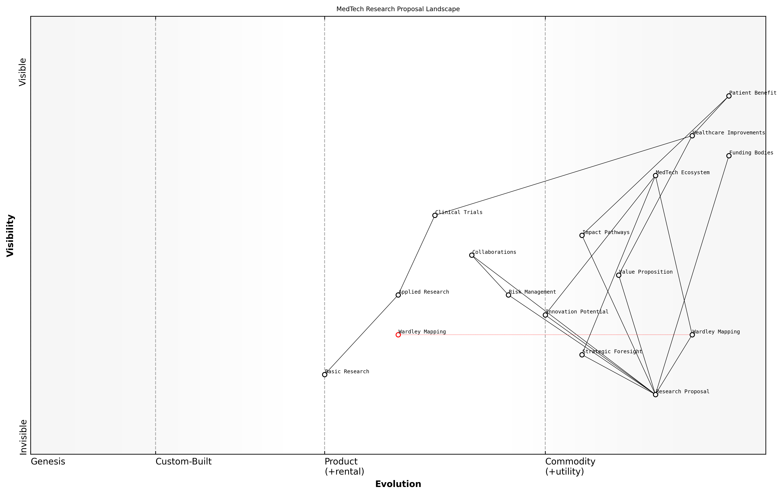

Draft Wardley Map: [Insert Wardley Map illustrating a typical MedTech research proposal, highlighting key components, dependencies, and evolution]

[Edit this draft Wardley Map](https://create.wardleymaps.ai/#92c02f2526f13561a1)

Incorporating Wardley Mapping into research proposals requires a shift in thinking for many investigators. It necessitates a broader, more strategic view of the research landscape, moving beyond the immediate focus of the proposed work to consider its place within the larger MedTech ecosystem. However, the benefits of this approach can be substantial, providing a powerful tool for articulating the rationale, potential impact, and strategic importance of a research project.

To effectively leverage Wardley Mapping in research proposals, investigators should consider the following best practices:

* Engage with stakeholders across the MedTech value chain to ensure a comprehensive understanding of the ecosystem
* Iterate on the map throughout the proposal development process, refining it based on feedback and new insights
* Use the map as a tool for internal strategic discussions, ensuring alignment within the research team
* Provide clear explanations and annotations to guide reviewers through the map and its implications
* Link the insights derived from the map directly to the proposed research objectives and methodologies

By integrating Wardley Mapping into the process of developing research rationales and funding applications, MedTech researchers can significantly enhance the strategic clarity and persuasiveness of their proposals. This approach not only strengthens the case for individual projects but also contributes to a more strategic and forward-thinking research culture within the MedTech community.

In my experience advising research institutions, those that have adopted Wardley Mapping as part of their proposal development process have seen a marked improvement in the strategic coherence of their applications. This has translated into higher success rates in competitive funding environments.

As the MedTech field continues to evolve rapidly, the ability to articulate a clear, strategic vision for research projects becomes increasingly crucial. Wardley Mapping provides a powerful tool for researchers to demonstrate their understanding of the field’s dynamics, anticipate future developments, and position their work for maximum impact. By embracing this approach, investigators can not only strengthen their individual proposals but also contribute to advancing the strategic thinking and innovation potential of the entire MedTech research community.

### Visualising project impact and potential outcomes

In the competitive landscape of MedTech research funding, the ability to effectively visualise project impact and potential outcomes is paramount. Wardley Mapping offers a powerful tool for researchers to articulate their vision, demonstrate strategic thinking, and showcase the potential value of their work. This section explores how Wardley Mapping can be leveraged to enhance the visual representation of research proposals, thereby increasing their persuasiveness and likelihood of securing funding.

Wardley Mapping provides a unique perspective on project impact by situating proposed research within the broader context of the MedTech ecosystem. By mapping the current state of relevant technologies, user needs, and market dynamics, researchers can clearly illustrate the strategic positioning of their project and its potential to drive innovation and create value.

* Contextualising research within the MedTech landscape
* Illustrating potential technological advancements
* Demonstrating alignment with user needs and market demands
* Visualising the evolution of project outcomes over time

One of the key advantages of using Wardley Mapping for visualising project impact is its ability to demonstrate the dynamic nature of research outcomes. By incorporating the evolution axis, researchers can illustrate how their proposed work will contribute to the advancement of technologies or practices along the value chain. This temporal perspective is particularly valuable in MedTech, where the pace of innovation is rapid and the ability to anticipate future developments is crucial.

Wardley Mapping has revolutionised our approach to presenting research proposals. It allows us to tell a compelling story about where our work fits in the broader healthcare technology landscape and how it will drive future innovations.

When visualising potential outcomes, Wardley Mapping enables researchers to illustrate multiple scenarios and their implications. By mapping out different potential paths of technology evolution or market adoption, researchers can demonstrate a nuanced understanding of the risks and opportunities associated with their project. This approach not only showcases the researcher’s strategic thinking but also provides funding bodies with a clear view of the project’s potential impact under various conditions.

* Mapping multiple outcome scenarios
* Illustrating potential ripple effects across the value chain
* Demonstrating awareness of risks and mitigation strategies
* Showcasing opportunities for scalability and wider impact

Furthermore, Wardley Mapping can be particularly effective in visualising the interdependencies between different components of a research project and their collective impact on the MedTech landscape. By mapping out how various elements of the research interact with existing technologies, practices, and stakeholders, researchers can provide a holistic view of their project’s potential to catalyse broader changes in healthcare delivery or technology adoption.

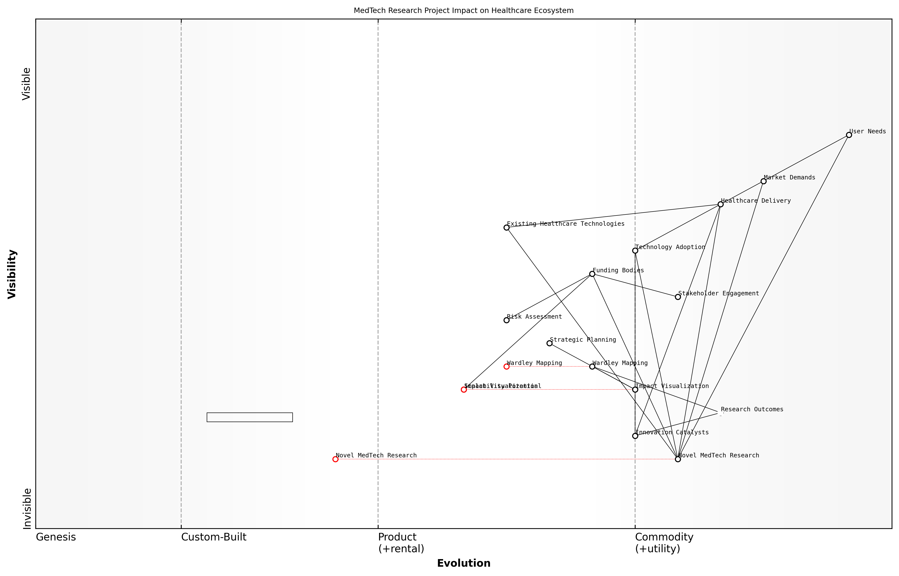

Draft Wardley Map: [Insert Wardley Map illustrating the potential impact of a novel MedTech research project on the healthcare ecosystem]

[Edit this draft Wardley Map](https://create.wardleymaps.ai/#37643798ef40f4865f)

To effectively use Wardley Mapping for visualising project impact and potential outcomes, researchers should consider the following best practices:

* Start with a clear articulation of the project’s primary objectives and intended beneficiaries
* Map the current state of relevant technologies, practices, and user needs
* Illustrate how the proposed research will drive evolution along the value chain
* Highlight potential second-order effects and broader impacts on the MedTech ecosystem
* Use colour coding or annotations to distinguish between current state, projected outcomes, and alternative scenarios
* Provide a narrative explanation to accompany the visual map, ensuring clarity for non-expert reviewers

It’s important to note that while Wardley Mapping offers a powerful visualisation tool, it should be used in conjunction with other established methods of presenting research proposals. Traditional elements such as literature reviews, methodology descriptions, and quantitative impact projections remain crucial. Wardley Mapping complements these by providing a strategic, visual overview that ties together various aspects of the proposal and situates them within the broader context of MedTech innovation.

The integration of Wardley Mapping into our research proposals has significantly enhanced our ability to communicate complex ideas to diverse stakeholders. It’s not just about securing funding; it’s about building a shared vision for the future of healthcare technology.

In conclusion, visualising project impact and potential outcomes through Wardley Mapping offers MedTech researchers a powerful tool to enhance their funding applications. By providing a strategic, contextual, and dynamic representation of their proposed work, researchers can more effectively communicate the value and potential of their projects. As funding bodies increasingly seek evidence of strategic thinking and long-term impact, the ability to leverage Wardley Mapping in this context may become a crucial skill for successful MedTech researchers in higher education.

### Addressing reviewer concerns through strategic mapping

In the competitive landscape of MedTech research funding, addressing reviewer concerns effectively can make the difference between a successful grant application and a missed opportunity. Wardley Mapping offers a powerful tool for researchers to anticipate, visualise, and strategically respond to potential reviewer concerns, thereby strengthening their research proposals and funding applications.

This section explores how Wardley Mapping can be leveraged to address reviewer concerns in MedTech research proposals, providing researchers with a strategic advantage in the funding process. By incorporating Wardley Maps into their proposal development and revision processes, researchers can demonstrate a deep understanding of their project’s positioning within the broader MedTech ecosystem, anticipate potential challenges, and articulate clear strategies for overcoming them.

Let’s delve into the key aspects of using Wardley Mapping to address reviewer concerns:

* Visualising the research landscape
* Identifying potential weaknesses and gaps
* Demonstrating strategic foresight
* Articulating contingency plans
* Enhancing interdisciplinary collaboration

Visualising the Research Landscape:

One of the primary benefits of Wardley Mapping in addressing reviewer concerns is its ability to provide a clear, visual representation of the research landscape. By mapping out the various components of their proposed research project, from foundational technologies to user needs, researchers can demonstrate a comprehensive understanding of their field and the potential impact of their work.

Wardley Maps offer a unique way to contextualise research within the broader MedTech ecosystem. They allow reviewers to quickly grasp the strategic positioning of a project and its potential for innovation.

This visual representation can address common reviewer concerns about the novelty and significance of the proposed research. By clearly showing how the project builds upon existing technologies and addresses unmet needs in the healthcare sector, researchers can pre-emptively counter potential criticisms about the originality or relevance of their work.

Identifying Potential Weaknesses and Gaps:

Wardley Mapping can be an invaluable tool for researchers to critically assess their own proposals and identify potential weaknesses before reviewers do. By mapping out the entire value chain of their proposed research, from basic scientific principles to clinical applications, researchers can spot gaps in their methodology or areas where additional expertise might be required.

This proactive approach allows researchers to address these issues within their proposals, demonstrating to reviewers that they have thoroughly considered potential challenges and have strategies in place to overcome them. For instance, if the map reveals a dependency on a rapidly evolving technology, researchers can outline plans for staying abreast of developments and adapting their approach as needed.

Demonstrating Strategic Foresight:

One common concern among reviewers is the long-term viability and impact of proposed research. Wardley Maps excel at illustrating the evolution of technologies and practices over time, allowing researchers to demonstrate strategic foresight in their proposals.

The ability to anticipate future developments and position research accordingly is a hallmark of truly innovative proposals. Wardley Mapping provides a framework for articulating this foresight in a clear, visual manner.

By mapping out the expected evolution of key components in their research area, researchers can show how their proposed work aligns with or drives these trends. This can address reviewer concerns about the potential obsolescence of research outcomes and demonstrate the long-term value of the proposed project.

Articulating Contingency Plans:

Reviewers often express concerns about the feasibility of proposed research and the ability of researchers to adapt to unforeseen challenges. Wardley Mapping can be used to develop and articulate robust contingency plans, addressing these concerns head-on.

By mapping out alternative pathways and potential pivot points within their research plan, researchers can demonstrate flexibility and resilience in their approach. This might include identifying alternative technologies that could be employed if primary methods prove unsuccessful, or outlining strategies for adapting to shifts in the regulatory landscape.

Enhancing Interdisciplinary Collaboration:

In the complex world of MedTech research, interdisciplinary collaboration is often crucial for success. Wardley Maps can be used to illustrate how different areas of expertise come together within a research project, addressing potential reviewer concerns about the integration of diverse skill sets.

By mapping out the contributions of various team members or collaborating institutions, researchers can demonstrate a well-rounded approach that leverages complementary expertise. This can allay concerns about potential gaps in knowledge or skills within the research team.

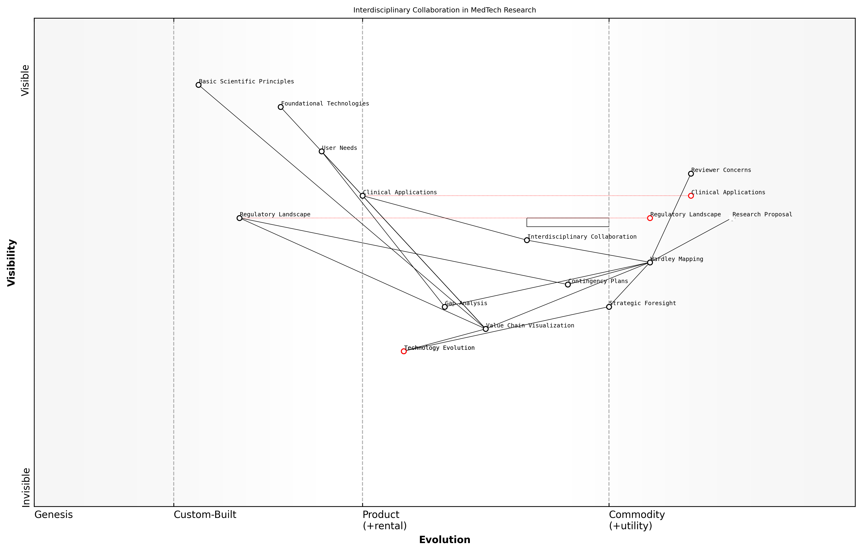

Draft Wardley Map: [Insert Wardley Map illustrating interdisciplinary collaboration in a MedTech research project]

[Edit this draft Wardley Map](https://create.wardleymaps.ai/#b18223ef2fcffadd4b)

In conclusion, Wardley Mapping offers a powerful approach for addressing reviewer concerns in MedTech research proposals. By providing a clear, strategic view of the research landscape, identifying potential challenges, demonstrating foresight, articulating contingency plans, and illustrating interdisciplinary collaboration, researchers can significantly strengthen their funding applications. As competition for research funding continues to intensify, the strategic insights provided by Wardley Mapping may prove to be a crucial differentiator in securing support for innovative MedTech research projects.

# Fostering Academic-Industry Collaborations in MedTech

## Mapping the Academic-Industry Interface

### Understanding stakeholder motivations and constraints

In the complex ecosystem of MedTech innovation, understanding stakeholder motivations and constraints is crucial for fostering successful academic-industry collaborations. This understanding forms the foundation for effective Wardley Mapping of the academic-industry interface, enabling strategic decision-making and mutually beneficial partnerships. As we delve into this critical aspect, we’ll explore how Wardley Mapping can illuminate the intricate web of relationships, goals, and limitations that shape the MedTech landscape.

To effectively map the academic-industry interface, we must first identify the key stakeholders and their primary drivers. These typically include:

* Academic institutions (universities, research centres)
* Industry partners (MedTech companies, healthcare providers)
* Regulatory bodies
* Funding agencies
* Healthcare professionals
* Patients and patient advocacy groups

Each of these stakeholders operates within a unique set of motivations and constraints that influence their decision-making and ability to collaborate. Let’s examine these in detail:

Academic Institutions: Universities and research centres are primarily motivated by the pursuit of knowledge, academic prestige, and the desire to translate research into real-world impact. However, they often face constraints such as limited funding, bureaucratic processes, and the pressure to publish. As one senior academic administrator noted:

Our challenge is to balance the need for academic freedom and rigorous research with the increasing demand for commercially viable innovations. Wardley Mapping helps us visualise where our strengths align with industry needs.

Industry Partners: MedTech companies are driven by market opportunities, competitive advantage, and return on investment. They seek to leverage academic expertise to accelerate innovation but are constrained by regulatory requirements, shareholder expectations, and the need for rapid commercialisation. Wardley Mapping can reveal areas where academic research aligns with industry roadmaps, facilitating more strategic collaborations.

Regulatory Bodies: These organisations are motivated by ensuring patient safety and efficacy of medical technologies. Their constraints include limited resources for assessment and the need to balance innovation with risk management. Mapping the regulatory landscape can help both academic and industry partners navigate compliance more effectively.

Funding Agencies: Government and private funding bodies aim to support research that addresses critical healthcare needs and drives economic growth. They are constrained by budget limitations and the need to demonstrate return on investment. Wardley Maps can illustrate how proposed research fits into the broader MedTech ecosystem, strengthening funding applications.

Healthcare Professionals: Clinicians and healthcare providers are motivated by improving patient outcomes and enhancing care delivery. They face constraints such as time limitations, resistance to change, and the need for evidence-based solutions. Engaging healthcare professionals in the mapping process can ensure that innovations address real-world clinical needs.

Patients and Patient Advocacy Groups: These stakeholders are driven by the desire for better health outcomes, improved quality of life, and access to innovative treatments. They may be constrained by limited influence on research priorities and regulatory processes. Including patient perspectives in Wardley Mapping can lead to more patient-centric innovations.

By mapping these stakeholders and their respective motivations and constraints, we can identify potential synergies and friction points in academic-industry collaborations. This process involves several key steps:

* Identify the value chain for a specific MedTech innovation or research area
* Position stakeholders along the value chain based on their roles and interests
* Map the evolution of components within the value chain
* Analyse the motivations and constraints for each stakeholder at different stages
* Identify areas of alignment and potential conflicts

A well-constructed Wardley Map of the academic-industry interface can reveal opportunities for strategic collaboration that address multiple stakeholder needs. For example, it might highlight areas where academic research can be aligned with industry R&D pipelines, or where joint funding applications could leverage complementary strengths.

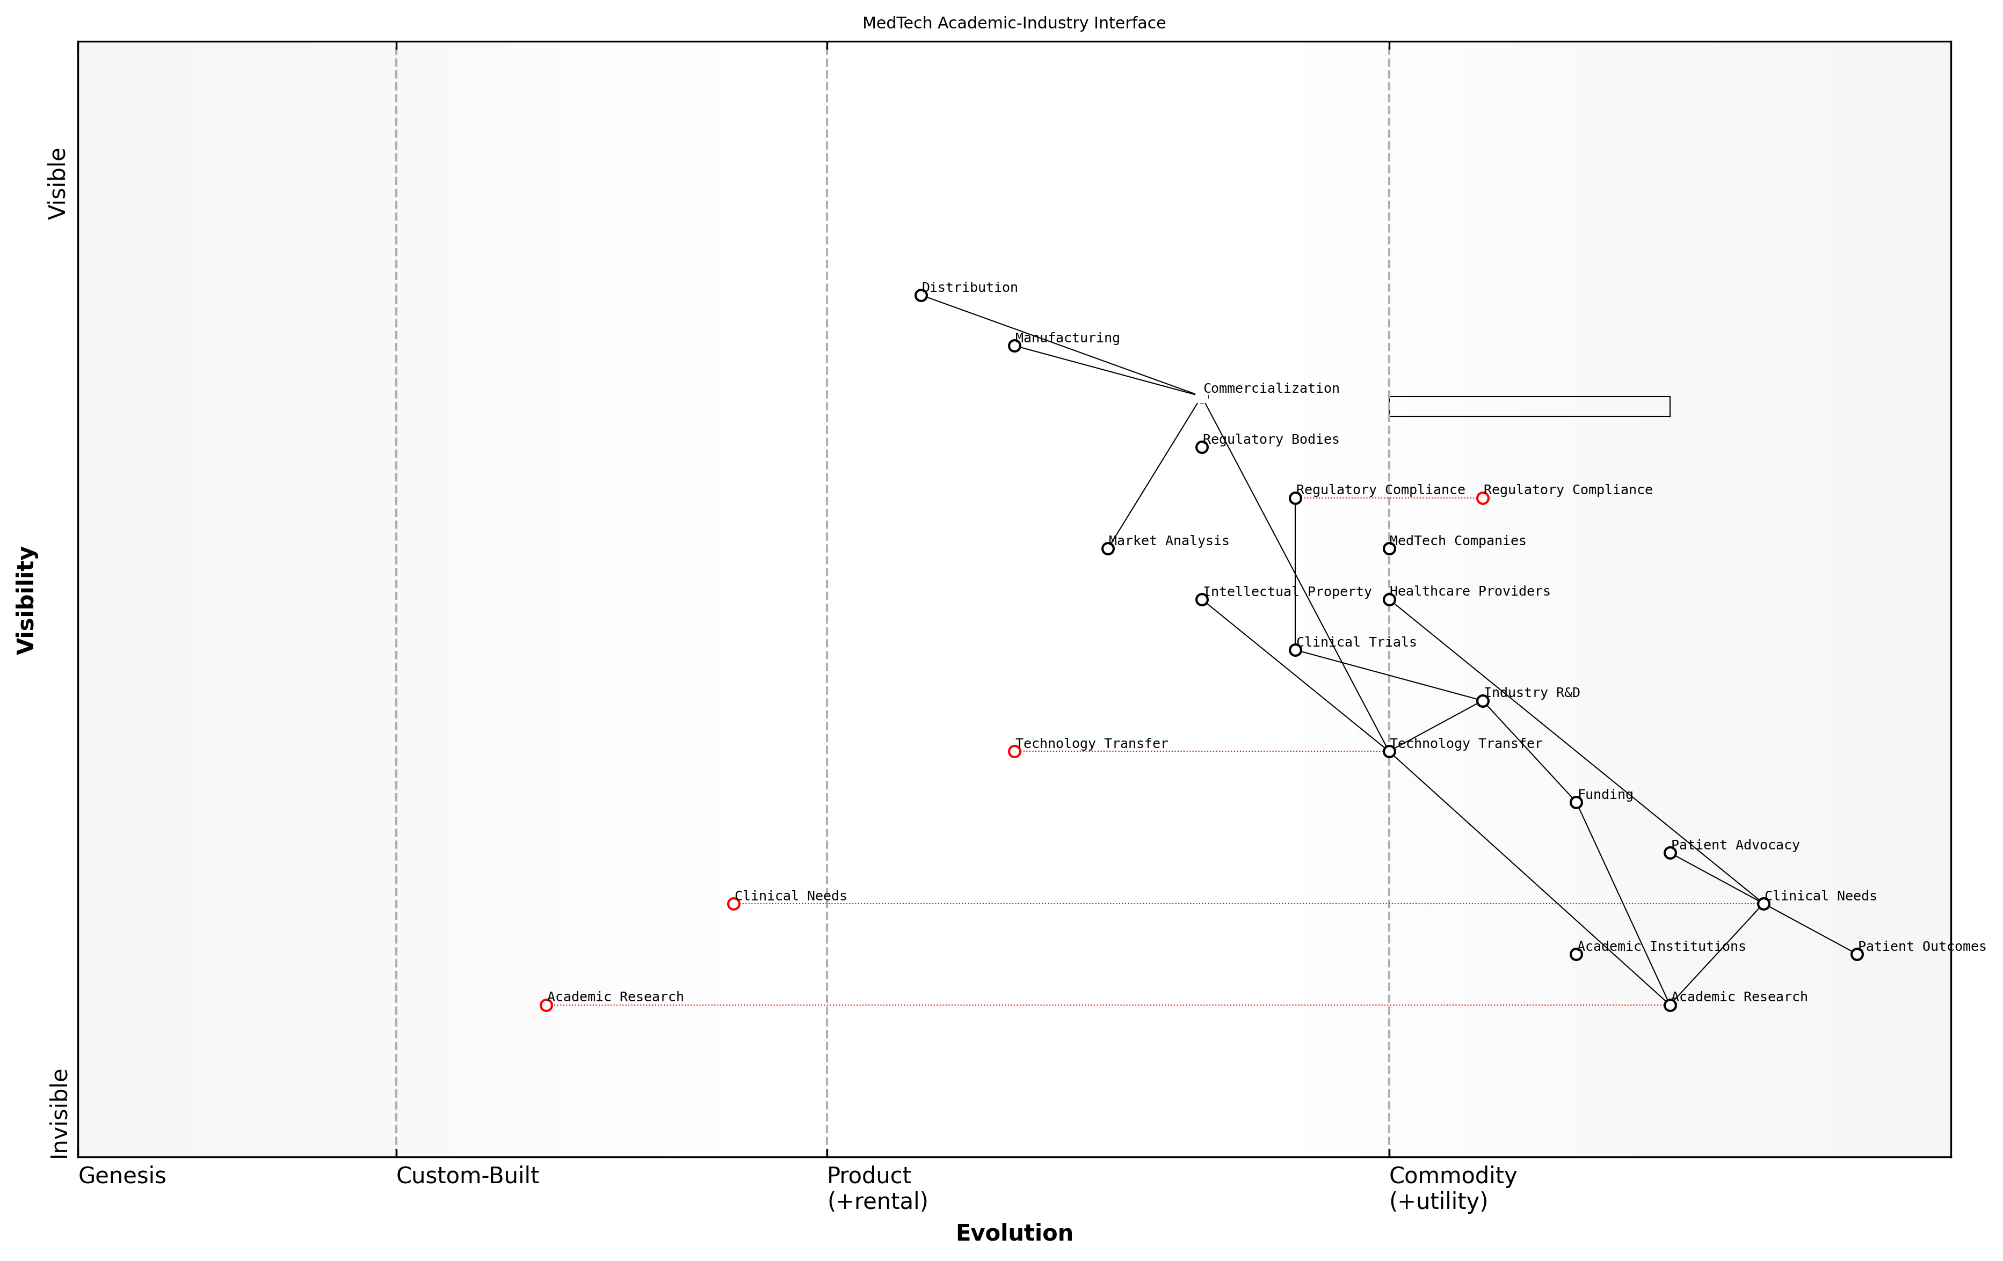

Draft Wardley Map: [Insert Wardley Map illustrating the academic-industry interface for a specific MedTech innovation, showing stakeholder positions and evolution of components]

[Edit this draft Wardley Map](https://create.wardleymaps.ai/#924f27735eca47c9fd)

One of the key benefits of using Wardley Mapping in this context is its ability to facilitate communication and shared understanding among diverse stakeholders. As a leading MedTech innovation consultant observed:

Wardley Maps act as a common language between academia and industry. They help translate abstract research concepts into tangible market opportunities, and conversely, help academics understand the commercial landscape their work could impact.

Moreover, Wardley Mapping can help identify potential barriers to collaboration early in the process. For instance, it might reveal misalignments in timelines between academic research cycles and industry product development schedules, or highlight areas where regulatory constraints might impact the feasibility of a proposed innovation.

To effectively leverage Wardley Mapping for understanding stakeholder motivations and constraints, consider the following best practices:

* Engage representatives from all key stakeholder groups in the mapping process
* Use workshops and collaborative sessions to create and refine maps
* Regularly update maps to reflect changes in the MedTech landscape
* Use maps as a tool for ongoing dialogue and strategy refinement
* Combine Wardley Mapping with other analytical tools (e.g., SWOT analysis, value network mapping) for a comprehensive view

In conclusion, understanding stakeholder motivations and constraints through Wardley Mapping is a powerful approach to fostering successful academic-industry collaborations in MedTech. By visualising the complex interplay of interests, capabilities, and limitations, stakeholders can identify strategic opportunities for collaboration, anticipate challenges, and develop more resilient partnerships. As the MedTech landscape continues to evolve, this approach will become increasingly valuable in navigating the complexities of innovation at the intersection of academia and industry.

### Identifying mutual benefits and synergies

In the realm of academic-industry collaborations in MedTech, identifying mutual benefits and synergies is crucial for fostering successful partnerships. Wardley Mapping serves as an invaluable tool in this process, enabling stakeholders to visualise the complex landscape of healthcare technology and pinpoint areas of shared interest and potential collaboration. This section explores how Wardley Mapping can be leveraged to uncover and maximise these synergies, ultimately driving innovation and progress in the MedTech sector.

To effectively identify mutual benefits and synergies, it is essential to first understand the distinct motivations and capabilities of both academic institutions and industry partners. Wardley Mapping allows us to map out these factors and analyse their interplay within the broader MedTech ecosystem.

* Academic motivations: Advancing knowledge, securing research funding, publishing findings, and training future professionals
* Industry motivations: Developing marketable products, improving patient outcomes, gaining competitive advantage, and ensuring regulatory compliance
* Shared motivations: Driving innovation, addressing unmet medical needs, and contributing to societal well-being

By mapping these motivations alongside the various components of the MedTech value chain, we can identify areas where academic expertise and industry resources can be synergistically combined. This process often reveals unexpected opportunities for collaboration that might otherwise be overlooked.

Wardley Mapping has revolutionised our approach to academic-industry partnerships. It allows us to visualise the entire MedTech landscape and pinpoint precisely where our research capabilities align with industry needs, leading to more targeted and impactful collaborations.

One of the key benefits of using Wardley Mapping in this context is its ability to highlight the evolution of technologies and practices within the MedTech sector. This temporal aspect is particularly valuable when identifying synergies, as it allows stakeholders to anticipate future needs and align their collaborative efforts accordingly.

For instance, a Wardley Map might reveal that a particular medical imaging technology is evolving from the custom-built to the product stage. This insight could prompt a collaboration between a university’s biomedical engineering department and a medical device manufacturer to develop standardised, cost-effective versions of the technology for widespread clinical use.

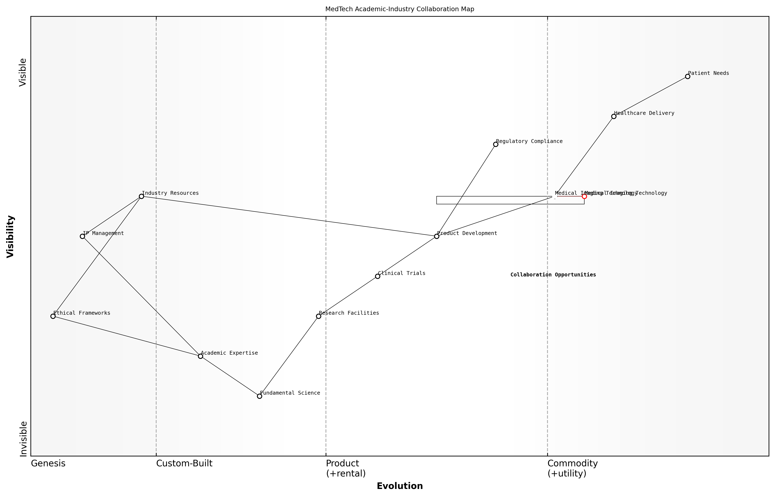

Draft Wardley Map: [Insert Wardley Map illustrating the evolution of medical imaging technology and potential collaboration points]

[Edit this draft Wardley Map](https://create.wardleymaps.ai/#f5b3ac7cfe97273f98)

Moreover, Wardley Mapping can help identify complementary strengths and resources between academic and industry partners. For example:

* Universities often possess cutting-edge research facilities and expertise in fundamental science, which can be complemented by industry’s product development capabilities and market access.
* Academic institutions can provide access to clinical trial networks and patient data, while industry partners can offer regulatory expertise and commercialisation pathways.
* Collaborative research programmes can leverage academic talent pools to address specific industry challenges, while providing real-world experience for students and early-career researchers.

By mapping these complementary assets and capabilities, stakeholders can design collaborations that maximise value creation for all parties involved. This approach not only enhances the likelihood of successful outcomes but also helps to build long-term, sustainable partnerships between academia and industry.

The beauty of using Wardley Mapping to identify synergies is that it forces both academic and industry partners to think beyond their immediate goals. It encourages a more holistic view of the MedTech landscape, often leading to innovative collaborations that address broader healthcare challenges.

Another critical aspect of identifying mutual benefits is the alignment of timelines and expectations. Academic research often operates on longer timescales compared to industry product development cycles. Wardley Mapping can help visualise these different timelines and identify optimal points of intersection where academic insights can be effectively translated into industry applications.

Furthermore, Wardley Mapping can assist in identifying potential barriers to collaboration and developing strategies to overcome them. Common challenges include:

* Intellectual property concerns
* Differences in organisational culture and decision-making processes
* Misalignment of research priorities and commercial objectives
* Regulatory and ethical considerations specific to healthcare technologies

By mapping these challenges alongside potential synergies, stakeholders can develop proactive strategies to address issues before they become roadblocks to collaboration. This might involve creating clear IP agreements, establishing joint governance structures, or developing shared ethical frameworks for MedTech innovation.

In conclusion, the use of Wardley Mapping to identify mutual benefits and synergies in academic-industry collaborations represents a powerful approach to driving innovation in the MedTech sector. By providing a visual representation of the complex healthcare technology landscape, Wardley Mapping enables stakeholders to uncover complementary strengths, align objectives, and anticipate future opportunities. This strategic approach not only enhances the effectiveness of individual collaborations but also contributes to the overall advancement of healthcare technology and improved patient outcomes.

Wardley Mapping has become an indispensable tool in our MedTech innovation strategy. It allows us to navigate the complex interplay between academic research and industry needs, ensuring that our collaborations are not just mutually beneficial, but truly transformative for healthcare delivery.

### Navigating regulatory and ethical considerations

In the complex landscape of academic-industry collaborations in MedTech, navigating regulatory and ethical considerations is paramount. As we map the interface between academia and industry using Wardley Mapping, it becomes evident that these considerations form a critical component of the value chain, influencing every stage from research and development to commercialisation and implementation.

Wardley Mapping provides a unique lens through which we can visualise and analyse the regulatory and ethical landscape, enabling stakeholders to anticipate challenges, identify opportunities, and develop robust strategies for compliance and ethical practice.

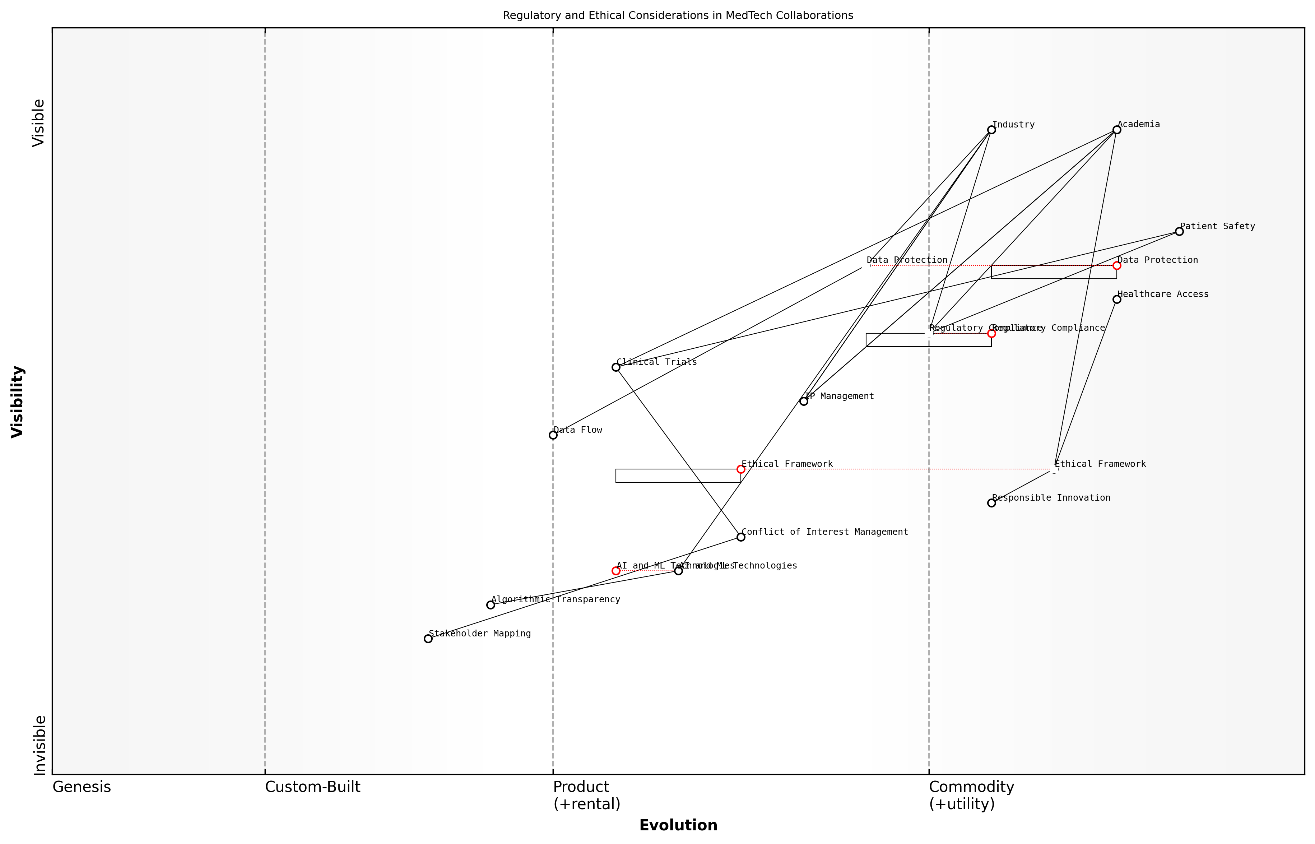

Draft Wardley Map: [Insert Wardley Map illustrating the position of regulatory and ethical considerations in the MedTech academic-industry collaboration landscape]

[Edit this draft Wardley Map](https://create.wardleymaps.ai/#3e6d939a505d591af5)

Let us delve into the key aspects of navigating regulatory and ethical considerations in academic-industry MedTech collaborations:

* Regulatory Compliance Mapping
* Ethical Framework Integration
* Data Protection and Privacy
* Intellectual Property Considerations
* Conflict of Interest Management

Regulatory Compliance Mapping: In the realm of MedTech, regulatory compliance is not a static entity but an evolving landscape. Utilising Wardley Mapping, we can plot the position of various regulatory requirements along the value chain, from basic research to market-ready products. This visual representation allows collaborators to identify which regulations are commodity-like (well-established and standardised) and which are still in the custom or product phases, requiring more attention and resources.

Mapping regulatory requirements allows us to anticipate future shifts and allocate resources more effectively. It’s not just about compliance; it’s about strategic positioning in a rapidly evolving regulatory environment.

Ethical Framework Integration: Ethical considerations in MedTech collaborations extend beyond mere compliance. They encompass issues of patient safety, equitable access to healthcare technologies, and responsible innovation. By mapping ethical considerations alongside technological and market evolution, we can identify potential ethical challenges early in the development process.

For instance, as AI and machine learning technologies move from the genesis stage towards more standardised applications in healthcare, ethical considerations such as algorithmic bias and transparency become increasingly critical. Wardley Mapping can help visualise this shift and prompt proactive ethical framework development.

Data Protection and Privacy: In the age of big data and interconnected health systems, data protection and privacy considerations are paramount. Mapping the data flow within academic-industry collaborations can reveal potential vulnerabilities and areas where enhanced protection measures are needed.

By visualising data flows and privacy considerations on a Wardley Map, we can identify where sensitive information intersects with various stakeholders and technologies, allowing for more targeted and effective data protection strategies.

Intellectual Property Considerations: The interface between academia and industry often involves complex intellectual property (IP) arrangements. Wardley Mapping can be employed to visualise the evolution of IP from basic research findings to patentable innovations and commercialised products. This approach helps in strategically managing IP rights and ensuring fair attribution and compensation for all parties involved.

Conflict of Interest Management: Academic-industry collaborations inherently carry the potential for conflicts of interest. By mapping the various stakeholders, their motivations, and potential areas of conflict, we can develop more robust conflict management strategies. This is particularly crucial in clinical trials and research involving human subjects, where the integrity of the research must be beyond reproach.

Practical Application: Consider a collaborative project developing a novel AI-powered diagnostic tool. A Wardley Map for this project might position regulatory approval processes, ethical AI guidelines, data protection protocols, IP agreements, and conflict of interest policies at various points along the value chain. This visual representation allows project leaders to:

* Identify which regulatory and ethical considerations are most critical at each stage of development
* Anticipate future shifts in the regulatory landscape and prepare accordingly
* Allocate resources more effectively to address emerging ethical challenges
* Develop a roadmap for navigating complex IP negotiations
* Implement proactive measures to manage potential conflicts of interest

In conclusion, navigating regulatory and ethical considerations in academic-industry MedTech collaborations requires a dynamic and strategic approach. Wardley Mapping provides a powerful tool for visualising these complex landscapes, enabling stakeholders to anticipate challenges, identify opportunities, and develop robust strategies for ethical and compliant innovation.

The true power of Wardley Mapping in this context lies not just in its ability to visualise current regulatory and ethical landscapes, but in its capacity to help us anticipate and shape future scenarios, ensuring that our MedTech innovations are not only groundbreaking but also responsible and sustainable.

## Facilitating Collaborative Innovation Projects

### Using Wardley Maps to define project scope and objectives

In the realm of academic-industry collaborations in MedTech, Wardley Mapping emerges as a powerful tool for defining project scope and objectives. This strategic approach not only enhances the clarity of collaborative endeavours but also aligns the diverse perspectives of stakeholders from both academia and industry. By leveraging Wardley Maps, project teams can visualise the entire value chain, identify key components, and strategically position their efforts within the broader MedTech landscape.

The application of Wardley Mapping in defining project scope and objectives can be broken down into several key areas:

* Visualising the MedTech value chain
* Identifying key components and dependencies
* Assessing component evolution and strategic positioning
* Aligning academic research with industry needs
* Defining clear project boundaries and deliverables

Let us explore each of these areas in detail to understand how Wardley Mapping can revolutionise the way we approach collaborative innovation projects in the MedTech sector.

Visualising the MedTech Value Chain:

The first step in using Wardley Maps to define project scope is to create a visual representation of the entire MedTech value chain relevant to the collaborative project. This involves mapping out all the components, from basic research and technology development to clinical applications and patient outcomes. By doing so, both academic and industry partners can gain a holistic view of where their project fits within the broader ecosystem.

A senior MedTech executive once remarked, ‘Wardley Mapping opened our eyes to the interconnectedness of our project with the wider healthcare system. It helped us identify opportunities we hadn’t previously considered and potential roadblocks we might have otherwise overlooked.’

Identifying Key Components and Dependencies:

Once the value chain is visualised, the next step is to identify the key components and their dependencies within the project scope. This process helps in understanding the critical path of the project and the relationships between different elements. For instance, in a collaborative project developing a new medical device, components might include sensor technology, data analytics algorithms, user interface design, and regulatory compliance. By mapping these components and their interdependencies, project teams can prioritise efforts and allocate resources more effectively.

Assessing Component Evolution and Strategic Positioning:

A unique feature of Wardley Mapping is its ability to represent the evolution of components along the value chain. In the context of MedTech projects, this is particularly valuable as it allows teams to anticipate technological advancements and market shifts. By positioning components on the evolution axis, from genesis to commodity, project leaders can make informed decisions about where to focus innovation efforts and where to leverage existing solutions.

As a leading academic researcher in MedTech innovation noted, ‘Understanding the evolutionary stage of each component in our project helped us focus our research efforts on areas where we could truly add value and differentiate ourselves in the market.’

Aligning Academic Research with Industry Needs:

One of the most significant challenges in academic-industry collaborations is aligning research objectives with commercial goals. Wardley Mapping facilitates this alignment by providing a common visual language that both parties can use to discuss project scope and objectives. By mapping out industry needs alongside academic research capabilities, project teams can identify areas of synergy and potential knowledge gaps that need to be addressed.

This alignment process often leads to more focused and impactful research outcomes. For example, an academic team might realise that their novel biosensor technology could be pivotal in addressing an unmet need in remote patient monitoring, as identified by their industry partner through the mapping process.

Defining Clear Project Boundaries and Deliverables:

With a comprehensive Wardley Map in place, project teams can more easily define clear boundaries and specific deliverables for their collaborative effort. The visual nature of the map allows for easy identification of what should be included within the project scope and what falls outside of it. This clarity is crucial for managing expectations and ensuring that both academic and industry partners are aligned on project goals and outcomes.

* Identify specific components to be developed or improved
* Set clear milestones based on the evolutionary stages of components
* Define success criteria that align with both academic and industry objectives
* Establish boundaries to prevent scope creep and maintain focus

By using Wardley Maps to define these elements, project teams can create a shared understanding of the project’s scope and objectives, reducing the risk of misalignment and enhancing the likelihood of successful collaboration.

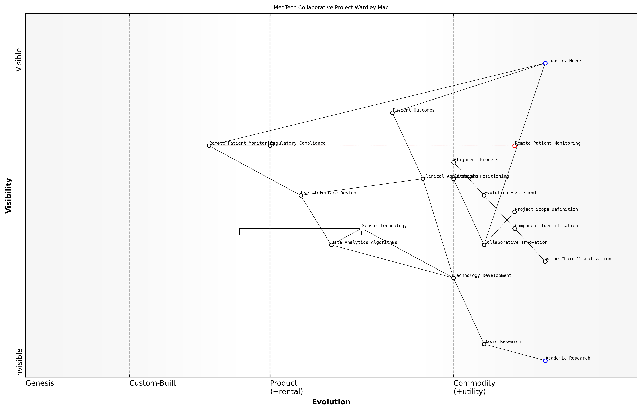

Draft Wardley Map: [Insert Wardley Map illustrating a typical MedTech collaborative project, highlighting key components, their evolution, and project boundaries]

[Edit this draft Wardley Map](https://create.wardleymaps.ai/#44f94ddefded7b77b0)

In conclusion, the application of Wardley Mapping in defining project scope and objectives for academic-industry collaborations in MedTech offers a structured and visual approach to strategic planning. By providing a common framework for discussion and decision-making, Wardley Maps enable more effective collaboration, better-aligned objectives, and clearer project boundaries. As the MedTech sector continues to evolve rapidly, this strategic tool will become increasingly valuable in navigating the complex landscape of innovation and ensuring that collaborative projects deliver meaningful outcomes for both academia and industry.

A prominent figure in healthcare innovation policy summarised it well: ‘Wardley Mapping has transformed how we approach collaborative projects in MedTech. It’s not just about defining scope; it’s about creating a shared vision and strategy that bridges the gap between academic research and real-world healthcare solutions.’

### Managing expectations and aligning goals

In the realm of academic-industry collaborations in MedTech, managing expectations and aligning goals is a critical component that can make or break the success of innovative projects. As we delve into this crucial aspect of facilitating collaborative innovation, it’s essential to recognise the unique challenges and opportunities that arise when academia and industry converge, particularly in the context of healthcare technology.

Wardley Mapping serves as an invaluable tool in this process, offering a visual and strategic framework to navigate the complex landscape of expectations and goals. By leveraging Wardley Maps, project leaders can create a shared understanding of the project’s trajectory, identify potential misalignments early, and foster a collaborative environment that maximises the strengths of both academic and industry partners.

Effective collaboration between academia and industry in MedTech is not just about combining resources; it’s about aligning visions and creating a shared language for innovation. Wardley Mapping provides that common ground, enabling us to visualise our collective journey and navigate the path to success together.

Let’s explore the key aspects of managing expectations and aligning goals in MedTech collaborations, underpinned by the strategic insights offered by Wardley Mapping.

1. Establishing a Shared Vision

The first step in managing expectations and aligning goals is to establish a shared vision for the collaborative project. This involves bringing together stakeholders from both academia and industry to co-create a Wardley Map that represents the project’s landscape, objectives, and anticipated evolution.

* Conduct a joint mapping session to visualise the project’s components and their interdependencies
* Identify areas of convergence and divergence in expectations between academic and industry partners
* Use the map to highlight the unique value propositions of each partner and how they complement each other

1. Defining Clear Roles and Responsibilities

With a shared vision in place, it’s crucial to define clear roles and responsibilities for all parties involved. Wardley Mapping can assist in this process by visualising the value chain and identifying where each partner’s expertise is most valuable.

* Map out the project’s value chain, from basic research to commercialisation
* Assign responsibilities based on each partner’s position in the value chain
* Use the map to identify potential gaps or overlaps in roles and address them proactively

1. Aligning Timelines and Milestones

Academic and industry partners often operate on different timelines and have distinct priorities. Wardley Mapping can help in aligning these disparate timelines by providing a visual representation of the project’s evolution over time.

* Use the evolution axis of the Wardley Map to plot key milestones and deliverables
* Identify potential conflicts in timing and resource allocation
* Develop a shared timeline that accommodates both academic research cycles and industry development sprints

1. Managing Intellectual Property Expectations

Intellectual property (IP) considerations are often a significant source of tension in academic-industry collaborations. Wardley Mapping can facilitate transparent discussions about IP by visualising the flow of knowledge and innovation throughout the project.

* Map out the key areas of IP generation within the project
* Use the map to discuss and agree upon IP ownership and licensing arrangements
* Identify potential areas of conflict and develop strategies to address them

1. Addressing Cultural Differences

Academic and industry cultures can differ significantly, potentially leading to misunderstandings and conflicts. Wardley Mapping provides a neutral ground for discussing these differences and finding common ground.

* Use the map to visualise different approaches to innovation and decision-making
* Identify areas where cultural differences may impact project outcomes
* Develop strategies to bridge cultural gaps and foster mutual understanding

1. Continuous Alignment and Adaptation

As the project progresses, it’s essential to maintain alignment and adapt to changing circumstances. Regular review and updating of the Wardley Map can facilitate this ongoing process.

* Schedule regular mapping sessions to review progress and reassess goals
* Use the map to identify emerging opportunities or challenges
* Adjust roles, responsibilities, and timelines as needed based on the evolving landscape

In my experience, the most successful MedTech collaborations are those that embrace the dynamic nature of innovation. By using Wardley Mapping as a living document, we create a flexible framework that allows us to navigate uncertainties and capitalise on unexpected opportunities as they arise.

1. Measuring and Communicating Success

Finally, it’s crucial to establish clear metrics for success and communicate progress effectively to all stakeholders. Wardley Mapping can aid in this process by providing a visual representation of the project’s journey and achievements.

* Use the map to define key performance indicators (KPIs) that align with both academic and industry goals
* Visualise progress along the evolution axis to demonstrate advancement
* Leverage the map in stakeholder communications to provide context and highlight achievements

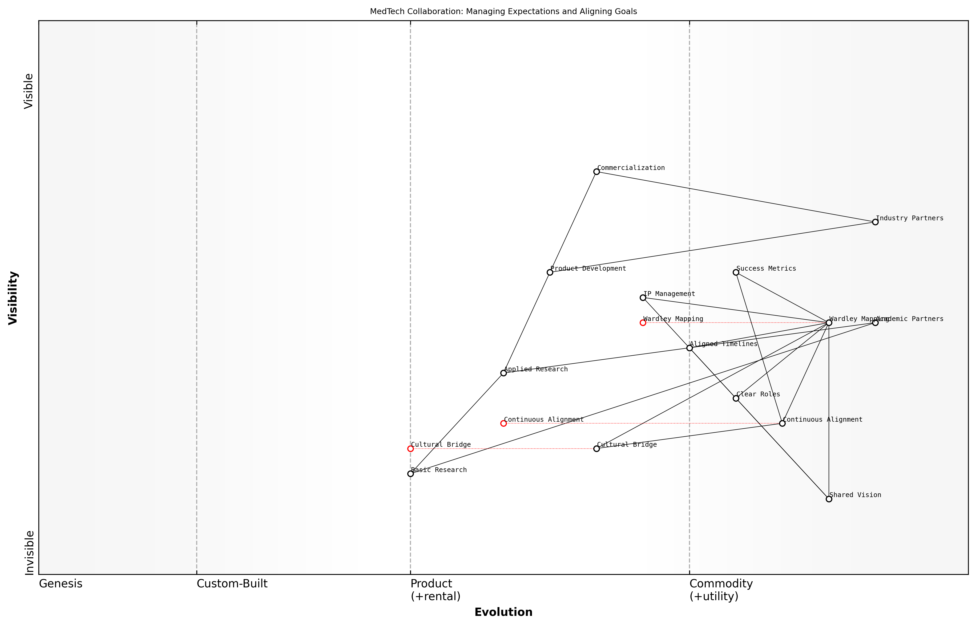

Draft Wardley Map: [Insert Wardley Map illustrating the key components of managing expectations and aligning goals in a MedTech collaboration project]

[Edit this draft Wardley Map](https://create.wardleymaps.ai/#2008bc3d1fd6df2d9f)

In conclusion, managing expectations and aligning goals in academic-industry collaborations for MedTech innovation is a complex but essential process. By leveraging Wardley Mapping as a strategic tool, project leaders can create a shared vision, navigate challenges, and foster an environment of mutual understanding and success. As the MedTech landscape continues to evolve, the ability to effectively manage these collaborations will become increasingly crucial in driving innovation and improving healthcare outcomes.

### Tracking progress and adapting to changes

In the dynamic landscape of MedTech innovation, tracking progress and adapting to changes are crucial elements of successful academic-industry collaborations. Wardley Mapping provides a powerful framework for visualising and managing these aspects, enabling project stakeholders to maintain alignment, identify emerging opportunities, and navigate unforeseen challenges.

The application of Wardley Mapping in tracking progress and adapting to changes within collaborative MedTech projects can be broken down into several key areas:

* Establishing baseline maps and milestones
* Continuous monitoring and map updates
* Identifying and responding to environmental shifts
* Facilitating agile decision-making
* Communicating progress and changes to stakeholders

Let’s explore each of these areas in detail, drawing upon best practices and real-world experiences in academic-industry collaborations within the MedTech sector.

Establishing Baseline Maps and Milestones:

At the outset of a collaborative project, it is essential to create a baseline Wardley Map that represents the current state of the MedTech landscape relevant to the project’s focus. This map serves as a reference point for tracking progress and identifying changes over time. Alongside the map, project teams should define clear milestones that align with the map’s components and evolution stages.

A seasoned MedTech project manager emphasises, ‘The initial Wardley Map acts as a shared visual language for all stakeholders. It allows us to agree on where we are starting from and where we aim to go, making it easier to track our journey and adapt our course as needed.’

Continuous Monitoring and Map Updates:

As the project progresses, it is crucial to regularly update the Wardley Map to reflect new developments, completed milestones, and emerging challenges. This process should involve input from both academic and industry partners to ensure a comprehensive view of the project’s evolution. Utilising digital mapping tools can facilitate real-time updates and version control, enabling all stakeholders to access the most current project landscape.

Identifying and Responding to Environmental Shifts:

The MedTech sector is subject to rapid technological advancements, regulatory changes, and shifts in market demands. Wardley Mapping helps project teams visualise these environmental changes and assess their potential impact on the collaboration. By regularly reviewing the map against external developments, teams can identify new opportunities or threats and adjust their strategies accordingly.

A leading academic researcher in MedTech innovation notes, ‘Wardley Mapping has been invaluable in helping us anticipate and respond to regulatory changes. By mapping out the potential impacts on our project, we’ve been able to proactively adapt our research focus and timelines.’

Facilitating Agile Decision-Making:

The visual nature of Wardley Maps supports agile decision-making processes within academic-industry collaborations. When unexpected challenges or opportunities arise, stakeholders can quickly assess the situation within the context of the overall project landscape. This enables rapid, informed decisions on resource allocation, priority shifts, or strategic pivots.

* Use the map to identify dependencies and potential ripple effects of changes
* Conduct ‘what-if’ scenarios to evaluate different courses of action
* Leverage the map to build consensus among diverse stakeholders on adaptive measures

Communicating Progress and Changes to Stakeholders:

Effective communication is paramount in maintaining alignment and trust within academic-industry collaborations. Wardley Maps serve as powerful tools for visualising and communicating project progress, changes, and adaptations to all stakeholders. Regular map-based progress reports can help maintain transparency and ensure that all parties have a shared understanding of the project’s evolution.

An industry partner in a successful MedTech collaboration shares, ‘Using Wardley Maps in our progress meetings has transformed our communication. It’s much easier to explain complex changes and their implications when we can visually represent them on the map.’

Implementing these practices in tracking progress and adapting to changes requires a commitment to ongoing learning and refinement of mapping skills. As project teams become more adept at using Wardley Mapping, they can develop more sophisticated approaches to managing the dynamic nature of MedTech collaborations.

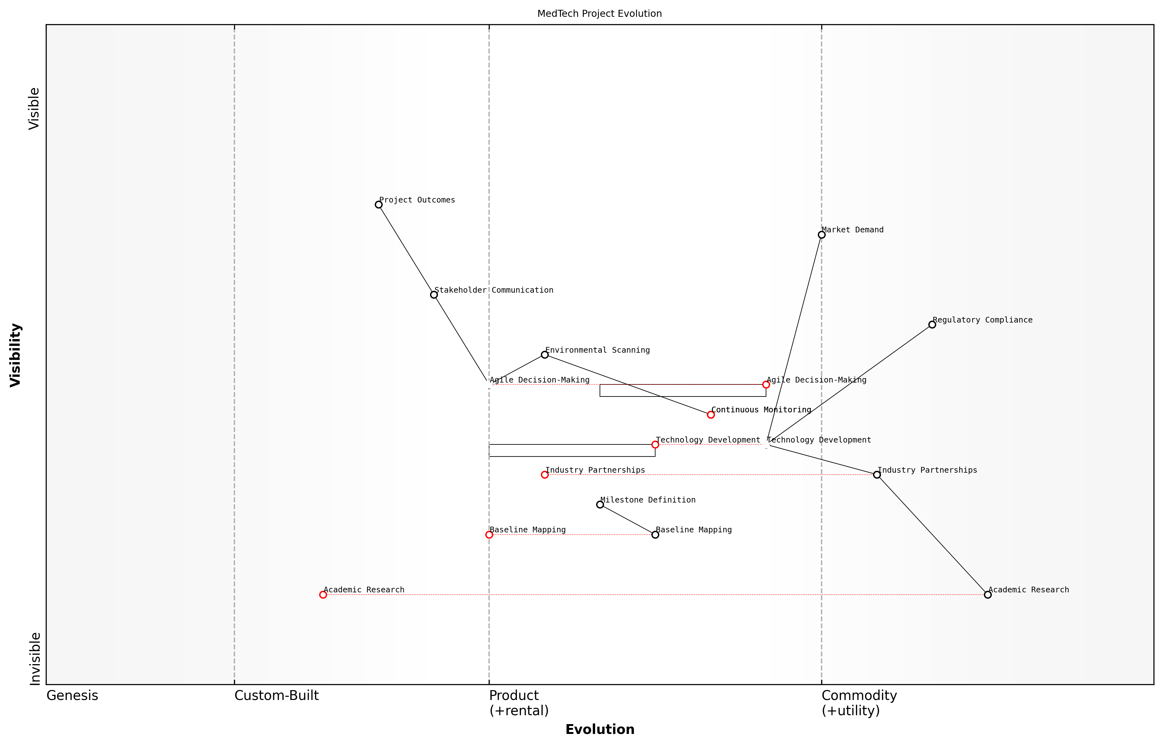

Draft Wardley Map: [Insert Wardley Map illustrating the evolution of a MedTech project over time, highlighting key milestones, adaptations, and environmental shifts]

[Edit this draft Wardley Map](https://create.wardleymaps.ai/#13997f406f36556673)

In conclusion, the effective use of Wardley Mapping for tracking progress and adapting to changes in academic-industry MedTech collaborations can significantly enhance project outcomes. By providing a shared visual framework for understanding the project landscape, facilitating agile decision-making, and supporting clear communication, Wardley Mapping enables collaborators to navigate the complex and rapidly evolving MedTech sector with greater confidence and success.

## Case Studies: Successful Academic-Industry Partnerships

### Developing a novel medical device through strategic collaboration

In the rapidly evolving landscape of medical technology, the development of novel medical devices often requires a synergistic collaboration between academia and industry. This case study exemplifies how Wardley Mapping can be leveraged to foster successful partnerships and drive innovation in the MedTech sector, particularly within the context of higher education and research institutions.

The project in focus involved the development of a cutting-edge wearable device for continuous glucose monitoring, combining the research expertise of a leading university’s biomedical engineering department with the manufacturing and commercialisation capabilities of a prominent MedTech company. By employing Wardley Mapping throughout the collaboration, both parties were able to align their strategies, identify key value chains, and navigate the complex landscape of medical device development.

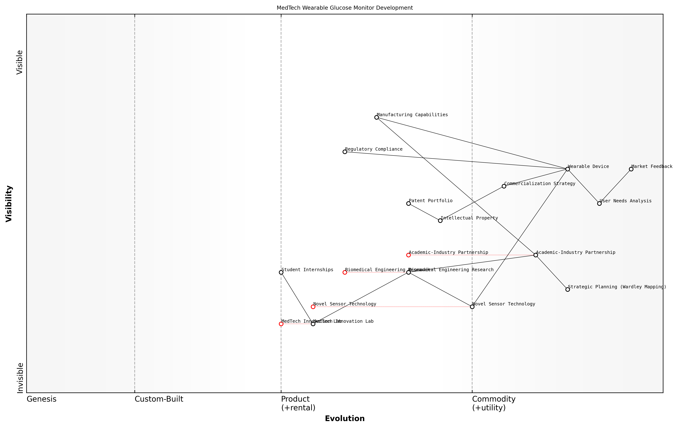

Draft Wardley Map: [Insert Wardley Map illustrating the value chain of the wearable glucose monitoring device development]

[Edit this draft Wardley Map](https://create.wardleymaps.ai/#d77592646338db376e)

The collaboration began with a joint mapping exercise, bringing together academic researchers, industry experts, and healthcare professionals. This initial step was crucial in establishing a shared understanding of the project’s scope and identifying potential challenges and opportunities.

* Mapping the current state of glucose monitoring technology
* Identifying key components and their evolutionary stages
* Analysing user needs and market demands
* Assessing regulatory requirements and potential hurdles
* Evaluating existing intellectual property and potential for new patents

By visualising these elements on a Wardley Map, the team was able to identify areas where the university’s research strengths could be leveraged to address specific gaps in the technology landscape. Simultaneously, the industry partner’s expertise in scaling production and navigating regulatory pathways was clearly positioned within the value chain.

The Wardley Mapping process was instrumental in aligning our research objectives with real-world market needs. It provided a common language for discussing strategy across academic and industry boundaries, enabling us to focus our efforts on truly innovative aspects of the device.

One of the key insights derived from the mapping exercise was the identification of a novel sensor technology being developed in the university’s labs that could significantly improve the accuracy and longevity of continuous glucose monitoring. This component was positioned as a potential game-changer in the map, prompting the industry partner to allocate additional resources to support its rapid development and integration into the device prototype.

Throughout the development process, the Wardley Map was regularly updated to reflect progress and shifts in the technological and regulatory landscape. This dynamic approach allowed for agile decision-making and resource allocation, ensuring that both academic and industry partners remained aligned in their objectives and efforts.

* Quarterly mapping reviews to assess progress and realign strategies
* Identification of emerging competitors and technological advancements
* Adaptation to evolving regulatory requirements
* Refinement of the commercialisation strategy based on market feedback

The collaborative nature of the project, underpinned by the shared understanding provided by Wardley Mapping, led to several positive outcomes:

* Accelerated development timeline, bringing the device to market 18 months ahead of initial projections
* Five new patents filed, strengthening both the university’s intellectual property portfolio and the industry partner’s market position
* Establishment of a long-term research partnership, including funding for a dedicated MedTech innovation lab at the university
* Creation of internship and employment pathways for students, enhancing the university’s industry engagement metrics

The success of this collaboration has significant implications for teaching and research in higher education, particularly in the context of MedTech applications. It demonstrates the value of integrating strategic tools like Wardley Mapping into both the curriculum and research methodologies of biomedical engineering and related disciplines.

This project has fundamentally changed how we approach industry collaborations. Wardley Mapping is now a core component of our postgraduate MedTech innovation programme, equipping our students with the strategic thinking skills needed to bridge the gap between academic research and commercial success.

In conclusion, this case study illustrates the power of Wardley Mapping in fostering successful academic-industry partnerships in the MedTech sector. By providing a shared visual language for strategy and innovation, Wardley Mapping enables more effective collaboration, accelerates development timelines, and enhances the real-world impact of academic research. As the MedTech landscape continues to evolve, the integration of such strategic tools into higher education curricula and research methodologies will be crucial in preparing the next generation of innovators and leaders in the field.

### Improving healthcare delivery systems through joint research

In the rapidly evolving landscape of healthcare technology, the collaboration between academia and industry has become increasingly crucial for improving healthcare delivery systems. This case study explores a successful partnership that leveraged Wardley Mapping to drive innovation and enhance patient care through joint research efforts.

The collaboration in focus involved a leading university’s biomedical engineering department and a prominent healthcare technology company. Their joint research aimed to develop and implement an AI-driven patient flow optimisation system for hospitals, addressing the critical challenge of emergency department overcrowding and prolonged wait times.

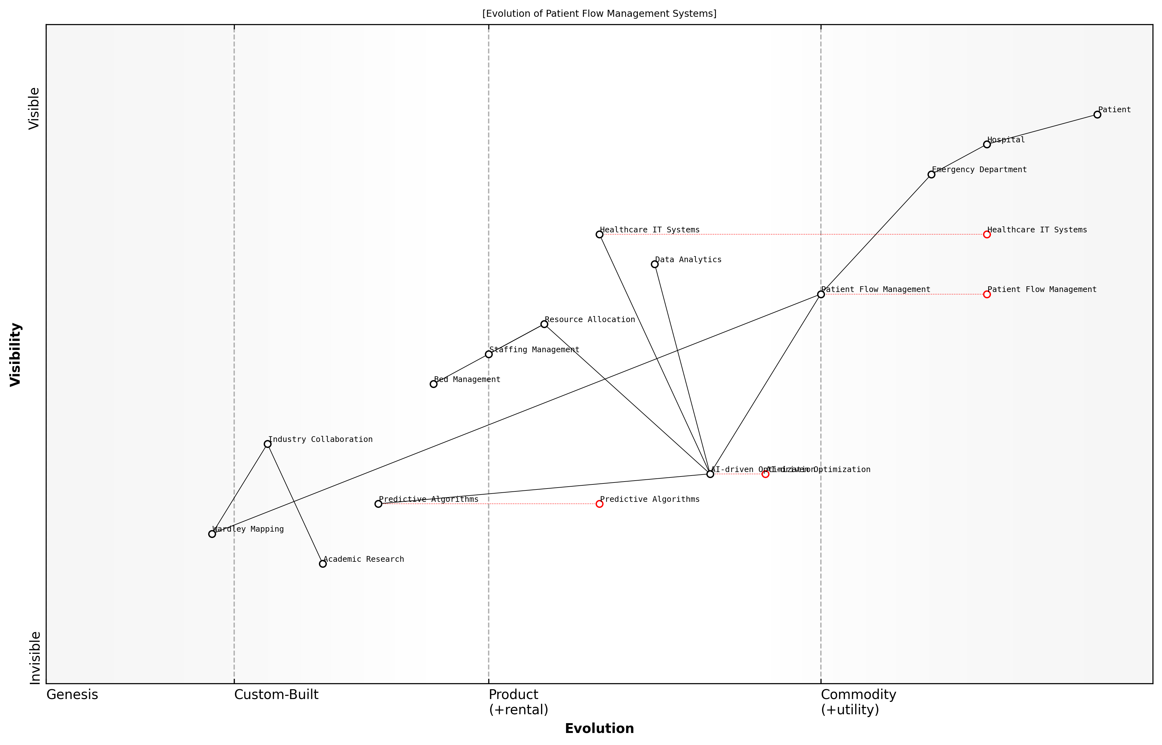

Draft Wardley Map: [Insert Wardley Map: Evolution of Patient Flow Management Systems]

[Edit this draft Wardley Map](https://create.wardleymaps.ai/#daff197d69d3e84fba)

The research team utilised Wardley Mapping to analyse the current state of patient flow management and identify opportunities for improvement. This strategic approach allowed them to visualise the entire healthcare delivery ecosystem, from patient admission to discharge, and pinpoint areas where AI and data analytics could make the most significant impact.

* Mapping the patient journey and identifying bottlenecks
* Analysing the evolution of healthcare IT systems and their integration points
* Identifying emerging technologies that could be leveraged for process optimisation
* Assessing the skills and capabilities required for successful implementation

By employing Wardley Mapping, the team was able to develop a comprehensive understanding of the complex interplay between various components of the healthcare delivery system. This strategic insight guided their research focus and helped align academic pursuits with real-world industry needs.

Wardley Mapping provided us with a shared language and visual framework to bridge the gap between academic theory and practical implementation. It allowed us to identify strategic opportunities that we might have otherwise overlooked.

The joint research team developed an AI algorithm that could predict patient influx patterns, optimise resource allocation, and suggest real-time adjustments to staffing and bed management. The system was designed to integrate seamlessly with existing hospital information systems, addressing a key challenge identified through the Wardley Mapping process.

To validate the effectiveness of their solution, the team conducted a pilot study in three hospitals of varying sizes and demographics. The results were impressive:

* 25% reduction in average emergency department wait times
* 15% improvement in bed utilisation rates
* 30% decrease in patient complaints related to long waiting periods
* 20% increase in staff satisfaction due to more efficient workflows

The success of this collaboration can be attributed to several factors, all of which were influenced by the strategic use of Wardley Mapping:

* Clear alignment of research objectives with industry needs
* Holistic understanding of the healthcare delivery ecosystem
* Identification of key integration points and potential barriers
* Anticipation of future trends and technological shifts
* Effective communication and shared vision between academic and industry partners

The use of Wardley Mapping not only guided the research process but also facilitated effective communication between academic researchers and industry professionals. It provided a common framework for discussing complex systems and strategies, enabling more productive collaborations.

The visual nature of Wardley Maps allowed us to quickly align our understanding of the problem space and potential solutions. It was instrumental in fostering a truly collaborative environment between our academic team and industry partners.

This case study demonstrates the power of integrating Wardley Mapping into academic-industry partnerships for MedTech innovation. By providing a strategic framework for analysing complex systems and anticipating future developments, Wardley Mapping enables researchers and industry professionals to collaboratively tackle significant challenges in healthcare delivery.

The success of this project has led to further collaborations between the university and healthcare technology companies, with Wardley Mapping becoming a standard tool for strategic planning and research direction setting. It has also influenced the curriculum of the university’s biomedical engineering programme, with students now learning to apply Wardley Mapping techniques to healthcare challenges as part of their coursework.

As we continue to face complex challenges in healthcare delivery, the strategic insights provided by Wardley Mapping will undoubtedly play an increasingly important role in guiding research efforts and fostering productive academic-industry collaborations. This case study serves as a compelling example of how this approach can lead to tangible improvements in patient care and healthcare system efficiency.

### Commercialising academic research in digital health

The commercialisation of academic research in digital health represents a critical juncture where the innovative potential of higher education institutions meets the practical needs of the healthcare industry. This subsection explores a compelling case study that exemplifies the successful translation of academic research into commercial digital health solutions, leveraging Wardley Mapping as a strategic tool throughout the process.

Our case study focuses on the development and commercialisation of a novel artificial intelligence-driven platform for early detection of cognitive decline, a project that emerged from a collaboration between a leading university’s neuroscience department and a prominent healthcare technology company.

The journey from academic research to commercial product can be broadly divided into four key stages, each of which benefited significantly from the application of Wardley Mapping:

* Initial Research and Concept Development
* Partnership Formation and Strategy Alignment
* Product Development and Clinical Validation
* Market Entry and Scaling

1. Initial Research and Concept Development:

The project began with groundbreaking research conducted by a team of neuroscientists and data scientists at the university. They developed an AI algorithm capable of detecting subtle cognitive changes indicative of early-stage dementia through analysis of speech patterns and facial micro-expressions.

At this stage, the research team employed Wardley Mapping to visualise the landscape of existing cognitive assessment tools and identify potential areas for innovation. This mapping exercise revealed a significant gap in the market for non-invasive, easily administrable cognitive screening tools that could be deployed at scale.

Wardley Mapping allowed us to see beyond the confines of our academic research and understand where our innovation could truly make an impact in the healthcare ecosystem.

1. Partnership Formation and Strategy Alignment:

Recognising the commercial potential of their research, the university’s technology transfer office initiated discussions with several healthcare technology companies. A partnership was ultimately formed with a company that had complementary expertise in developing user-friendly digital health platforms.

During the partnership negotiations, both parties collaboratively created a Wardley Map to align their strategic visions. This exercise helped identify key areas of synergy and potential challenges in the commercialisation process. It also facilitated discussions around intellectual property rights, resource allocation, and long-term product evolution.

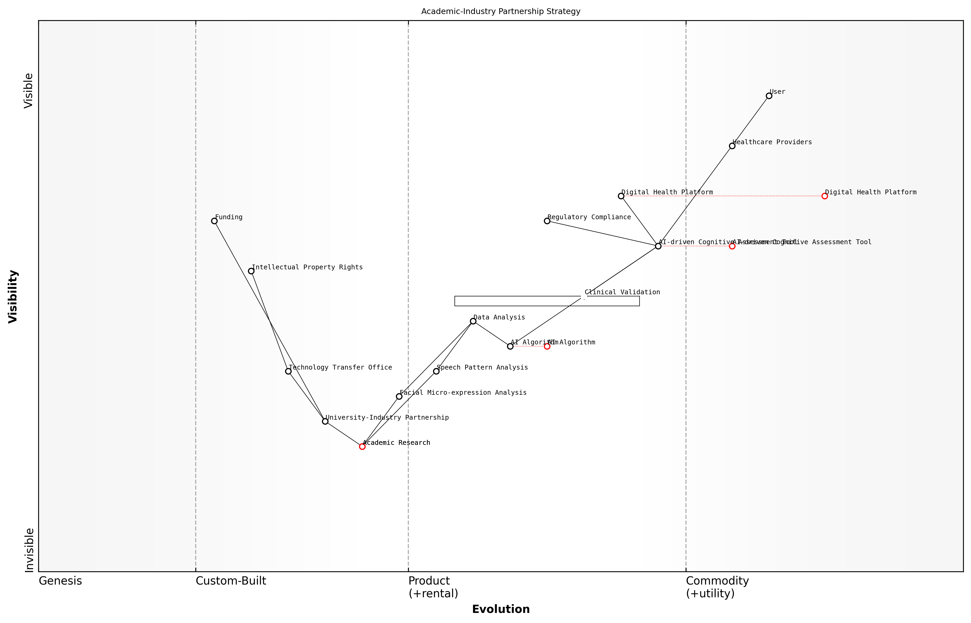

Draft Wardley Map: [Insert Wardley Map: Academic-Industry Partnership Strategy]

[Edit this draft Wardley Map](https://create.wardleymaps.ai/#abd00663fe5ad07239)

1. Product Development and Clinical Validation:

The product development phase involved translating the academic research into a user-friendly digital application. Wardley Mapping was instrumental in this stage, helping the team to:

* Identify and prioritise key features based on their position in the value chain
* Anticipate technological shifts that could impact the product’s long-term viability
* Plan for scalability and integration with existing healthcare IT systems
* Navigate the regulatory landscape for medical devices and AI in healthcare

Concurrently, the team conducted clinical validation studies to demonstrate the efficacy and reliability of the AI-driven cognitive assessment tool. The Wardley Map was regularly updated to reflect new insights gained from these studies and to guide decision-making around further product refinements.

1. Market Entry and Scaling:

As the product neared market readiness, the team used Wardley Mapping to develop a comprehensive go-to-market strategy. This included mapping out potential early adopters, identifying key opinion leaders in the field of cognitive health, and planning for integration with existing healthcare workflows.

The map also helped in anticipating and preparing for potential barriers to adoption, such as reimbursement challenges and the need for healthcare provider education. By visualising these factors, the team was able to develop targeted strategies to address each challenge proactively.

The Wardley Map became our shared language for strategic discussions. It allowed us to quickly identify and address potential roadblocks, ensuring a smoother path to market for our innovation.

Outcomes and Lessons Learned:

The AI-driven cognitive assessment tool was successfully launched and has since been adopted by numerous healthcare providers across the country. Its impact on early detection and intervention in cognitive decline has been significant, demonstrating the immense value that can be created when academic research is effectively commercialised.

Key lessons from this case study include:

* The importance of early and continuous strategic mapping throughout the commercialisation process
* The value of collaborative mapping exercises in aligning academic and industry partners
* The role of Wardley Mapping in anticipating and navigating regulatory and market challenges
* The need for flexibility and regular map updates as new information and insights emerge

This case study exemplifies how Wardley Mapping can serve as a powerful tool in bridging the gap between academic research and commercial success in the digital health sector. By providing a shared visual language and strategic framework, Wardley Mapping facilitates more effective collaboration between academia and industry, ultimately accelerating the translation of innovative research into impactful healthcare solutions.

# Ethical Considerations and Future Trends in MedTech Innovation

## Ethical Implications of Emerging MedTech

### Privacy and data security in connected healthcare

In the rapidly evolving landscape of MedTech, privacy and data security in connected healthcare have emerged as critical ethical considerations. As we integrate Wardley Mapping into our teaching and research methodologies for MedTech applications, it is imperative to address these concerns comprehensively. This section explores the multifaceted challenges and strategic approaches to ensuring privacy and data security in connected healthcare systems, leveraging Wardley Mapping to provide a structured analysis of the evolving technological and ethical landscape.

Connected healthcare, characterised by the integration of Internet of Things (IoT) devices, wearable technologies, and cloud-based health information systems, offers unprecedented opportunities for improving patient care, research outcomes, and healthcare efficiency. However, it also introduces complex privacy and security risks that must be carefully navigated. By applying Wardley Mapping to this domain, we can better understand the evolution of privacy and security components within the connected healthcare ecosystem, identify potential vulnerabilities, and develop strategic approaches to mitigate risks.

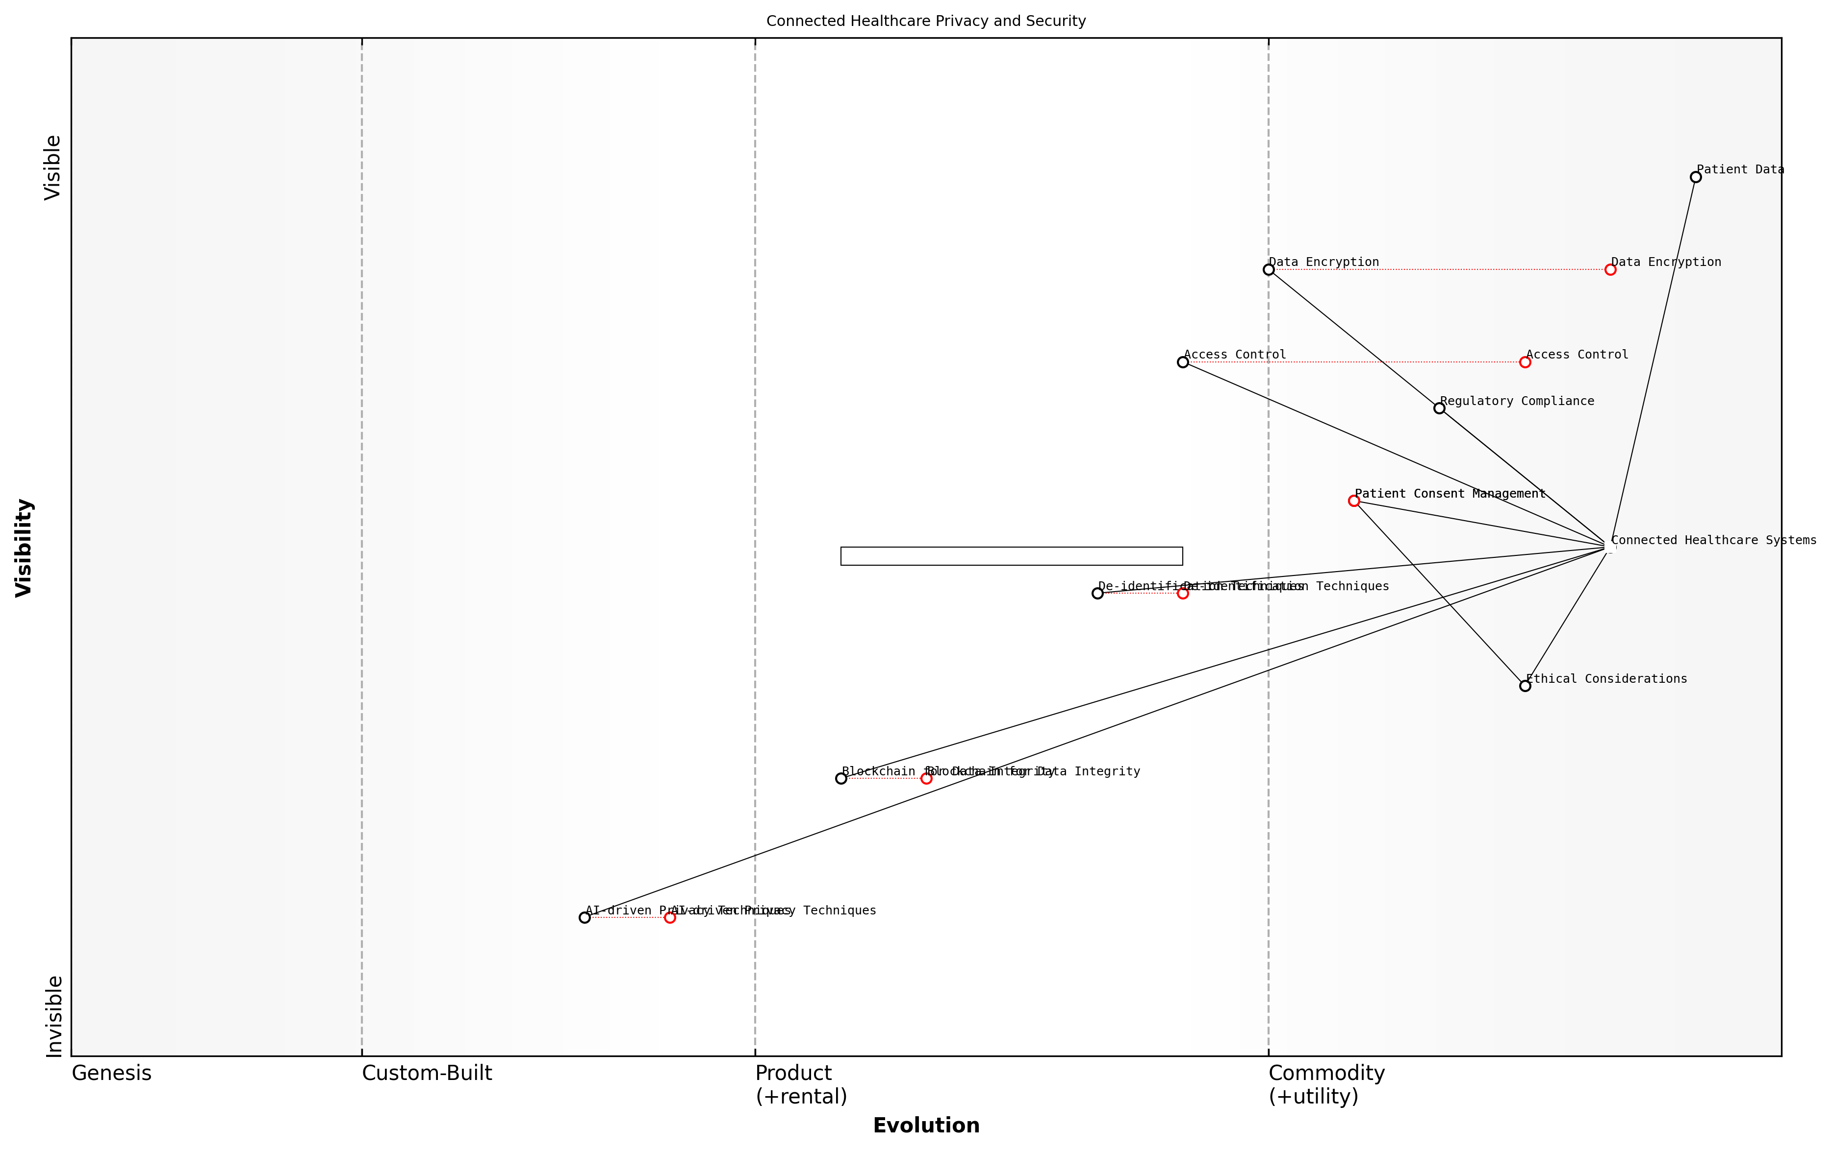

Draft Wardley Map: [Insert Wardley Map: Evolution of Privacy and Security Components in Connected Healthcare]

[Edit this draft Wardley Map](https://create.wardleymaps.ai/#904ce6ca0e8f74f2ba)

The Wardley Map above illustrates the key components of privacy and security in connected healthcare, ranging from basic data encryption (commodity) to advanced AI-driven threat detection systems (genesis). By mapping these components, we can identify areas of strategic importance and potential innovation, guiding both our teaching curricula and research focus in MedTech education.

* Data Encryption and Transmission Security
* Access Control and Authentication Mechanisms
* Regulatory Compliance (e.g., GDPR, HIPAA)
* Patient Consent Management
* De-identification and Anonymisation Techniques
* Blockchain for Health Data Integrity
* AI-driven Privacy Preserving Techniques

Each of these components represents a critical area for both teaching and research in MedTech education. By incorporating Wardley Mapping into our curriculum, we can help students understand the strategic importance of these elements and their evolution over time. This approach not only enhances their technical knowledge but also develops their ability to think strategically about privacy and security in the context of MedTech innovation.

Wardley Mapping has revolutionised our approach to teaching privacy and security in connected healthcare. It allows students to visualise the complex interplay between technological advancements, regulatory requirements, and ethical considerations, fostering a more holistic understanding of the challenges and opportunities in this field.

In our research endeavours, Wardley Mapping provides a powerful tool for identifying emerging trends and potential areas of vulnerability in connected healthcare systems. By mapping the evolution of privacy and security components, researchers can anticipate future challenges and focus their efforts on developing innovative solutions that address the most critical needs of the healthcare industry.

One of the key ethical challenges in connected healthcare is balancing the need for data accessibility with the imperative of patient privacy. Wardley Mapping can help us navigate this complex landscape by illustrating the relationships between various stakeholders, technologies, and ethical considerations. For instance, we can map the evolution of patient consent mechanisms from basic opt-in/opt-out systems to more nuanced, granular consent models that give patients greater control over their data.

The application of Wardley Mapping to privacy and security in connected healthcare has enabled us to identify critical gaps in current practices and develop targeted research initiatives. It has been instrumental in securing funding for projects that address the most pressing challenges in this domain.

As educators and researchers in the field of MedTech, it is our responsibility to ensure that future healthcare professionals are equipped with the knowledge and skills to navigate the complex ethical landscape of connected healthcare. By integrating Wardley Mapping into our teaching and research methodologies, we can foster a more strategic and holistic approach to addressing privacy and security challenges.

* Develop case studies that use Wardley Mapping to analyse real-world privacy breaches in connected healthcare
* Create hands-on workshops where students apply Wardley Mapping to design privacy-preserving connected healthcare systems
* Collaborate with industry partners to map the evolving regulatory landscape and its impact on MedTech innovation
* Conduct research on the effectiveness of various privacy-enhancing technologies using Wardley Mapping as an analytical framework

In conclusion, privacy and data security in connected healthcare represent a critical ethical frontier in MedTech innovation. By leveraging Wardley Mapping in our teaching and research practices, we can equip the next generation of MedTech professionals with the strategic thinking skills necessary to navigate this complex landscape. As the field continues to evolve, our ability to map and anticipate changes in privacy and security components will be crucial in developing ethical, secure, and innovative connected healthcare solutions.

### Equity and access in technology-driven healthcare

As we delve into the ethical implications of emerging MedTech, it is crucial to address the pressing issue of equity and access in technology-driven healthcare. This topic is of paramount importance within the context of Teaching and Research in Higher Education Using Wardley Mapping with a Focus on MedTech Applications, as it intersects with fundamental principles of healthcare provision, technological innovation, and social responsibility. The rapid advancement of medical technologies presents both unprecedented opportunities and significant challenges in ensuring equitable access to healthcare services across diverse populations.

To effectively analyse and address these challenges, we can leverage Wardley Mapping as a strategic tool to visualise the complex landscape of healthcare technology adoption and its impact on equity. By mapping the value chain of MedTech innovations and their dependencies, we can identify potential barriers to access and develop targeted strategies to overcome them.

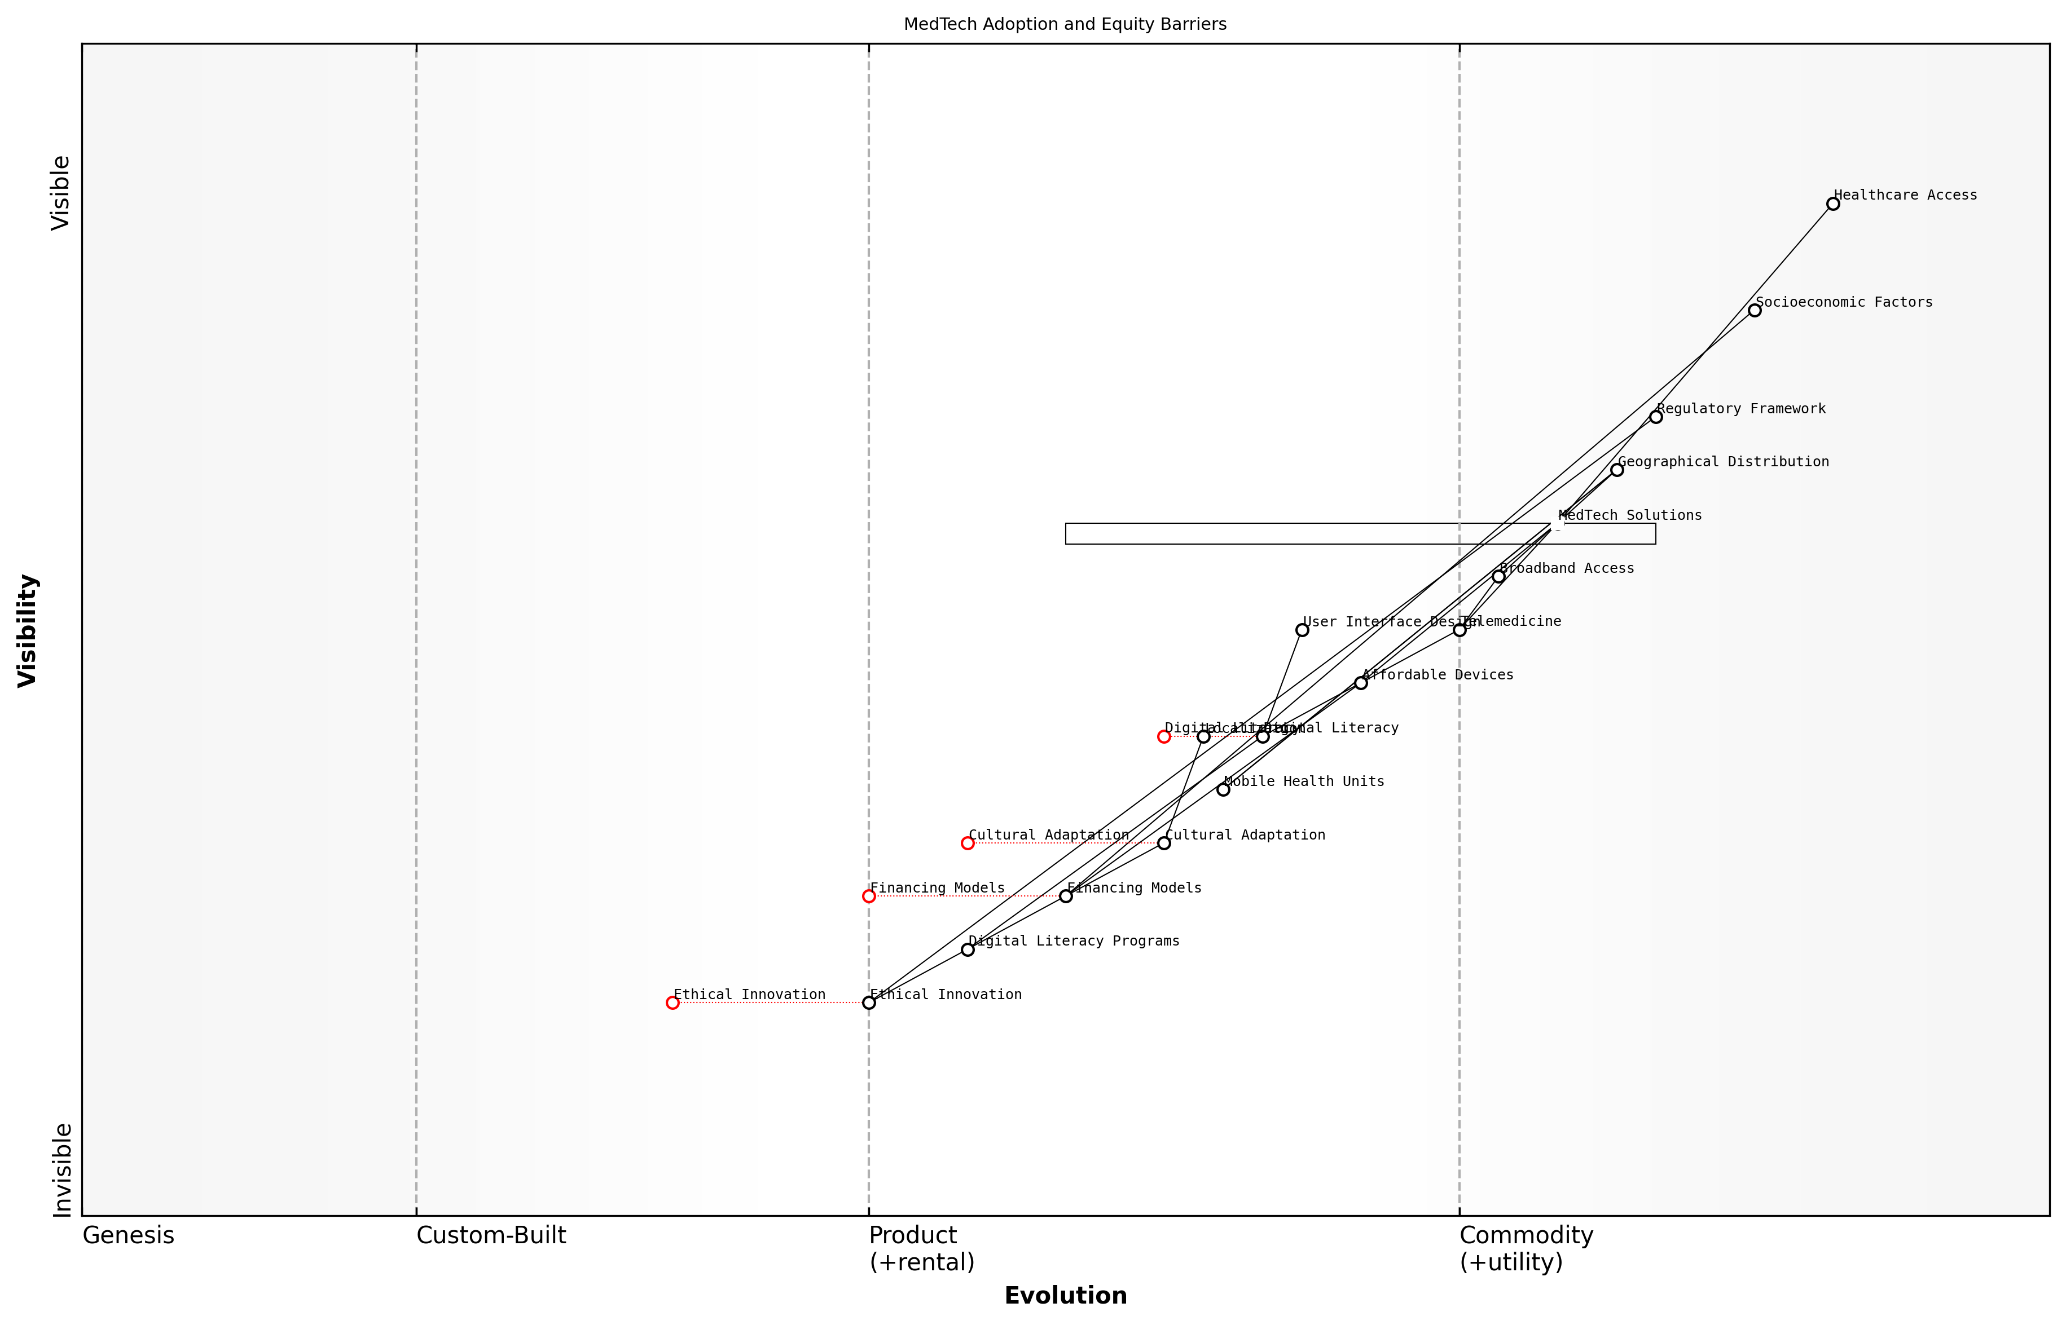

Draft Wardley Map: [Insert Wardley Map illustrating the value chain of MedTech adoption and potential equity barriers]

[Edit this draft Wardley Map](https://create.wardleymaps.ai/#3bf0fdc5aa1125c04f)

Let us explore the key aspects of equity and access in technology-driven healthcare through the lens of Wardley Mapping:

* Geographical disparities in MedTech distribution
* Socioeconomic factors influencing access to advanced healthcare technologies
* Digital literacy and its impact on healthcare technology utilisation
* Cultural and linguistic barriers in MedTech adoption
* Regulatory frameworks and their role in promoting equitable access

Geographical disparities in MedTech distribution pose a significant challenge to equitable healthcare access. By mapping the current distribution of advanced medical technologies across different regions, we can identify areas of concentration and scarcity. This visual representation enables policymakers and healthcare providers to develop targeted strategies for expanding MedTech infrastructure in underserved areas.

Socioeconomic factors play a crucial role in determining access to advanced healthcare technologies. Wardley Mapping can help us visualise the relationship between various socioeconomic indicators and MedTech adoption rates. By identifying the key dependencies and barriers, we can design interventions that address the root causes of inequitable access, such as developing affordable versions of critical medical devices or implementing innovative financing models.

The true measure of a healthcare system’s success lies not in the sophistication of its technologies, but in its ability to make those technologies accessible to all members of society, regardless of their socioeconomic status.

Digital literacy emerges as a critical factor in the effective utilisation of healthcare technologies. As we map the user journey in interacting with MedTech solutions, we can identify potential points of friction for individuals with varying levels of digital proficiency. This analysis can inform the development of more intuitive user interfaces and targeted digital literacy programmes to ensure that technological advancements do not exacerbate existing health disparities.

Cultural and linguistic barriers often impede the adoption of MedTech solutions in diverse communities. By mapping the cultural landscape alongside technological evolution, we can identify areas where localisation and cultural adaptation of MedTech solutions are necessary. This approach can lead to the development of more inclusive and culturally sensitive healthcare technologies that resonate with diverse user groups.

Regulatory frameworks play a pivotal role in shaping the landscape of MedTech adoption and access. Through Wardley Mapping, we can visualise the impact of different regulatory approaches on the equity of healthcare technology distribution. This analysis can inform policy recommendations that balance innovation with equitable access, potentially leading to adaptive regulatory frameworks that incentivise the development and deployment of MedTech solutions in underserved areas.

As educators and researchers in higher education, it is our responsibility to instil a deep understanding of these equity considerations in the next generation of MedTech innovators. By incorporating Wardley Mapping exercises that focus on equity and access into our curricula, we can cultivate a mindset that prioritises inclusive innovation from the outset of the design process.

Education is the most powerful tool we have to address healthcare inequities. By teaching our students to map and analyse the complex factors influencing MedTech access, we empower them to become architects of a more equitable healthcare future.

In practice, this could involve collaborative projects where students use Wardley Mapping to analyse real-world healthcare equity challenges and propose innovative solutions. For instance, a case study from my consultancy experience involved working with a government health department to map the MedTech landscape in rural areas. This exercise revealed significant gaps in telemedicine infrastructure, leading to a targeted initiative to expand broadband access and deploy mobile health units in underserved communities.

Moreover, by integrating equity considerations into our research methodologies, we can ensure that MedTech innovations are developed with a comprehensive understanding of their potential societal impact. This approach aligns with the broader principles of responsible innovation and ethical technology development, which are increasingly crucial in the rapidly evolving healthcare technology landscape.

As we look to the future, it is clear that addressing equity and access in technology-driven healthcare will remain a central challenge. By leveraging Wardley Mapping as a strategic tool for analysis and planning, we can foster a more inclusive approach to MedTech innovation. This not only enhances the ethical dimension of our work but also contributes to the development of more robust and widely applicable healthcare solutions that can truly transform lives across all segments of society.

### Ethical decision-making in AI-assisted medical interventions

As we delve into the realm of ethical decision-making in AI-assisted medical interventions, it is crucial to recognise the profound impact that artificial intelligence is having on healthcare delivery and the ethical challenges it presents. This topic sits at the intersection of cutting-edge technology, medical practice, and moral philosophy, making it a critical area of focus for educators and researchers in the MedTech field. By applying Wardley Mapping to this complex landscape, we can gain valuable insights into the evolution of AI in healthcare and the ethical considerations that must be addressed as these technologies become increasingly prevalent.

To effectively explore this topic, we will examine several key aspects of ethical decision-making in AI-assisted medical interventions, including the principles of bioethics, the role of human oversight, issues of transparency and explainability, and the potential for bias and discrimination. Throughout this discussion, we will consider how Wardley Mapping can be used as a tool to navigate these ethical challenges and inform strategic decision-making in MedTech education and research.

Principles of Bioethics in AI-Assisted Healthcare

The fundamental principles of bioethics – autonomy, beneficence, non-maleficence, and justice – provide a crucial framework for evaluating the ethical implications of AI in healthcare. When applying these principles to AI-assisted medical interventions, we must consider how these technologies impact patient autonomy, the potential benefits and risks they present, and issues of fairness and equitable access.

* Autonomy: How can we ensure that patients maintain control over their healthcare decisions when AI systems are involved in diagnosis and treatment planning?
* Beneficence and Non-maleficence: What safeguards need to be in place to maximise the benefits of AI while minimising potential harm to patients?
* Justice: How can we address issues of fairness and equity in the development and deployment of AI-assisted medical interventions?

By mapping these ethical principles onto the evolving landscape of AI in healthcare, educators and researchers can identify areas where ethical considerations intersect with technological development and clinical practice. This approach allows for a more nuanced understanding of the ethical challenges that arise as AI technologies move from genesis to commodity in the healthcare value chain.

Human Oversight and the Role of Healthcare Professionals

As AI systems become more sophisticated, questions arise about the appropriate level of human oversight in medical decision-making. It is essential to strike a balance between leveraging the capabilities of AI and maintaining the critical role of healthcare professionals in patient care.

The integration of AI into medical practice should augment, not replace, the expertise and judgement of healthcare professionals. We must ensure that AI remains a tool in the hands of skilled practitioners rather than a substitute for human compassion and ethical reasoning.

Using Wardley Mapping, we can visualise the evolving relationship between AI systems and healthcare professionals, identifying points of interaction and potential friction. This analysis can inform the development of educational programmes that prepare future healthcare professionals to work effectively alongside AI technologies while maintaining their ethical responsibilities to patients.

Transparency, Explainability, and Trust

The ‘black box’ nature of many AI algorithms poses significant challenges for transparency and explainability in medical decision-making. Patients and healthcare providers alike must be able to understand and trust the recommendations made by AI systems, particularly when these recommendations inform critical treatment decisions.

* Developing interpretable AI models that can provide clear explanations for their outputs
* Establishing standards for AI transparency in healthcare settings
* Creating educational programmes that equip healthcare professionals with the skills to critically evaluate AI-generated recommendations

By mapping the journey towards greater transparency and explainability in AI-assisted medical interventions, we can identify key areas where research and educational efforts should be focused. This approach can help guide the development of curricula that address the technical and ethical aspects of AI transparency in healthcare.

Addressing Bias and Discrimination

AI systems are only as unbiased as the data they are trained on and the algorithms that process this data. In healthcare, where decisions can have life-altering consequences, it is crucial to address potential biases that may lead to discrimination or unfair treatment of certain patient groups.

The ethical implementation of AI in healthcare requires a proactive approach to identifying and mitigating biases. We must develop robust methodologies for auditing AI systems and ensure that diverse perspectives are represented in the development and deployment of these technologies.

Wardley Mapping can be used to visualise the various components of AI systems in healthcare, from data collection and curation to algorithm development and deployment. By mapping these elements, we can identify potential sources of bias and develop strategies to address them at each stage of the AI lifecycle.

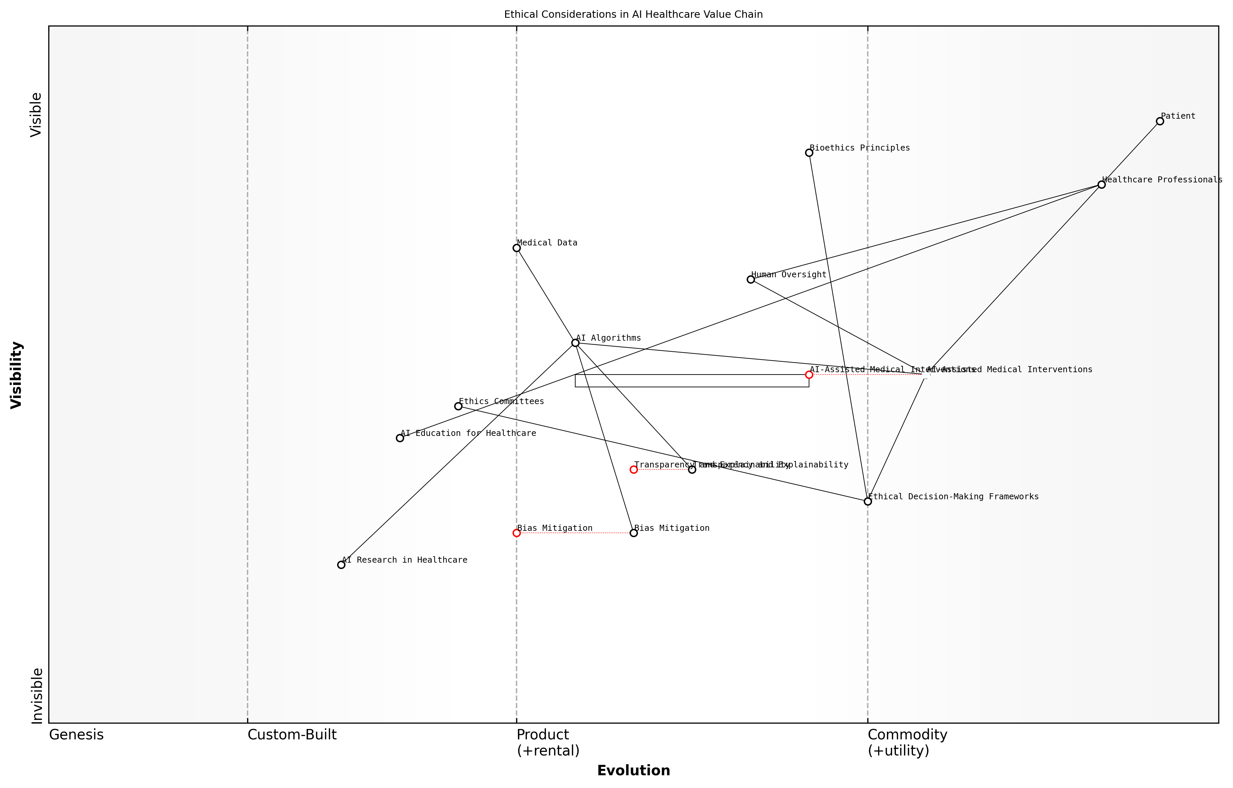

Draft Wardley Map: [Insert Wardley Map illustrating the ethical considerations in the AI healthcare value chain]

[Edit this draft Wardley Map](https://create.wardleymaps.ai/#c4d01d43dc42fcba95)

Ethical Decision-Making Frameworks for AI in Healthcare

To address the complex ethical challenges presented by AI-assisted medical interventions, it is essential to develop robust decision-making frameworks that can guide healthcare professionals, researchers, and policymakers. These frameworks should integrate ethical principles with practical considerations, ensuring that AI technologies are deployed in a manner that aligns with societal values and professional standards.

* Developing ethical guidelines specific to AI in healthcare
* Creating decision support tools that incorporate ethical considerations
* Establishing ethics committees with expertise in AI and healthcare

By applying Wardley Mapping to the development and implementation of these ethical decision-making frameworks, we can identify key stakeholders, dependencies, and potential barriers to adoption. This strategic approach can inform the creation of educational programmes that prepare healthcare professionals to navigate the ethical complexities of AI-assisted medical interventions.

Conclusion

Ethical decision-making in AI-assisted medical interventions represents a critical challenge for the MedTech field. By leveraging Wardley Mapping as a strategic tool, educators and researchers can gain valuable insights into the evolving landscape of AI in healthcare and the ethical considerations that must be addressed. This approach enables the development of comprehensive educational programmes and research initiatives that prepare healthcare professionals to harness the potential of AI while upholding the highest ethical standards.

As we continue to integrate AI technologies into healthcare practice, it is imperative that we maintain a focus on ethical considerations at every stage of development and deployment. By doing so, we can ensure that AI-assisted medical interventions enhance patient care, promote equity, and uphold the fundamental principles of medical ethics in an increasingly technologically-driven healthcare environment.

## Anticipating Future MedTech Developments

### Mapping potential disruptive technologies

In the rapidly evolving landscape of medical technology, anticipating and mapping potential disruptive technologies is crucial for educators, researchers, and industry professionals alike. This process not only informs strategic decision-making but also ensures that higher education curricula remain relevant and forward-thinking. By leveraging Wardley Mapping techniques, we can visualise the potential trajectories of emerging technologies and their impact on the MedTech ecosystem.

To effectively map potential disruptive technologies in MedTech, we must consider several key aspects:

* Identifying emerging technologies with disruptive potential
* Assessing the current position of these technologies on the evolution axis
* Projecting the future movement and impact of these technologies
* Analysing the interdependencies between emerging technologies and existing components
* Considering the ethical implications and societal readiness for adoption

Let’s explore each of these aspects in detail, drawing upon Wardley Mapping principles and their application in the MedTech context.

Identifying emerging technologies with disruptive potential is the first crucial step. In the MedTech sector, this might include technologies such as CRISPR gene editing, artificial intelligence-driven diagnostics, 3D-printed organs, or nanomedicine. To identify these technologies, educators and researchers must maintain a pulse on cutting-edge research, industry trends, and cross-disciplinary innovations. As a senior researcher in the field noted, ‘The most disruptive MedTech innovations often emerge at the intersection of multiple disciplines, challenging us to broaden our perspective beyond traditional medical boundaries.’

Once potential disruptive technologies are identified, the next step is to assess their current position on the evolution axis of a Wardley Map. This involves determining whether the technology is in the genesis, custom-built, product, or commodity stage. For instance, while AI-driven diagnostics might be in the product stage for certain applications, more advanced AI systems capable of complex medical decision-making may still be in the genesis or custom-built stages.

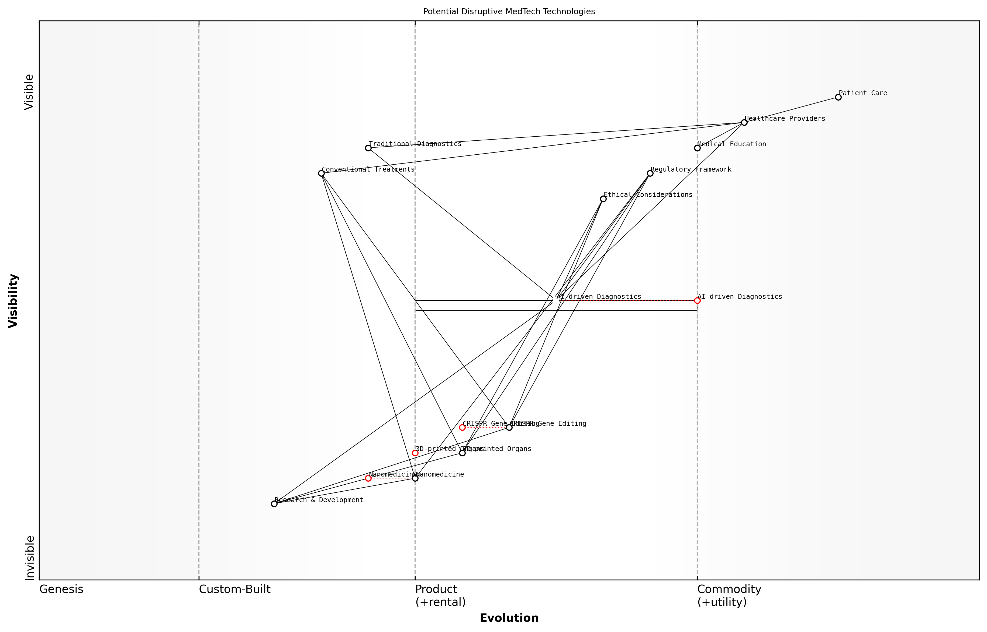

Draft Wardley Map: [Insert Wardley Map showing the current positioning of potential disruptive MedTech technologies]

[Edit this draft Wardley Map](https://create.wardleymaps.ai/#0e65c72c7289a30280)

Projecting the future movement and impact of these technologies is perhaps the most challenging aspect of this mapping process. It requires a deep understanding of technological trends, market forces, and regulatory landscapes. For example, while 3D-printed organs are currently in the early stages of development, we can project their movement towards the product stage as the technology matures and regulatory frameworks adapt. This projection allows educators to prepare students for future scenarios and helps researchers focus on areas with the greatest potential impact.

Analysing the interdependencies between emerging technologies and existing components is crucial for understanding the broader implications of disruptive innovations. In MedTech, this might involve mapping how AI-driven diagnostics could impact existing imaging technologies, laboratory processes, and clinical decision-making workflows. By visualising these interdependencies, we can identify potential bottlenecks, synergies, and areas requiring adaptation in the healthcare system.

Understanding the complex web of interdependencies in healthcare is key to successful innovation. A disruptive technology that fails to integrate with existing systems and workflows is unlikely to achieve widespread adoption, regardless of its potential benefits.

Considering the ethical implications and societal readiness for adoption is a critical aspect often overlooked in traditional technology mapping. In MedTech, this is particularly important given the sensitive nature of healthcare and the potential impact on human lives. For instance, while CRISPR gene editing shows immense promise, its evolution and adoption may be significantly influenced by ethical debates and regulatory decisions. Incorporating these considerations into our Wardley Maps provides a more holistic view of the technology’s potential trajectory.

To effectively teach and apply these mapping techniques in higher education, consider the following approaches:

* Engage students in collaborative mapping exercises using real-world MedTech scenarios
* Incorporate diverse perspectives by inviting guest speakers from industry, regulatory bodies, and ethics committees
* Encourage students to create and defend their own maps of potential disruptive technologies
* Use case studies of past disruptive technologies to illustrate the mapping process and its predictive power
* Integrate mapping exercises with other foresight techniques such as scenario planning and Delphi methods

By mastering the art of mapping potential disruptive technologies, MedTech educators and researchers can better prepare the next generation of healthcare innovators. This approach not only enhances strategic thinking skills but also fosters a proactive mindset essential for navigating the complex and rapidly evolving landscape of medical technology.

As we continue to refine our mapping techniques and integrate them into MedTech education and research, we must remain adaptable and open to new insights. The field of healthcare technology is notoriously difficult to predict, and our maps should be living documents, constantly updated as new information emerges and technologies evolve. By embracing this dynamic approach, we can ensure that our educational programmes and research initiatives remain at the forefront of MedTech innovation.

The true value of mapping potential disruptive technologies lies not in perfect prediction, but in cultivating a mindset of strategic foresight and adaptability among our students and researchers. It’s about preparing them to navigate uncertainty and seise opportunities in the ever-changing landscape of medical technology.

### Predicting shifts in healthcare delivery models

In the rapidly evolving landscape of medical technology, predicting shifts in healthcare delivery models is crucial for educators, researchers, and industry professionals alike. By leveraging Wardley Mapping techniques, we can anticipate and prepare for these changes, ensuring that our teaching and research in higher education remain at the forefront of MedTech innovation.

The application of Wardley Mapping to predict shifts in healthcare delivery models offers a strategic advantage in understanding the complex interplay between emerging technologies, patient needs, and healthcare systems. This approach allows us to visualise the evolution of various components within the healthcare ecosystem and identify potential disruptors that may reshape how care is delivered.

Wardley Mapping has revolutionised our ability to foresee and adapt to changes in healthcare delivery. It’s not just about predicting the future; it’s about shaping it through informed decision-making and strategic planning.

Let’s explore key aspects of using Wardley Mapping to predict shifts in healthcare delivery models:

* Identifying emerging technologies and their potential impact
* Analysing patient-centric care models
* Evaluating the role of data and AI in healthcare delivery
* Assessing the shift towards preventative and personalised medicine
* Examining the integration of remote and virtual care solutions

Identifying emerging technologies and their potential impact is a critical first step in predicting shifts in healthcare delivery models. By mapping the current technological landscape and projecting its evolution, we can anticipate how innovations such as advanced wearables, nanotechnology, and gene editing might reshape patient care. For instance, the integration of continuous health monitoring devices could lead to a more proactive and preventative approach to healthcare delivery.

Analysing patient-centric care models through Wardley Mapping allows us to visualise the movement towards more personalised and empowering healthcare experiences. This shift is driven by increasing patient expectations and the availability of data-driven insights. By mapping the components of patient engagement, from appointment scheduling to treatment decision-making, we can identify areas ripe for innovation and predict how care delivery might evolve to put patients at the centre of their health journey.

Evaluating the role of data and AI in healthcare delivery is crucial for anticipating future models. Wardley Maps can help us understand how the increasing availability of health data, coupled with advancements in AI and machine learning, might lead to more precise diagnostics, personalised treatment plans, and predictive healthcare interventions. This analysis can inform curriculum development in MedTech education, ensuring that students are prepared for a data-driven healthcare landscape.

The integration of AI and big data analytics in healthcare is not just a technological shift; it’s a fundamental reimagining of how we approach patient care and medical decision-making. Wardley Mapping helps us navigate this complex transition and prepare our students for the healthcare systems of tomorrow.

Assessing the shift towards preventative and personalised medicine is another key area where Wardley Mapping proves invaluable. By mapping the components of traditional reactive healthcare models against emerging preventative approaches, we can visualise the transition towards more personalised, genetics-informed care. This insight can guide research priorities and help educators develop curricula that emphasise the importance of preventative strategies and personalised treatment plans.

Examining the integration of remote and virtual care solutions has become increasingly important, especially in light of recent global events. Wardley Mapping can help us understand how telemedicine, remote monitoring, and virtual consultations are likely to evolve and integrate with traditional care models. This analysis can inform the development of new healthcare delivery frameworks that blend in-person and virtual care seamlessly.

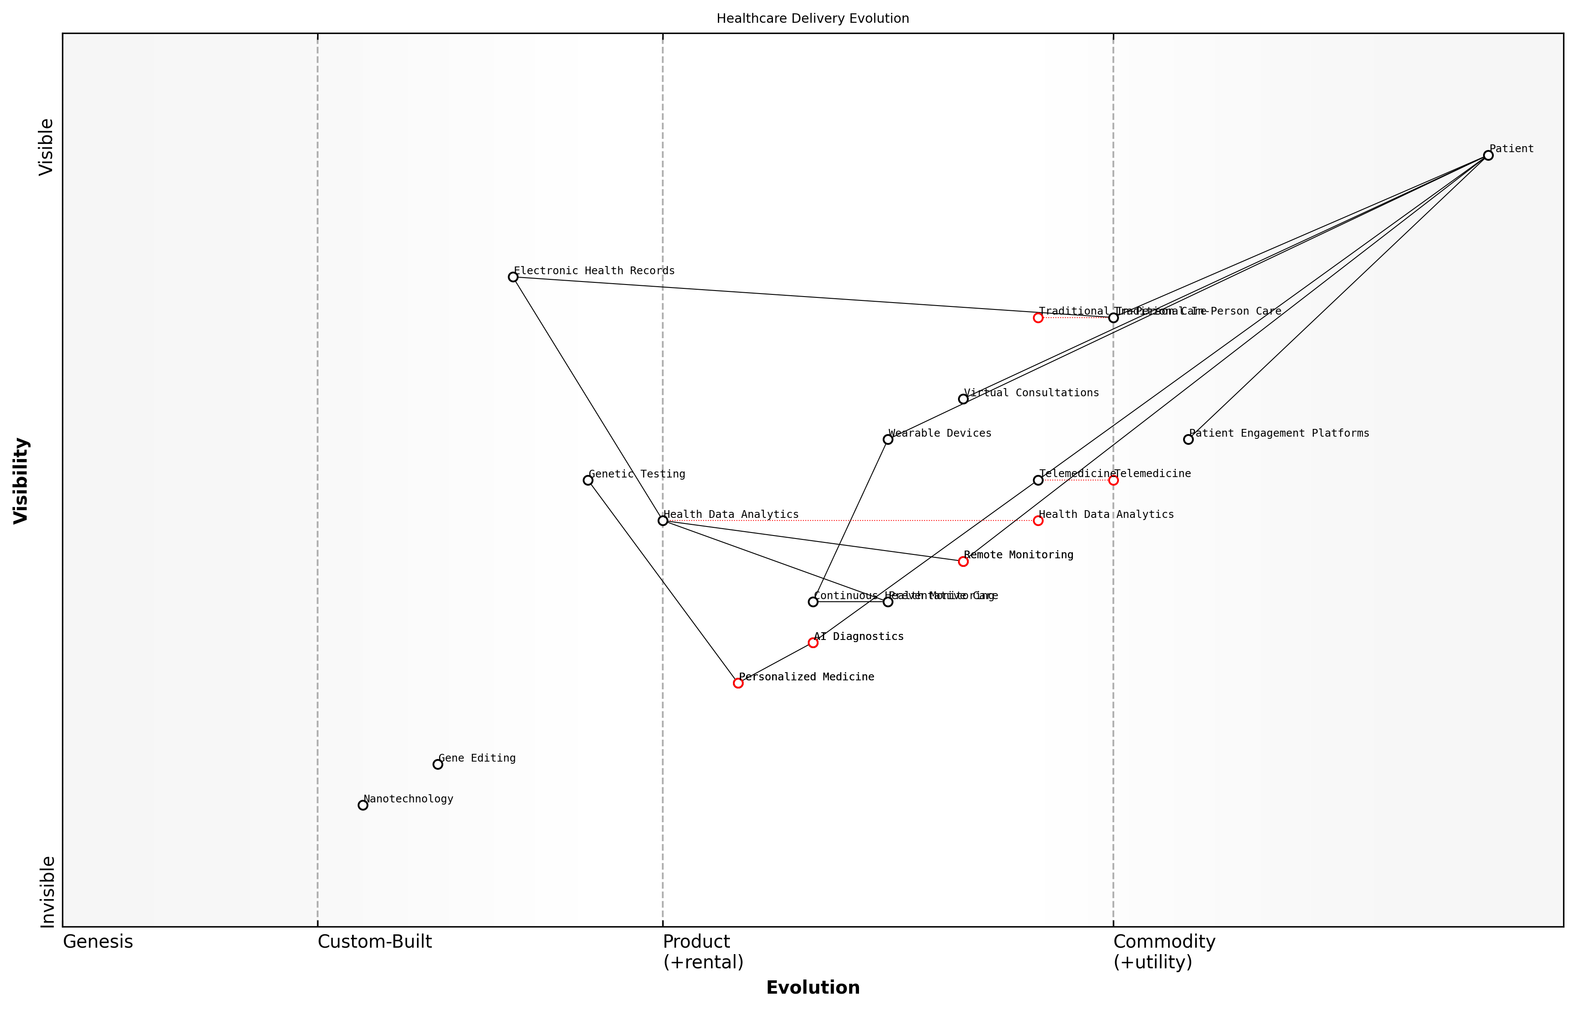

Draft Wardley Map: [Insert Wardley Map illustrating the evolution of healthcare delivery models, from traditional in-person care to integrated virtual and personalised solutions]

[Edit this draft Wardley Map](https://create.wardleymaps.ai/#193b4c7cca67249159)

To effectively use Wardley Mapping in predicting shifts in healthcare delivery models, it’s essential to consider the following practical applications:

* Collaborative mapping exercises with healthcare providers, technologists, and policymakers to gain diverse perspectives on future trends
* Regular updating of maps to reflect rapid technological advancements and changing patient expectations
* Integration of scenario planning techniques to explore multiple potential futures in healthcare delivery
* Use of maps to identify potential barriers to adoption of new delivery models and strategies to overcome them
* Leveraging maps to guide curriculum development and research focus in MedTech education programmes

By incorporating these practices into our teaching and research methodologies, we can better prepare students and healthcare professionals for the evolving landscape of healthcare delivery. Wardley Mapping provides a powerful tool for visualising complex systems and anticipating change, enabling us to stay ahead of the curve in MedTech innovation and education.

In my experience advising government health agencies, Wardley Mapping has been instrumental in helping policymakers understand and prepare for future healthcare delivery models. It provides a common language and visual framework that bridges the gap between technology, policy, and patient care.

In conclusion, predicting shifts in healthcare delivery models through Wardley Mapping is an essential skill for educators, researchers, and professionals in the MedTech field. By embracing this strategic approach, we can ensure that our teaching and research remain relevant, innovative, and aligned with the future needs of healthcare systems and patients. As we continue to refine our mapping techniques and integrate them into higher education curricula, we pave the way for a new generation of MedTech innovators who are well-equipped to shape the future of healthcare delivery.

### Preparing students and researchers for future challenges

In the rapidly evolving landscape of medical technology, preparing students and researchers for future challenges is paramount. This subsection explores the critical role of Wardley Mapping in equipping the next generation of MedTech professionals with the skills and foresight necessary to navigate the complexities of tomorrow’s healthcare ecosystem.

Wardley Mapping serves as an invaluable tool for anticipating and addressing future challenges in MedTech. By visualising the evolution of technologies, practices, and market dynamics, students and researchers can develop a strategic mindset that is crucial for innovation and adaptability in this fast-paced field.

Wardley Mapping is not just a tool; it’s a way of thinking that empowers MedTech professionals to anticipate change, identify opportunities, and navigate the complex landscape of healthcare innovation.

To effectively prepare students and researchers for future challenges, we must focus on several key areas:

* Developing strategic thinking skills
* Enhancing adaptability and resilience
* Fostering interdisciplinary collaboration
* Cultivating ethical awareness
* Encouraging continuous learning and upskilling

Developing strategic thinking skills is fundamental to preparing for future challenges. By integrating Wardley Mapping into MedTech curricula, we can teach students to analyse complex systems, identify dependencies, and anticipate technological shifts. This strategic mindset is crucial for navigating the uncertainties of emerging technologies and evolving healthcare needs.

Enhancing adaptability and resilience is essential in a field where disruptive innovations can rapidly transform the landscape. Wardley Mapping exercises that simulate various future scenarios can help students and researchers develop the flexibility to pivot their strategies and research focus in response to changing circumstances.

Fostering interdisciplinary collaboration is increasingly important as MedTech innovations often arise at the intersection of multiple fields. Wardley Mapping can facilitate this by providing a common language and visual framework for professionals from diverse backgrounds to communicate and collaborate effectively.

The future of MedTech lies in our ability to break down silos and foster collaboration across disciplines. Wardley Mapping provides a shared platform for this crucial interdisciplinary dialogue.

Cultivating ethical awareness is critical as emerging technologies raise new moral and societal questions. By incorporating ethical considerations into Wardley Maps, we can train students and researchers to anticipate and address potential ethical challenges proactively, ensuring that future innovations align with societal values and regulatory requirements.

Encouraging continuous learning and upskilling is vital in a field where knowledge quickly becomes obsolete. Wardley Mapping can help identify emerging skill gaps and guide the development of targeted learning programmes to keep professionals at the forefront of MedTech innovation.

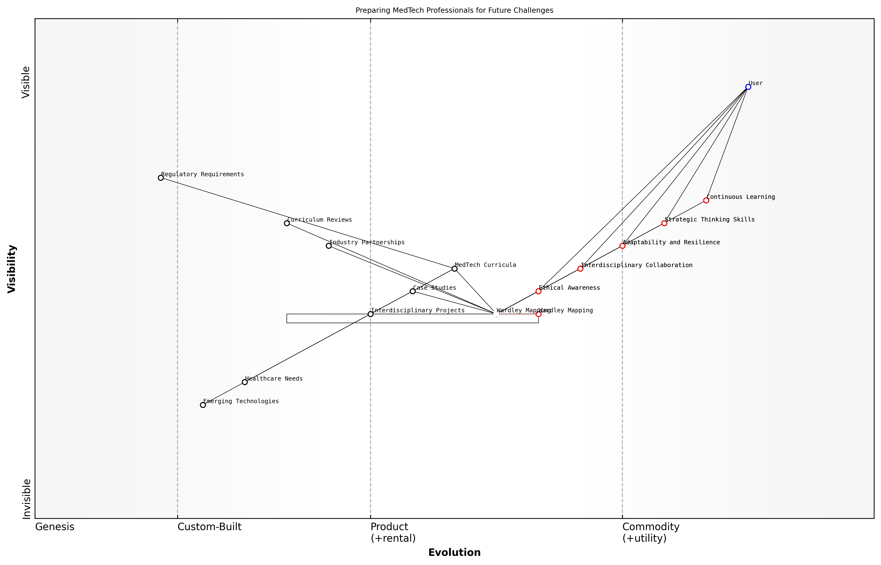

Draft Wardley Map: [Insert Wardley Map illustrating the evolution of key MedTech skills and competencies over time]

[Edit this draft Wardley Map](https://create.wardleymaps.ai/#16103e175788cf859c)

To effectively implement these strategies, higher education institutions and research organisations should consider the following practical approaches:

* Integrating Wardley Mapping workshops into core MedTech curricula
* Developing case studies that challenge students to apply Wardley Mapping to real-world MedTech scenarios
* Creating interdisciplinary project teams that use Wardley Mapping to tackle complex healthcare challenges
* Establishing partnerships with industry leaders to ensure educational content aligns with future market needs
* Implementing regular curriculum reviews using Wardley Maps to identify and address emerging skill gaps

By adopting these approaches, institutions can create a dynamic learning environment that not only prepares students and researchers for known challenges but also equips them with the tools to anticipate and address unforeseen developments in the MedTech landscape.

Our goal is not just to teach current knowledge, but to instil the ability to learn, adapt, and innovate in the face of an uncertain future. Wardley Mapping is the compass that will guide our students and researchers through this ever-changing terrain.

In conclusion, preparing students and researchers for future challenges in MedTech requires a multifaceted approach that combines strategic thinking, adaptability, collaboration, ethical awareness, and continuous learning. By leveraging Wardley Mapping as a core tool in this preparation, we can empower the next generation of MedTech professionals to not only navigate but also shape the future of healthcare innovation.

## The Future of Wardley Mapping in MedTech Education and Research

### Evolving mapping techniques for complex healthcare ecosystems

As the healthcare landscape continues to evolve at an unprecedented pace, the need for sophisticated mapping techniques to navigate complex healthcare ecosystems has never been more critical. Wardley Mapping, with its focus on strategic positioning and value chain analysis, is poised to play an increasingly pivotal role in MedTech education and research. This section explores the future trajectory of Wardley Mapping techniques, specifically tailored to address the unique challenges and opportunities within the rapidly changing healthcare sector.

The evolution of Wardley Mapping in MedTech contexts is driven by several key factors, including the increasing complexity of healthcare systems, the rapid pace of technological innovation, and the growing emphasis on value-based care. As we look to the future, several emerging trends and adaptations in mapping techniques are likely to shape the landscape of MedTech education and research:

* Integration of real-time data and dynamic mapping
* Enhanced visualisation techniques for multi-dimensional analysis
* Incorporation of AI and machine learning for predictive mapping
* Development of collaborative mapping platforms for cross-disciplinary teams
* Adaptation of mapping techniques to address ethical and regulatory considerations

One of the most significant developments in Wardley Mapping for healthcare ecosystems is the integration of real-time data and dynamic mapping capabilities. Traditional static maps, while valuable, often struggle to capture the rapid changes and complex interdependencies within modern healthcare systems. Future mapping techniques are likely to incorporate live data feeds from various sources, including electronic health records, medical devices, and health information exchanges. This real-time integration will enable educators and researchers to create ‘living maps’ that continuously update to reflect the current state of the healthcare ecosystem.

The future of Wardley Mapping in healthcare lies in its ability to capture and visualise the dynamic nature of our rapidly evolving medical landscape. Static maps will give way to real-time, data-driven representations that allow us to anticipate and respond to changes as they occur.

Enhanced visualisation techniques represent another frontier in the evolution of Wardley Mapping for MedTech applications. As healthcare ecosystems become increasingly complex, traditional two-dimensional maps may prove insufficient to capture the full range of relationships and dependencies. Future mapping techniques are likely to incorporate advanced visualisation methods, such as 3D mapping, virtual reality (VR), and augmented reality (AR) interfaces. These enhanced visualisation tools will allow students and researchers to explore healthcare ecosystems from multiple perspectives, gaining deeper insights into the interplay between various components and stakeholders.

The incorporation of artificial intelligence (AI) and machine learning (ML) into Wardley Mapping processes is set to revolutionise predictive capabilities within MedTech education and research. By leveraging vast datasets and advanced algorithms, AI-enhanced mapping techniques will be able to forecast potential future states of healthcare ecosystems with greater accuracy. This predictive element will be invaluable for strategic planning, risk assessment, and innovation forecasting in MedTech contexts.

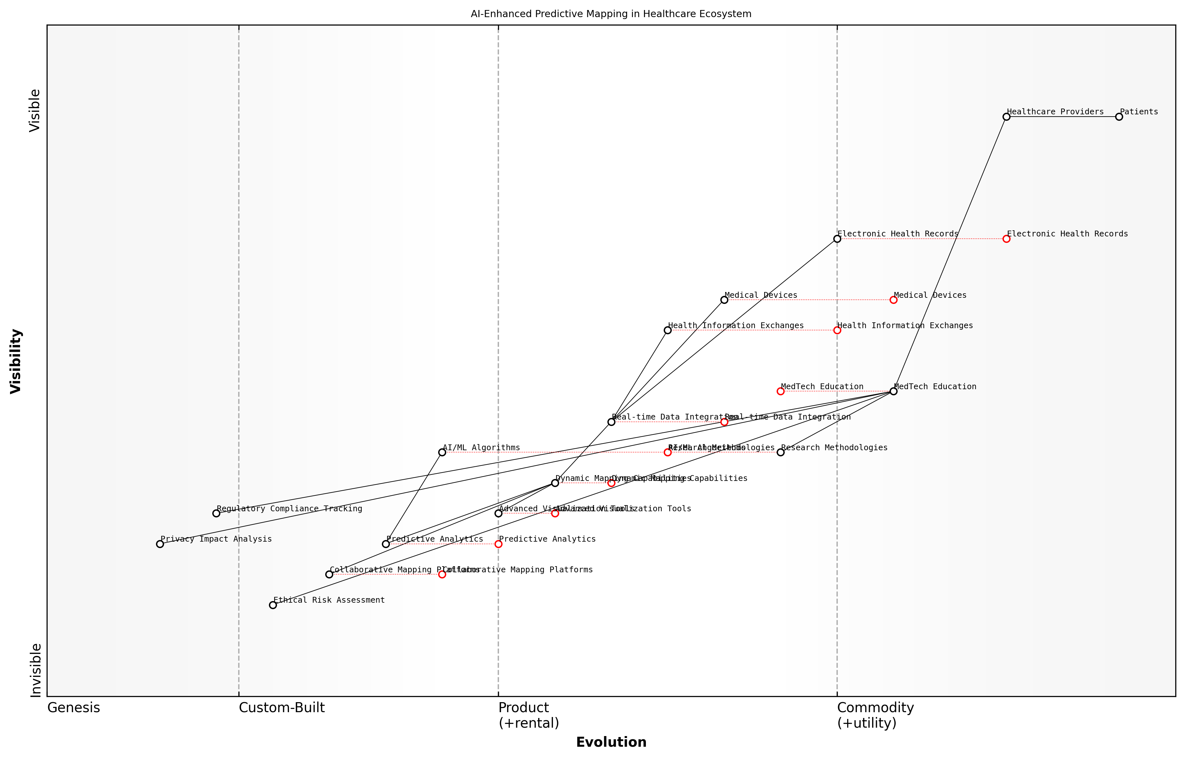

Draft Wardley Map: [Insert Wardley Map illustrating AI-enhanced predictive mapping in a healthcare ecosystem]

[Edit this draft Wardley Map](https://create.wardleymaps.ai/#e8fcf87cfeca10e380)

The development of collaborative mapping platforms tailored for cross-disciplinary teams represents another crucial evolution in Wardley Mapping techniques for healthcare. The complexity of modern healthcare challenges often requires input from diverse stakeholders, including clinicians, engineers, data scientists, and policymakers. Future mapping tools are likely to facilitate real-time collaboration, allowing multidisciplinary teams to co-create and iterate on maps simultaneously. These platforms will support more holistic and inclusive approaches to healthcare innovation and strategic planning.

The power of Wardley Mapping in healthcare lies not just in the maps themselves, but in the collaborative process of creating them. As we move forward, our mapping techniques must evolve to support seamless collaboration across disciplines, breaking down silos and fostering innovative solutions to complex healthcare challenges.

As MedTech continues to push the boundaries of what’s possible in healthcare, ethical and regulatory considerations are becoming increasingly central to innovation processes. Future Wardley Mapping techniques will need to adapt to explicitly address these concerns, incorporating elements such as ethical risk assessment, regulatory compliance tracking, and privacy impact analysis. This evolution will ensure that MedTech education and research remain grounded in ethical principles and aligned with evolving regulatory frameworks.

In the context of higher education, these evolving mapping techniques will have profound implications for both teaching and research methodologies. Educators will need to develop new curricula that not only introduce students to the fundamentals of Wardley Mapping but also prepare them to work with these advanced, dynamic mapping tools. Research methodologies will similarly need to adapt, leveraging these new capabilities to explore complex healthcare challenges from novel perspectives.

* Development of specialised courses in advanced healthcare ecosystem mapping
* Integration of real-time mapping exercises into clinical simulations
* Creation of interdisciplinary research projects centred around collaborative mapping
* Establishment of partnerships with healthcare providers for live data integration in mapping exercises
* Incorporation of ethical decision-making scenarios in mapping-based assessments

As we look to the future, it’s clear that Wardley Mapping techniques for complex healthcare ecosystems will continue to evolve, driven by technological advancements and the changing needs of the healthcare sector. These evolving techniques will play a crucial role in shaping the next generation of MedTech innovators, equipping them with the tools and mindset needed to navigate the complexities of modern healthcare systems. By embracing these advancements and integrating them into our educational and research practices, we can ensure that Wardley Mapping remains a powerful and relevant tool for driving innovation and strategic thinking in the ever-changing landscape of healthcare technology.

### Integrating Wardley Mapping with other strategic tools

As the field of MedTech education and research continues to evolve, the integration of Wardley Mapping with other strategic tools presents a compelling opportunity to enhance decision-making and strategic planning in healthcare technology. This integration not only amplifies the strengths of individual methodologies but also addresses their limitations, providing a more comprehensive approach to tackling complex challenges in the MedTech landscape.

The synergy between Wardley Mapping and complementary strategic tools can be categorised into three primary areas: enhancing situational awareness, improving decision-making processes, and facilitating communication and collaboration. Let us explore each of these areas in detail.

Enhancing Situational Awareness:

* SWOT Analysis: Combining Wardley Mapping with SWOT analysis allows for a more dynamic understanding of strengths, weaknesses, opportunities, and threats within the MedTech ecosystem. By mapping these elements onto the value chain, educators and researchers can better visualise how they evolve over time and identify strategic leverage points.
* Porter’s Five Forces: Integrating Porter’s Five Forces with Wardley Maps provides a deeper insight into the competitive landscape of MedTech. This combination helps in understanding how industry forces interact with the evolution of technologies and practices, enabling more informed strategic decisions in both education and research.
* Scenario Planning: Wardley Mapping can significantly enhance scenario planning exercises by providing a visual representation of potential future states. This integration is particularly valuable in MedTech, where rapid technological advancements and regulatory changes can dramatically alter the landscape.

Improving Decision-Making Processes:

* Balanced Scorecard: Integrating Wardley Mapping with the Balanced Scorecard approach can help align strategic objectives with the evolving MedTech landscape. This combination enables educators and researchers to develop more adaptive and responsive performance metrics that reflect the dynamic nature of healthcare technology.
* Design Thinking: The marriage of Wardley Mapping and Design Thinking methodologies can foster innovation in MedTech education and research. By mapping user needs and technological capabilities, this integration supports the development of more user-centric and future-proof solutions.
* Agile Methodologies: Incorporating Wardley Mapping into Agile frameworks can enhance the adaptability of MedTech research projects and educational programmes. This integration allows for more responsive planning and execution, aligning with the fast-paced nature of healthcare technology innovation.

Facilitating Communication and Collaboration:

* Business Model Canvas: Combining Wardley Mapping with the Business Model Canvas can provide a more comprehensive view of value creation and capture in MedTech ventures. This integration is particularly useful for academic-industry collaborations, helping to align research outputs with market needs.
* Stakeholder Mapping: Integrating stakeholder mapping techniques with Wardley Maps can enhance understanding of the complex relationships within the MedTech ecosystem. This combination supports more effective engagement strategies and helps identify potential collaborations or partnerships.
* Technology Roadmapping: The synthesis of Wardley Mapping and technology roadmapping can provide a more nuanced view of technological trajectories in MedTech. This integration supports better alignment of research priorities with anticipated industry needs and technological developments.

The integration of Wardley Mapping with other strategic tools represents a significant leap forward in our ability to navigate the complexities of MedTech innovation. It allows us to combine the strengths of multiple approaches, providing a more holistic view of the challenges and opportunities in this rapidly evolving field.

As we look to the future of MedTech education and research, the integration of Wardley Mapping with other strategic tools will likely become increasingly sophisticated. We can anticipate the development of specialised software platforms that seamlessly combine these methodologies, offering powerful visualisation and analysis capabilities. Moreover, the emergence of AI-assisted mapping tools could potentially automate certain aspects of the integration process, allowing for real-time updates and more dynamic strategic planning.

However, it is crucial to approach this integration thoughtfully. While the combination of multiple strategic tools can provide valuable insights, it also risks increasing complexity and potentially overwhelming users. Therefore, educators and researchers must focus on developing frameworks that balance comprehensiveness with usability, ensuring that the integrated approach remains accessible and practical for both students and professionals in the MedTech field.

To fully realise the potential of integrating Wardley Mapping with other strategic tools in MedTech education and research, several key considerations must be addressed:

* Curriculum Development: Educational institutions must develop curricula that not only teach individual strategic tools but also emphasise their integration. This approach will equip students with a more comprehensive skill set for addressing complex MedTech challenges.
* Professional Development: Ongoing training and workshops for educators and researchers will be essential to ensure they can effectively leverage integrated strategic approaches in their work.
* Collaborative Research: Encouraging interdisciplinary research projects that utilise integrated strategic tools can drive innovation in both methodology and MedTech applications.
* Industry Partnerships: Engaging with industry partners to apply integrated strategic approaches to real-world MedTech challenges can provide valuable feedback and drive further refinement of these methodologies.
* Ethical Considerations: As these integrated approaches become more powerful, it will be crucial to consider the ethical implications of their use, particularly in healthcare contexts where decisions can have significant impacts on patient outcomes and privacy.

The future of MedTech education and research lies not just in mastering individual strategic tools, but in understanding how to integrate and apply them synergistically. This holistic approach will be crucial in preparing the next generation of healthcare technology innovators to navigate the complex and rapidly evolving MedTech landscape.

In conclusion, the integration of Wardley Mapping with other strategic tools represents a significant opportunity to enhance MedTech education and research. By combining the strengths of multiple methodologies, we can develop more comprehensive, adaptive, and insightful approaches to addressing the complex challenges in healthcare technology. As this integration continues to evolve, it will play a crucial role in shaping the future of MedTech innovation, driving advancements that have the potential to transform healthcare delivery and improve patient outcomes globally.

### Building a community of practice in MedTech strategic thinking

As we look towards the future of Wardley Mapping in MedTech education and research, one of the most crucial aspects to consider is the development and nurturing of a robust community of practice. This community will play a pivotal role in advancing strategic thinking within the MedTech sector, fostering innovation, and ensuring that the principles of Wardley Mapping continue to evolve alongside the rapidly changing healthcare technology landscape.

The concept of a community of practice, first introduced by Etienne Wenger and Jean Lave, refers to a group of people who share a concern or passion for something they do and learn how to do it better as they interact regularly. In the context of MedTech strategic thinking, this community would comprise educators, researchers, industry professionals, and policymakers who are committed to leveraging Wardley Mapping to drive innovation and improve healthcare outcomes.

The power of a community of practice lies in its ability to generate and share knowledge, foster innovation, and create a shared language and understanding around complex topics. In the rapidly evolving field of MedTech, such a community is not just beneficial—it’s essential.

Let’s explore the key components and strategies for building a thriving community of practice in MedTech strategic thinking:

* Establishing a shared domain
* Fostering community engagement
* Developing a shared repertoire
* Leveraging technology for collaboration
* Encouraging cross-sector partnerships

1. Establishing a shared domain: The first step in building a community of practice is to clearly define its domain. In our case, this would encompass the application of Wardley Mapping to MedTech innovation, education, and research. This shared domain provides a common ground for members to connect and collaborate, regardless of their specific roles or organisations.
2. Fostering community engagement: Regular interaction is crucial for a thriving community of practice. This can be achieved through various means, such as:

* Organising annual conferences or symposia focused on Wardley Mapping in MedTech
* Hosting monthly webinars or virtual meetups to discuss case studies and best practices
* Creating online forums or discussion boards for ongoing dialogue
* Establishing mentorship programmes to connect experienced practitioners with newcomers

1. Developing a shared repertoire: As the community evolves, it will naturally develop a shared set of resources, experiences, and tools. This might include:

* A repository of MedTech-specific Wardley Maps
* Case studies demonstrating successful applications in various healthcare contexts
* Best practice guidelines for teaching Wardley Mapping in MedTech curricula
* Templates and tools for applying Wardley Mapping to MedTech research proposals

1. Leveraging technology for collaboration: In today’s digital age, technology plays a crucial role in facilitating community interaction and knowledge sharing. Consider implementing:

* A dedicated online platform for community members to connect and collaborate
* Cloud-based tools for collaborative mapping and project management
* AI-powered recommendation systems to suggest relevant resources and connections within the community
* Virtual reality environments for immersive, collaborative mapping sessions

1. Encouraging cross-sector partnerships: The MedTech field is inherently interdisciplinary, and our community of practice should reflect this. Actively encourage participation and collaboration between:

* Academic institutions and research centres
* Healthcare providers and hospital systems
* MedTech startups and established industry players
* Regulatory bodies and policymakers
* Patient advocacy groups and healthcare consumers

The true power of a community of practice in MedTech strategic thinking lies in its ability to bridge the gap between theory and practice, academia and industry, technology and healthcare. By fostering these connections, we can accelerate innovation and drive meaningful improvements in patient care.

As we look to the future, it’s clear that the role of Wardley Mapping in MedTech education and research will continue to grow in importance. By building a strong community of practice, we can ensure that this powerful strategic tool evolves alongside the rapidly changing healthcare landscape, driving innovation and improving outcomes for patients worldwide.

To illustrate the potential impact of such a community, let’s consider a hypothetical case study:

A university research team working on a novel AI-powered diagnostic tool connects with a startup developing complementary sensor technology through the community’s online platform. Simultaneously, a policymaker seeking input on upcoming regulations for AI in healthcare joins a community webinar. The resulting collaboration leads to a groundbreaking project that not only advances the technology but also helps shape responsible innovation policies.

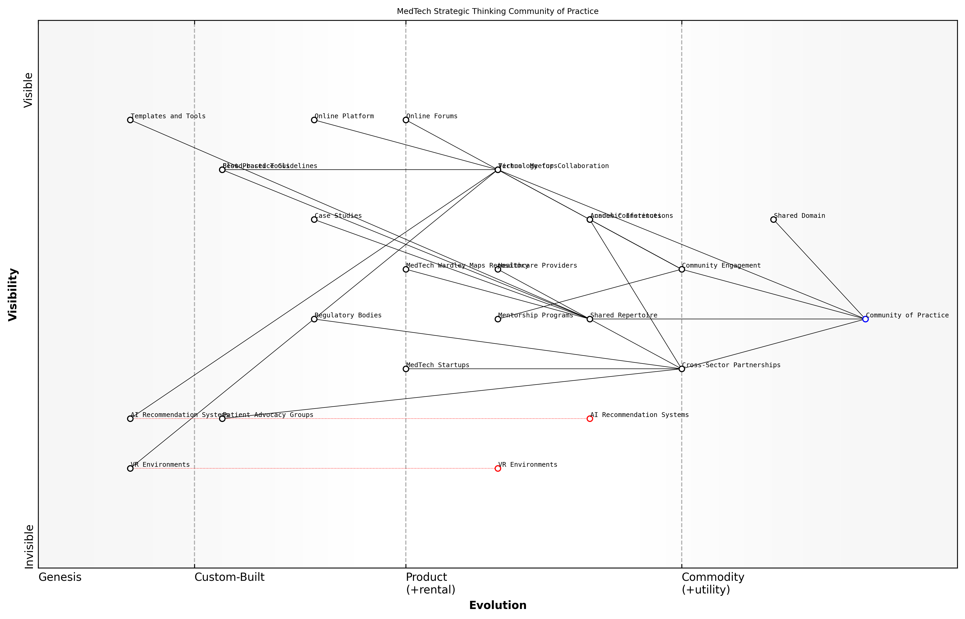

Draft Wardley Map: [Insert Wardley Map illustrating the evolution of the MedTech strategic thinking community of practice]

[Edit this draft Wardley Map](https://create.wardleymaps.ai/#bc649161e117f03265)

This example demonstrates how a well-functioning community of practice can catalyse innovation, foster collaboration, and drive positive change in the MedTech sector.

In conclusion, building a community of practice in MedTech strategic thinking is not just about creating a network of professionals. It’s about fostering an ecosystem where knowledge flows freely, innovation thrives, and the principles of Wardley Mapping are continuously applied and refined to address the complex challenges of healthcare technology. As we move forward, this community will play a crucial role in shaping the future of MedTech education, research, and innovation.